
CyberNova

Sprint 3 Project Documentation
For
BusNova Bus Management Version 3.0


Submission date: 03 November 2026
For: Mr. D. Boucher

Declaration of Work:
We, CyberNova, declare that:
- The system developed is our original work and has not in part been submitted for the purposes of final assessment for any other 3rd year project module,
- We have permission to use images shown in our system and have created our own logos that are used in our system,
- Where we have made use of programming assistance, we acknowledge this fact in the acknowledgements section below,
- We did not outsource the building of the entire system to a third party.
Group Members and Roles:
Name and Surname | Student Number | Role(s) | Electronic Signature
Anesipho Kalazana | 202327653 | BA
Elihle Nteyi | 202316017 | BA
Esethu Mtose | 224072208 | BA
Nadia Mpohlekana | 224104608 | PM; DO | 
Olebogeng Gumbu | 224111100 | PR
Simanye Siximba | 224017307 | PR | 
Yonwaba Mgqulwana | 224090097 | BA; DO
Role Key:
PM: Project Manager (only one member can be PM at any given time)
BA: Business Analyst
DO: Documenter
PR: Programmer
A team member can complete multiple roles.

Acknowledgements:
We would like to thank:
1. Lecturers:
- Lecture: Mr D. Boucher | Email: dboucher@ufh.ac.za
- Business Analysis: Assoc. Prof R. Piderit | Email: rpiderit@ufh.ac.za
- Databases: Dr V. Funda | Email: vfunda@ufh.ac.za
- Programming: Mr T. Breetzke | Email: tbreekze@ufh.ac.za

2. Our Mentor: Anelisa Gobingca

Table of Contents
System Matrix 10
System Overview 12
1. Section A: Business Process Description 13
1.1. Use Case Diagram 13
1.2. Use Case Narrative 14
1.2.1. Use Case Narrative: UC1 Register 14
1.2.2 Activity Diagram: UC1 Register 16
1.2.3. Use Case Narrative: UC2: Login 17
1.2.4 Activity Diagram: UC2 Login 18
1.2.5. Use Case Narrative: UC3 Register Bus 19
1.2.6. Activity Diagram: UC3 Register Bus 20
1.2.7. Use Case Narrative: UC4 Create Routes 21
1.2.8. Activity Diagram: UC4 Create Routes 22
1.2.9. Use Case Narrative: UC5 Assign Routes 23
1.2.10. Activity Diagram: UC5 Assign Routes 25
1.2.11. Use Case Narrative: UC9 View Assigned Routes 26
1.2.12. Activity Diagram: UC9 View Assigned Routes 27
1.2.13. Use Case Narrative: UC17 View Maintenance Schedule 28
1.2.14. Activity Diagram: UC7 View Maintenance Schedule 30
1.2.15. Use Case Narrative: UC8 Review Fuel 31
1.2.16. Activity Diagram: UC8 Review Fuel 32
1.2.19. Use Case Narrative: UC6 Monitor Operations 33
1.2.20. Activity Diagram: UC6 Monitor Operations 34
1.2.21. Use Case Narrative: UC13 View Routes 35
1.2.22. Activity Diagram: UC13 View Routes 36
1.2.23. Use Case Narrative: UC10 Report Fuel Use 37
1.2.24. Activity Diagram: UC10 Report Fuel 39
1.2.25. Use Case Narrative: UC18 Log Servicing Activities 40
1.2.26. Activity Diagram: UC18 Log Servicing Activities 41
1.2.27. Use Case Narrative: UC15 Purchase Ticket 42
1.2.28. Activity Diagram: UC15 Purchase Ticket 43
1.2.29. Use Case Narrative: UC14 Check availability 44
1.2.30. Activity diagram: UC14 Check availability 45
1.2.31. Use Case Narrative: UC11 Report Issues 46
1.2.32. Activity Diagram: UC11 Report Issues 47
1.2.33. Use Case Narrative: UC21 Register Employees 48
1.2.34. Activity Diagram: UC21 Register Employees 49
1.2.35. Use Case Narrative: UC7 View Reports 50
1.2.36. Activity Diagram: UC7 View Reports 51
1.2.37. Use Case Narrative: UC12 Update Status 52
1.2.38. Activity Diagram: UC12 Update Status 53
1.2.39. Use Case Narrative: UC16 Receive Confirmation 54
1.2.40. Activity Diagram: UC16 Receive Confirmation 55
1.2.41. Use Case Narrative: UC19 Update Vehicle Status 56
1.2.42. Activity Diagram: UC19 Update Vehicle Status 57
1.2.43. Use Case Narrative: UC20 Receive Maintenance Alerts 58
1.2.44. Activity Diagram: UC20 Receive Maintenance Alerts 59
2. Section B: Data Modelling Requirements 60
2.1. Entity Relationship Diagram 60
2. 2. Attribute Framing 61
2.2.1. Employees 61
2.2.2. Passengers 62
2.2.3. Bus 63
2.2.4. Bus Schedule 63
2.2.5. Route 64
2.2.6. Route Assignments 65
2.2.7. Maintenance Logs 66
2.2.8. Maintenance Parts 67
2.2.9. Fuel Logs 67
2.2.10. Tickets 68
2.2.11. Tickets Validation 69
2.2.12. Booking 70
2.2.13. Notification 70
2.2.14. Payment Event 71
2.2.15. Payment Refund 71
2.2.16. Payment Transaction 72
2.2.17. Audit Logs 73
2.2.18. Trip Inspection 74
2.2.19. Trip Pin 74
3. Section C: Systems Design Requirements 75
3.1. Windows Navigation Diagram 75
3.2. Screen Design Specification 76
3.2.1. Screen 01: Home Page 76
3.2.2. Screen 02: Register 77
3.2.3. Screen 03: Login 79
3.2.4. Screen 04: Manager Dashboard 80
3.2.5. Screen 05: Bus Driver Dashboard 82
3.2.6. Screen 06: Passenger Dashboard 83
3.2.7. Screen 07: Maintenance Staff Dashboard 84
3.2.8. Screen 08: Manage Users 85
3.2.9. Screen 09: Log Fuel 86
3.2.10. Screen 10: Report Issue 87
3.2.11. Screen 11: Register Bus 88
3.2.12. Screen 12: Create Routes 89
3.2.13. Screen 13: Assign Routes 90
3.2.14. Screen 14: View Assigned Routes 91
3.2.15. Screen 15: Issue Ticket 92
3.2.16. Screen 16: Ticket 93
3.2.17. Screen 17: Route Completion 94
3.2.18. Screen 18: Fuel Efficiency 95
3.2.19. Screen 19: Driver Performance 96
3.2.20. Screen 20: Maintenance Due 97
3.2.21. Screen 21: Payment 98
3.2.21. Screen 22: Live Map 99
3.2.22. Screen 23: Passenger Manifest 100
3.2.23. Screen 24: Ticket Sales 101
3.2.24. Screen 25: Driver Schedule 102
3.2.25. Screen 26: Route List 103
Sprint Backlog 105
Risk Log 107
Sprint Progress Report 108

List of Figures
Figure 1 Use Case Diagram 13
Figure 2 Activity Diagram: UC1 Register 16
Figure 3 Activity Diagram: UC2 Login 18
Figure 4 Activity Diagram: UC3 Register Bus 20
Figure 5 Activity Diagram: UC4 Create Routes 22
Figure 6 Activity Diagram: UC5 Assign Routes 25
Figure 7 Assigned Routes Activity Diagram 27
Figure 8 Activity Diagram: UC7 View Maintenance Schedule 30
Figure 9 Activity Diagram: UC8 Review Fuel 32
Figure 10 Activity Diagram: UC6 Monitor Operations 34
Figure 11 Activity Diagram: UC13 View Routes 36
Figure 12 Activity Diagram: UC10 Report Fuel 39
Figure 13 Activity Diagram: UC18 Log Servicing Activities 41
Figure 14 Activity Diagram: UC15 Purchase Ticket 43
Figure 15 Activity diagram: UC14 Check availability 45
Figure 16 Activity Diagram: UC11 Report Issues 47
Figure 17 Activity Diagram: UC21 Register Employees 49
Figure 18 Activity Diagram: UC7 View Reports 51
Figure 19 Activity Diagram: UC12 Update Status 53
Figure 20 Activity Diagram: UC16 Receive Confirmation 55
Figure 21 Activity Diagram: UC19 Update Vehicle Status 57
Figure 22 Activity Diagram: UC20 Receive Maintenance Alerts 59
Figure 23 Entity Relationship Diagram 60
Figure 24 Windows Navigation Diagram 75
Figure 25 Screen 01: Home Page 76
Figure 26 Screen 02: Register 77
Figure 27 Screen 03: Login 79
Figure 28 Screen 04: Manager Dashboard 80
Figure 29 Screen 05: Bus Driver Dashboard 82
Figure 30 Screen 06: Passenger Dashboard 83
Figure 31 Screen 07: Maintenance Staff Dashboard 84
Figure 32 Screen 08: Manage Users 85
Figure 33 Screen 09: Log Fuel 86
Figure 34 Screen 10: Report Issue 87
Figure 35 Screen 11: Register Bus 88
Figure 36 Screen 12: Create Routes 89
Figure 37 Screen 13: Assign Routes 90
Figure 38 Screen 14: View Assigned Routes 91
Figure 39 Screen 15: Issue Ticket 92
Figure 40 Screen 16: Ticket 93
Figure 41 Screen 17: Route Completion 94
Figure 42 Screen 18: Fuel Efficiency 95
Figure 43 Screen 19: Driver Performance 96
Figure 44 3.2.20. Screen 20: Maintenance Due 97
Figure 45 Screen 21: Payment 98
Figure 46 Screen 22: Live Map 99
Figure 47 Screen 23: Passenger Manifest 100
Figure 48 Screen 24: Ticket Sales 101
Figure 49 Screen 25: Driver Schedule 102
Figure 50 Screen 26: Route List 103

List of Tables
Table 1 System Matrix 11
Table 2 Use Case Narrative: Register 15
Table 3 Use Case Narrative: UC2: Login 17
Table 4 Use Case Narrative: Register Bus 19
Table 5 Use Case Narrative: Create Routes 21
Table 6 Use Case Narrative: Assign Routes 24
Table 7 Use Case Narrative: View Assigned Routes 26
Table 8 Use Case Narrative: View Maintenance Schedule 29
Table 9 Use Case Narrative: Review Fuel 31
Table 10 Use Case Narrative: Monitor Operations 33
Table 11 Use Case Narrative: View Routes 35
Table 12 Use Case Narrative: Report Fuel 38
Table 13 Use Case Narrative: Log Servicing Activities 40
Table 14 Use Case Narrative: Purchase Ticket 42
Table 15 Use Case Narrative: Check availability 44
Table 16 Use Case Narrative: Report Issues 46
Table 17 Use Case Narrative: Register Employees 48
Table 18 Use Case Narrative: UC17 View Reports 50
Table 19 Use Case Narrative: UC12 Update Status 52
Table 20 Use Case Narrative: UC16 Receive Confirmation 54
Table 21 Use Case Narrative: UC19 Update Vehicle Status 56
Table 22Use Case Narrative: UC20 Receive Maintenance Alerts 58
Table 23 Employees 61
Table 24 Passengers 62
Table 25 Bus 63
Table 26 Bus Schedule 63
Table 27 Route 64
Table 28 Route Assignments 65
Table 29 Maintenance Logs 66
Table 30 Maintenance Parts 67
Table 31 Fuel Logs 67
Table 32 Tickets 68
Table 33 Tickets Validation 69
Table 34 Booking 70
Table 35 Notification 70
Table 36 Payment Event 71
Table 37 Payment Refund 71
Table 38 Payment Transaction 72
Table 39 Audit Logs 73
Table 40 Trip Inspection 74
Table 41 Trip Pin 74
Table 42 Screen Narrative and Controls: SC1 76
Table 43 Screen Narrative and Controls: SC2 78
Table 44 Screen Narrative and Controls: SC3 79
Table 45 Screen Narrative and Controls: SC04 81
Table 46 Screen Narrative and Controls: SC05 82
Table 47 Screen Narrative and Controls: SC06 83
Table 48 Screen Narrative and Controls: SC07 84
Table 49 Screen Narrative and Controls: SC08 85
Table 50 Screen Narrative and Controls: SC09 86
Table 51 Screen Narrative and Controls: SC10 87
Table 52 Screen Narrative and Controls: SC11 88
Table 53 Screen Narrative and Controls: SC12 89
Table 54 Screen Narrative and Controls: SC13 90
Table 55 Screen Narrative and Controls: SC14 91
Table 56 Screen Narrative and Controls: SC15 92
Table 57 Screen Narrative and Controls: SC16 93
Table 58 Screen Narrative and Controls: SC17 94
Table 59 Screen Narrative and Controls: SC18 95
Table 60 Screen Narrative and Controls: SC19 96
Table 61 Screen Narrative and Controls: SC20 97
Table 62 Screen 21: Payment 98
Table 63 Screen 22: Live Map 99
Table 64 Screen 23: Passenger Manifest 100
Table 65 Screen 24: Passenger Manifest 101
Table 66 Screen 25: Driver Schedule 102
Table 67 Screen 26: Route List 103

System Matrix
Business Process | Reference | Use Case | Table | Screen | Report
Register an account | UC1 | Register | User | SC2 | List of Registered Users
Login to the system | UC2 | Login | User | SC3 | Login Activity Report
Register buses | UC3 | Register bus | Bus | SC4 | Registered Buses Report
Create routes | UC4 | Create route | Route | SC5 | Route List Report
Assign routes | UC5 | Assign route | Route Assignment | SC6 | Route Assignment Report
Monitor bus operations | UC6 | Monitor operations | Bus | SC8 | Bus Operations Report
Review reports on route completion | UC7 | View reports | Route | SC9 | Route Completion Report
Review fuel efficiency | UC8 | Review fuel | FuelLog | SC10 | Fuel Efficiency Report
View assigned routes & schedule | UC9 | View assigned routes | RouteAssignment | SC7 | Driver Schedule Report
Report fuel usage | UC10 | Report Fuel | FuelLog | SC11 | Fuel Usage Report
Report maintenance issues | UC11 | Report Issue | MaintenanceLog | SC12 | Maintenance Issues Report
Update trip status | UC12 | Update Status | Bus | SC13 | Trip Status Report
View bus routes | UC13 | View Routes | Route | SC14 | Route Report
Check availability | UC14 | Check Availability | Bus | SC15 | Bus Availability Report
Purchase ticket | UC15 | Purchase Ticket | Ticket | SC16 | Ticket Sales Report
Receive confirmation email | UC16 | Receive Confirmation | Ticket | SC17 | Booking Confirmation Report
View maintenance schedule | UC17 | View Maintenance Schedule | MaintenanceLog | SC18 | Maintenance Schedule Report
Log reports and servicing activities | UC18 | Log Service Activities | MaintenanceLog | SC19 | Service History
Update vehicle condition | UC19 | Update Vehicle Status | MaintenanceLog, Bus | SC20 | Vehicle Condition Report
Receive alerts for upcoming and overdue services | UC20 | Receive Maintenance Alerts | MaintenanceLog | SC21 | Maintenance Alert Report
Adding employees to the system | UC21 | Register employees | Employees | SC22 | N/A
Table 1 System Matrix

System Overview
BusNova is an integrated Bus Management System designed to centralise and streamline the management of bus fleet operations, transportation services and vehicle maintenance. The system provides role-based functionality for Managers, Bus Drivers, Passengers and Maintenance Staff, enabling users to perform activities according to their responsibilities. These include user registration and authentication, bus registration, route creation and assignment, trip-status updates, passenger ticket purchasing, fuel monitoring, maintenance management and operational reporting.
The system connects these processes through a centralised database containing information relating to users, buses, routes, route assignments, tickets, fuel logs and maintenance records. Managers can allocate available buses and drivers to routes while the system validates availability to prevent scheduling conflicts. Drivers can access assigned routes and schedules, while Maintenance Staff can monitor servicing schedules, record maintenance activities and receive alerts for overdue services. Passengers can view routes, check availability, purchase tickets and receive booking confirmations.
BusNova supports Sustainable Development Goal 9 (Industry, Innovation and Infrastructure) by digitally integrating and improving transportation infrastructure management. It supports SDG 11 (Sustainable Cities and Communities) by facilitating organised and accessible public transportation services. The system also contributes to SDG 12 (Responsible Consumption and Production) through fuel-usage and fuel-efficiency monitoring, as well as preventative vehicle maintenance. These functions collectively promote more efficient resource utilisation and sustainable transport operations.
Overall, BusNova provides a unified platform that improves operational coordination, information accuracy, fleet visibility and decision-making across the bus management environment.

1. Section A: Business Process Description

1.1. Use Case Diagram
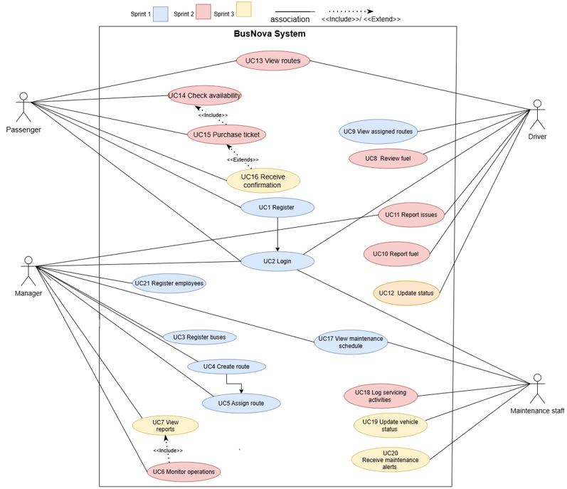
Figure 1 Use Case Diagram

1.2. Use Case Narrative

1.2.1. Use Case Narrative: UC1 Register
BusNova
Use Case Specification
Use Case Id | UC1
User Case Name | Register
Actor(s) | Passenger
Brief Description | A new passenger registers an account by entering their details. The system validates the information, checks whether the email address already exists, encrypts the password, stores the user's information in the database, creates the account, and redirects the user to the login page upon successful registration.
Frequency of use | Once per passenger.
Preconditions | 1. The passenger has access to the BusNova registration page.  2. The passenger does not already have a registered account.
Main Flow of Events | Actor |  | System
Main Flow of Events | 1. Opens the Registration page.  2. Enters details in the registration form.  3. Clicks Register button. |  | 1.2. Displays registration form.  3.1. Validates user information.  3.2. Display error message and redirects user back to input.  3.3. Displays successfully registered.  3.4. Redirects the user to the Login page upon successful registration.
Alternative Flows of Events | If required fields are missing, invalid, or the email address already exists, the system displays a validation error message and returns the passenger to the Registration form to correct the information.
Postconditions | A new Passenger account is created and stored in the User table. The passenger can subsequently log in to access ticket purchasing and route information.
Special Requirements | 1. Password must be encrypted before storage.  2. Email address must be unique across all roles.  3. Role must be correctly recorded as "Passenger" for this account.
Created by | Elihle Nteyi | Last Modified by |  | Yonwaba Mqulwana
Date | 01 August 2026 | Date |  | 03 November 2026
Table 2 Use Case Narrative: Register

1.2.2 Activity Diagram: UC1 Register
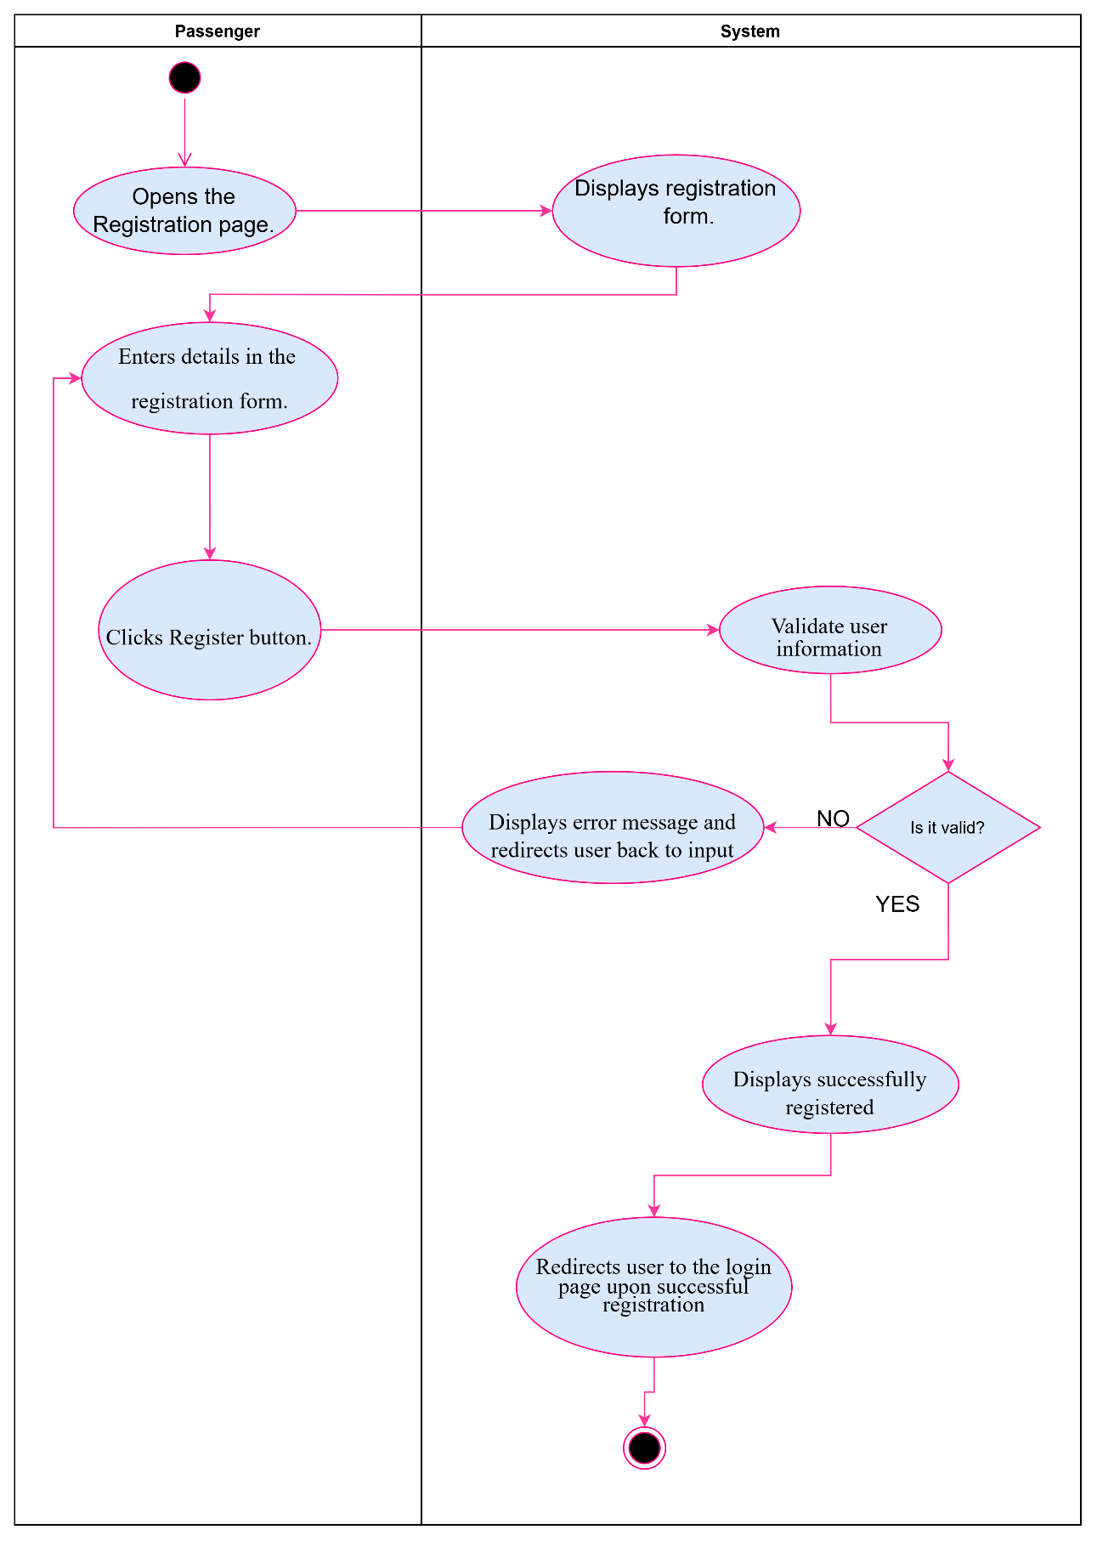
Figure 2 Activity Diagram: UC1 Register

1.2.3. Use Case Narrative: UC2: Login
BusNova
Use Case Specification
Use Case Id | UC2
User Case Name | Login
Actor(s) | Manager, Bus Driver, Passenger, Maintenance Staff
Brief Description | The user enters their login details to access the system.
Frequency of use | Daily, whenever a user wants to access the system.
Preconditions | 1. The user must have a registered account.
Main Flow of Events | Actor |  | System
Main Flow of Events | 1. Clicks Login.  2. Enters email and password.  3. Click “Login” |  | 1.1 Display login page.  3.1 Verify credentials  3.2 Grant access/Display error message and redirects back to input.  3.3 Displays user dashboard.
Alternative Flows of Events | 1. Account does not exist  2. The entered password or email does not match; the system displays the error message "Invalid login details."
Postconditions | The user has successfully logged into the system using their email and password and is taken to their role-specific dashboard.
Special Requirements | Passwords must be encrypted. Login credentials must be validated against the database. Access and dashboard content must be based on the user's role.
Created by | Yonwaba Mgqulwana | Last Modified by |  | Simanye Siximba
Date | 30 July 2026 | Date |  | 03 November 2026
Table 3 Use Case Narrative: UC2: Login

1.2.4 Activity Diagram: UC2 Login
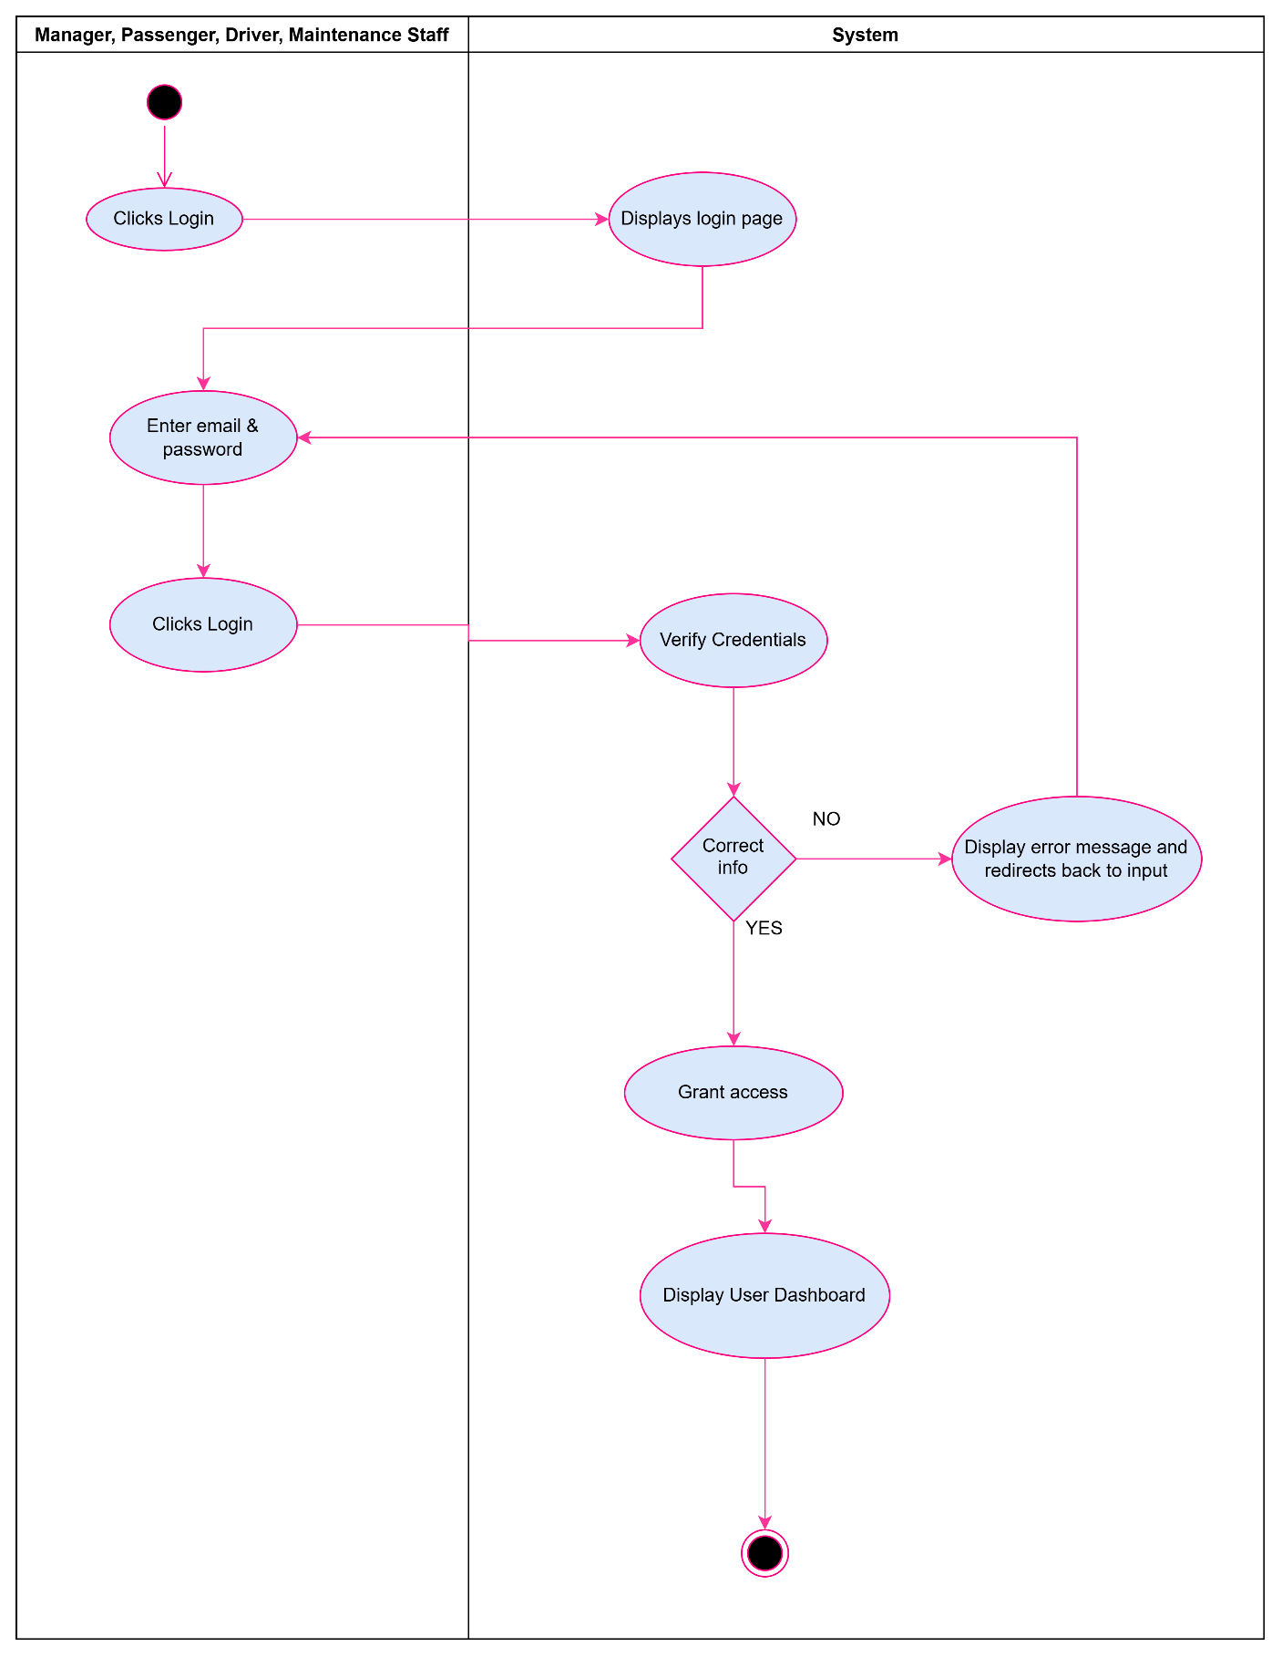
Figure 3 Activity Diagram: UC2 Login

1.2.5. Use Case Narrative: UC3 Register Bus
BusNova
Use Case Specification
Use Case Id | UC3
User Case Name | Register Buses
Actor(s) | Manager
Brief Description | A manager registers a new bus into the system by providing bus details such as registration number, model, manufacturer, seating capacity and fuel type. After successful registration, the bus becomes available for route assignment and scheduling.
Frequency of use | Low
Preconditions | Manager is logged in with an active session (role-based access, no separate permission check).
Main Flow of Events | Actor |  | System
Main Flow of Events | 1. Selects “Register Buses”.  2. Enters the bus details.  3. Clicks “Register”. |  | 1.1 Displays an empty bus registration form.  3.1 Validates required fields and checks registration number uniqueness.  3.2 Saves the bus record and displays a confirmation message. “Bus registered successfully”.
Alternative Flows of Events | 1. If required fields are missing or invalid, the system highlights the errors and remains on the form.  2. If the registration number already exists, the system reminds the manager to enter a different registration number.
Postconditions | New bus record is stored in the database, bus becomes available for route assignment, driver scheduling and maintenance scheduling.
Special Requirements | Registration number must be unique; seating capacity must be a positive number.
Created by | Anesipho Kalazana | Last Modified by |  | Elihle Nteyi
Date | 03 August 2026 | Date |  | 03 November 2026
Table 4 Use Case Narrative: Register Bus

1.2.6. Activity Diagram: UC3 Register Bus
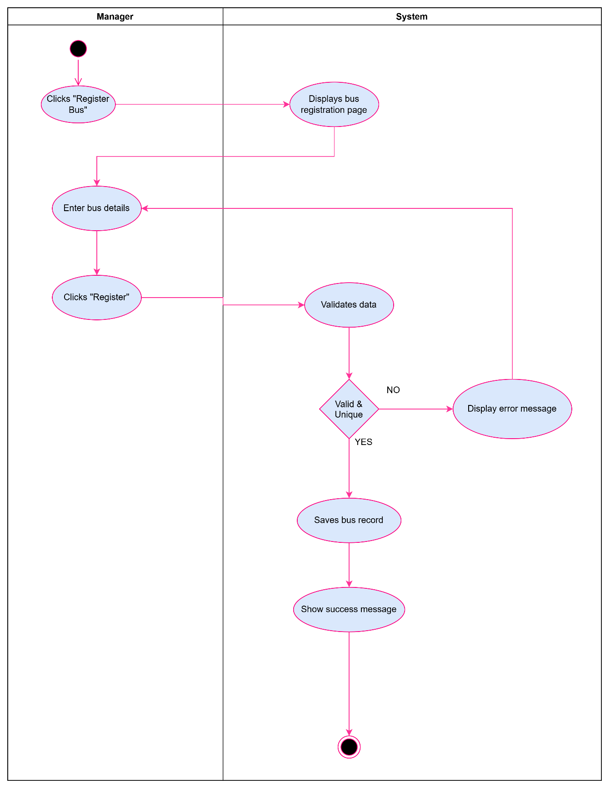
Figure 4 Activity Diagram: UC3 Register Bus

1.2.7. Use Case Narrative: UC4 Create Routes
BusNova
Use Case Specification
Use Case Id | UC4
User Case Name | Create Routes
Actor(s) | Manager
Brief Description | Describes how the Manager defines a new bus route in the system.
Frequency of use | As needed, whenever new routes must be added or existing service areas expanded.
Preconditions | The Manager is logged into the system with valid credentials.
Main Flow of Events | Actor |  | System
Main Flow of Events | 1. Select "Create Routes".  2. Enters the route details and adds intermediate stops.  3. Submits the route for saving |  | 1.1. Displays the route creation form.  3.1. Validates the entered data.  3.2. Checks that the route ID/name is unique.  3.3. Saves the new route to the database.  3.4. Displays a confirmation message.
Alternative Flows of Events | If required fields are missing or incorrectly formatted, the system displays an error message and returns the Manager to step 3.
Postconditions | Success: A new route record is created and saved in the system database.
Special Requirements | The system must validate all route details before saving and ensure that the information complies with the database constraints.
Created by | Nadia Mpohlekana | Last Modified by |  | Anesipho Kalazana
Date | 28 July 2026 | Date |  | 03 November 2026
Table 5 Use Case Narrative: Create Routes

1.2.8. Activity Diagram: UC4 Create Routes
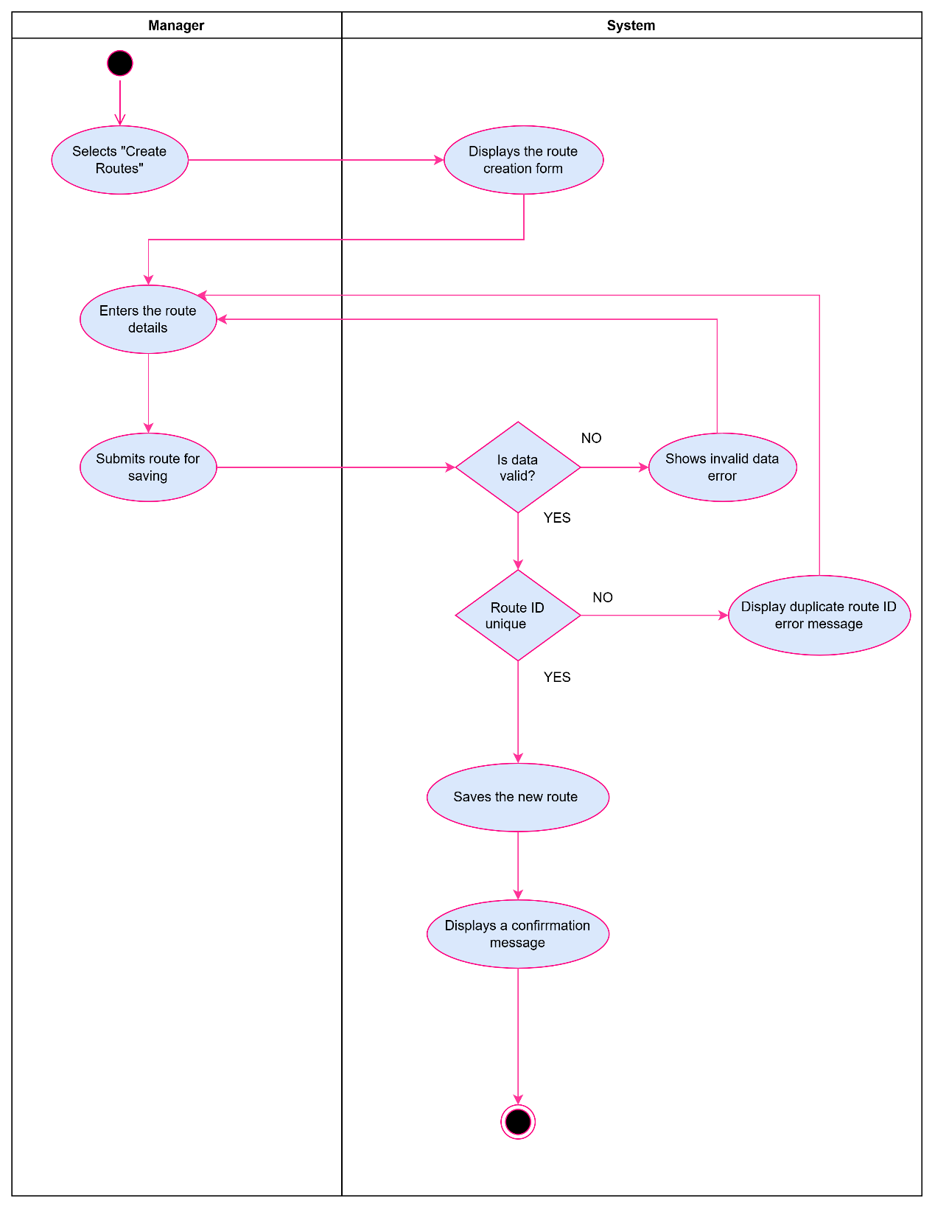
Figure 5 Activity Diagram: UC4 Create Routes

1.2.9. Use Case Narrative: UC5 Assign Routes
BusNova
Use Case Specification
Use Case Id | UC5
User Case Name | Assign routes
Actor(s) | Manager
Brief Description | The manager assigns an available bus and driver to a specific route and schedule. The system validates the availability of the selected bus and driver before saving the assignment and updating the schedule
Frequency of use | Whenever a new route needs to be assigned or an existing assignment needs to be updated
Preconditions | The Manager is logged into the system; driver must be valid before a route assignment can be performed
Main Flow of Events | Actor |  | System
Main Flow of Events | 1. Selects Assign Routes  2. Selects the route  3. Selects bus  4. Selects driver  5. Click “Assign Route” |  | 1.1 Displays routes, buses, and drivers  2.1 Displays route details  5.1 Validates bus availability  5.2 Display “Bus unavailable” and return to Select bus  5.3 Validates driver availability  5.4 Display “Driver unavailable” and return to Select driver  5.5 Save route assignment  5.6 Updates driver’s schedule  5.7 Updates bus allocation  5.8 Display confirmation message
Alternative Flows of Events | 1. If the selected bus unavailable the system shows an error message  2. If the selected driver is already assigned to another route, the system displays an error message
Postconditions | Upon completion of the route assignment process, the system saves the assignment.
Special Requirements | The system must allow only Managers to assign routes and must validate the availability of the selected bus and driver before saving the assignment.
Created by | Olebogeng Gumbu | Last Modified by |  | Yonwaba Mqulwana
Date | 29 July 2026 | Date |  | 03 November 2026
Table 6 Use Case Narrative: Assign Routes

1.2.10. Activity Diagram: UC5 Assign Routes
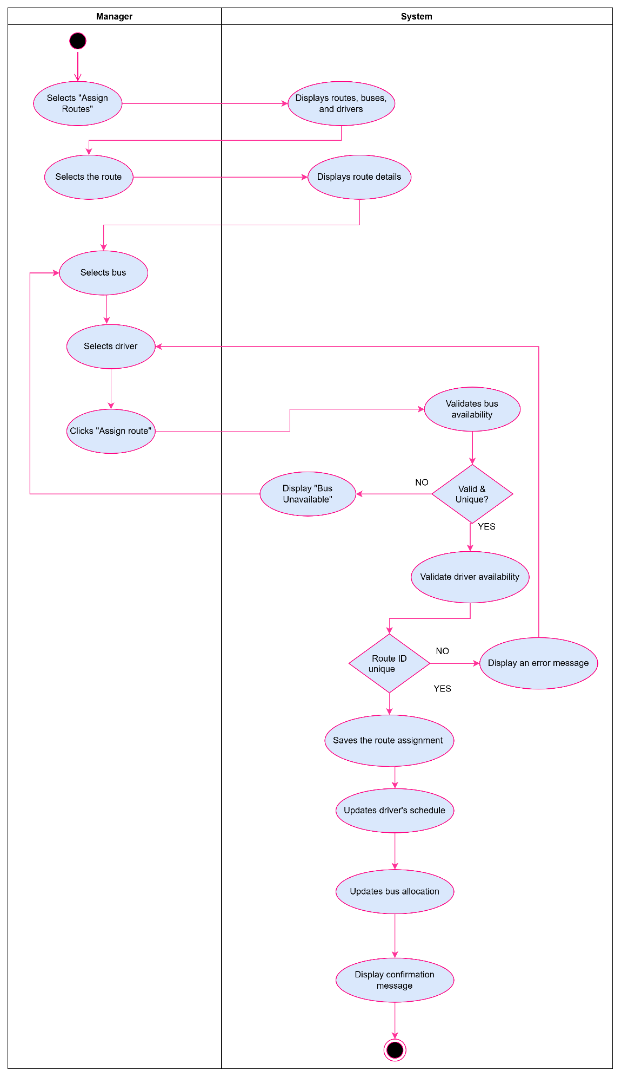
Figure 6 Activity Diagram: UC5 Assign Routes

1.2.11. Use Case Narrative: UC9 View Assigned Routes
BusNova
Use Case Specification
Use Case Id | UC9
User Case Name | View Assigned Routes
Actor(s) | Driver
Brief Description | The Driver views the routes and trip schedule assigned to them, including trip details such as route path, stops, and pickup/drop-off times.
Frequency of use | Daily
Preconditions | 1. The Driver has a registered account and is logged into the system.  2. Routes/trips have been assigned to the driver.
Main Flow of Events | Actor |  | System
Main Flow of Events | 1. Driver navigates to "My Schedule" or "Assigned Routes".  2. Driver selects a route/trip to view further details.  3. Clicks on Trip to view details |  | 1.1 Retrieve and display the routes and trip schedule assigned to the driver.  3.1 Display detailed trip information (route path, stops, pickup/drop-off times, assigned bus).
Alternative Flows of Events | No routes/trips have been assigned to the driver, System displays "No routes assigned".
Postconditions | The Driver has viewed their assigned routes and trip schedule. No data is modified by this use case.
Special Requirements | Schedule information must reflect real-time updates; driver view must be usable on mobile devices.
Created by | Siximba Simanye | Last Modified by |  | Yonwaba Mqulwana
Date | 03 August 2026 | Date |  | 03 November 2026
Table 7 Use Case Narrative: View Assigned Routes

1.2.12. Activity Diagram: UC9 View Assigned Routes
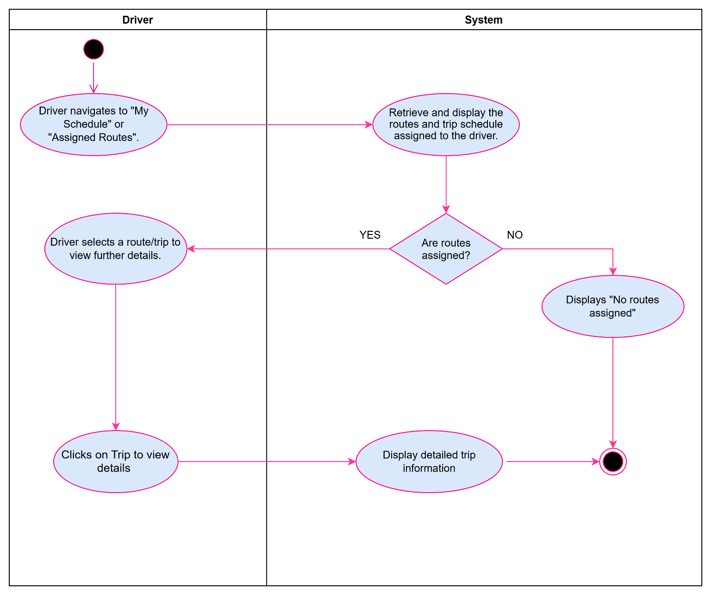
Figure 7 Assigned Routes Activity Diagram

1.2.13. Use Case Narrative: UC17 View Maintenance Schedule
BusNova
Use Case Specification
Use Case Id | UC17
User Case Name | View Maintenance Schedule
Actor(s) | Maintenance Staff
Brief Description | Maintenance Staff view the maintenance and servicing schedule for buses in the fleet.
Frequency of use | Medium
Preconditions | 1. Maintenance Staff has a registered account and is logged into the system.
Main Flow of Events | Actor |  | System
Main Flow of Events | 1. Maintenance Staff navigates to "Maintenance Schedule".  2. Maintenance Staff filters or searches records by bus, date, or status.  3. Clicks “Filter” button  4. Maintenance Staff Clicks the “View” action on a service record to view further details.  5. Clicks “Close” on the details panel. |  | 1.1 Display the Maintenance Schedule screen.  1.2 Retrieves and displays the open maintenance records: bus, reported by, date, problem, condition, severity, status and action.  3.1 Retrieve and display the matching maintenance or service records.  4.1 Display detailed service information: last service date, next due date, service type, status.  4.2 If overdue, highlight the record and trigger an alert.  4.3 If no parts were recorded for the service, displays “No parts recorded for this service”.  5.1 “Close” hides the details panel and leaves the current search results in place.
Alternative Flows of Events | No maintenance records match the filter criteria, System displays "No maintenance records found".
Postconditions | Maintenance Staff has reviewed the maintenance schedule, with overdue services flagged. No data is modified by this use case.
Special Requirements | Schedule information must reflect real-time updates.
Created by | Siximba Simanye | Last Modified by |  | Nadia Mpohlekana
Date | 03 August 2026 | Date |  | 03 November 2026
Table 8 Use Case Narrative: View Maintenance Schedule

1.2.14. Activity Diagram: UC7 View Maintenance Schedule
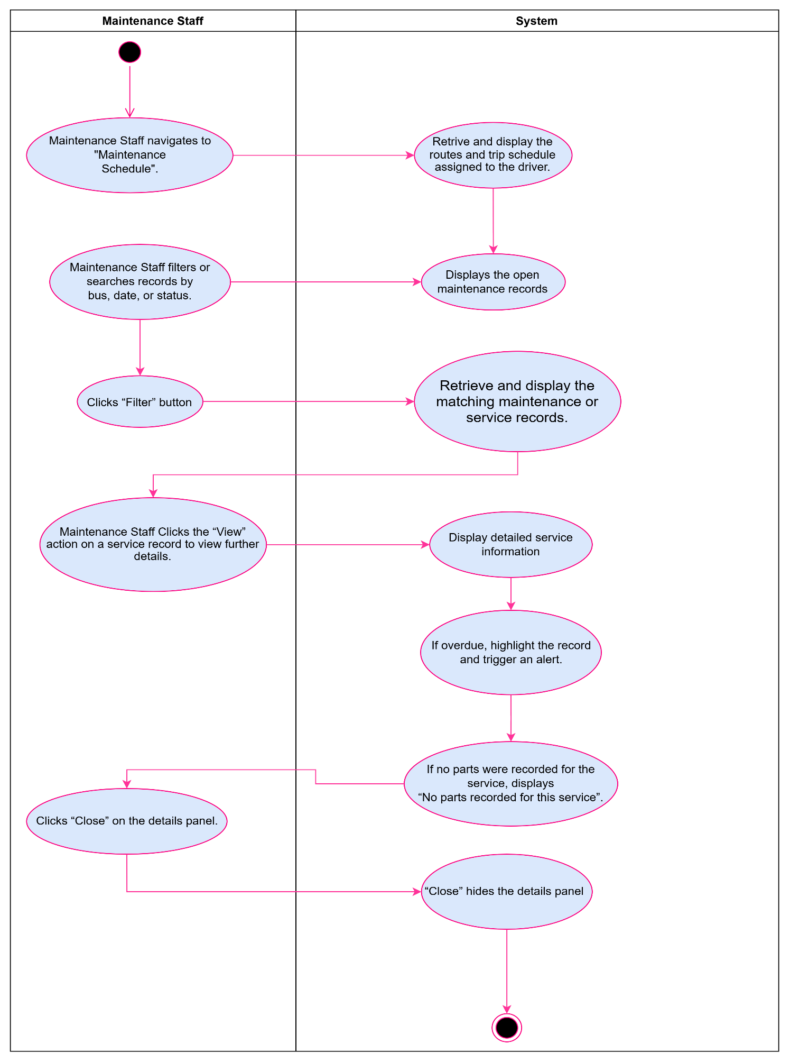
Figure 8 Activity Diagram: UC7 View Maintenance Schedule

1.2.15. Use Case Narrative: UC8 Review Fuel
BusNova
Use Case Specification
Use Case Id | UC8
User Case Name | Review Fuel
Actor(s) | Manager
Brief Description | Allows a manager to review the fuel logs and fuel efficiency information recorded for the bus(es) they operate. The system retrieves the fuel amount, cost, odometer reading and calculated fuel efficiency for each logged entry, allowing the driver to monitor fuel usage and consumption trends over time.
Frequency of use | As needed, typically after each trip or refuelling stop.
Preconditions | 1. The Manager has a registered account and is logged into the system.  2. Fuel logs exist for the bus(es) assigned to the driver.
Main Flow of Events | Actor |  | System
Main Flow of Events | 1. Selects "Review Fuel".  2. Filters or searches fuel records by bus or date.  3. Selects a fuel record to view further details. |  | 1.1 Retrieve and display the fuel logs for the bus assigned to the driver.  2.1 Retrieve and display the fuel records matching the filter criteria.  3.1 Display detailed fuel information.
Alternative Flows of Events | No fuel logs match the filter criteria, The system displays "No fuel records found".
Postconditions | The Manager has reviewed the fuel log and fuel efficiency information. No data is modified by this use case.
Special Requirements | Fuel efficiency must be calculated accurately from the logged fuel amount, cost and distance travelled; fuel log information must reflect the most recently logged records.
Created by | Nadia Mpohlekana | Last Modified by |  | Anesipho Kalazana
Date | 22 August 2026 | Date |  | 03 November 2026
Table 9 Use Case Narrative: Review Fuel

1.2.16. Activity Diagram: UC8 Review Fuel
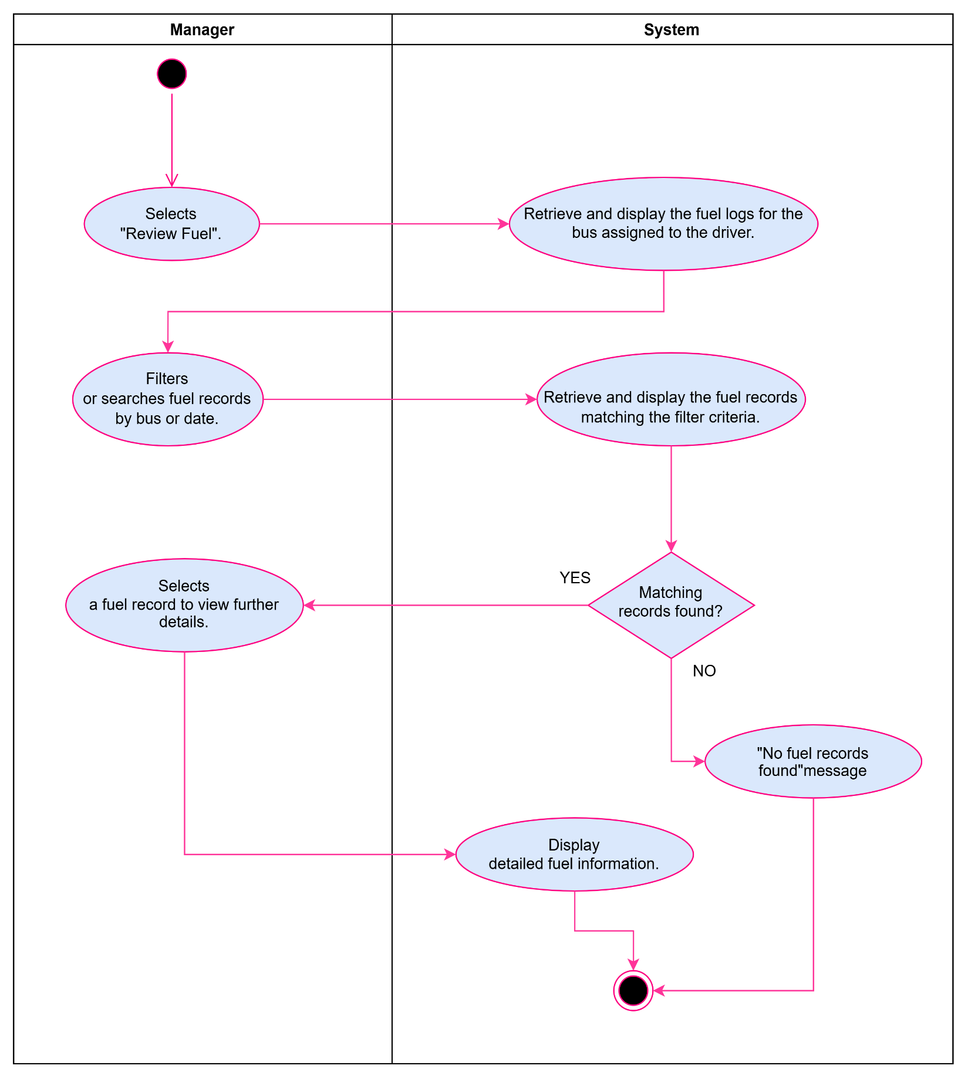
Figure 9 Activity Diagram: UC8 Review Fuel

1.2.19. Use Case Narrative: UC6 Monitor Operations
BusNova
Use Case Specification
Use Case Id | UC6
User Case Name | Monitor Operations
Actor(s) | Manager
Brief Description | Allows the Manager to monitor ongoing bus operations in real time from a central dashboard, including vehicle locations, trip progress, delays and driver check-ins.
Frequency of use | High, used throughout the operating day.
Preconditions | Manager is logged in.  Routes have been assigned and buses are actively operating trips.
Main Flow of Events | Actor |  | System
Main Flow of Events | 1. Navigate to the "Operations Dashboard".  2. Clicks the View action on the row for a specific bus or trip in the active operations table.  3. Select a specific bus or trip to view further detail. |  | 1.1 Display the operations dashboard  1.2 Displays the real-time status of all active buses and trips  3.1 Display detailed status for the selected bus or trip
Alternative Flows of Events | 1. If a bus reports a delay or issue beyond the acceptable threshold, the System highlights the affected bus/trip on the dashboard and notifies the Manager.  2. If there are no active trips at the time of viewing, the System displays a "No active operations" message.
Postconditions | Fleet Manager has an up-to-date view of fleet operations. Delayed or problem trips are flagged for follow-up
Special Requirements | Dashboard data must refresh in near real time; the System must generate alerts for delays or reported issues; the dashboard must remain usable when monitoring multiple simultaneous trips.
Created by | Simanye Siximba | Last Modified by |  | Nadia Mpohlekana
Date | 24 August 2026 | Date |  | 03 November 2026
Table 10 Use Case Narrative: Monitor Operations

1.2.20. Activity Diagram: UC6 Monitor Operations
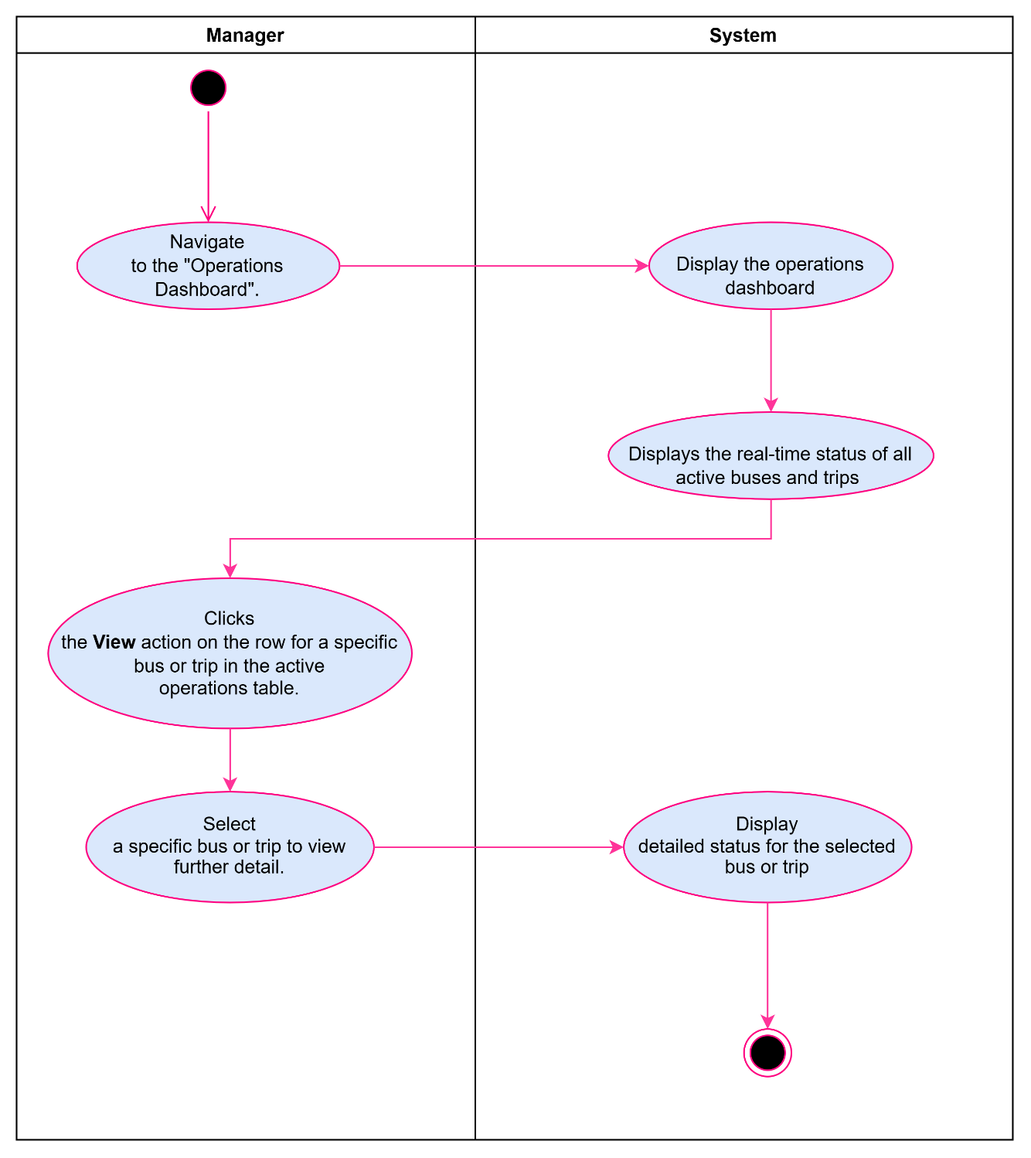
Figure 10 Activity Diagram: UC6 Monitor Operations

1.2.21. Use Case Narrative: UC13 View Routes
BusNova
Use Case Specification
Use Case Id | UC13
User Case Name | View Routes
Actor(s) | Passenger
Brief Description | A signed-in Passenger opens the View Routes screen to see the bus routes and trips that are currently available to travel on. The screen lists each trip with its route, origin, destination, departure and arrival times, and the number of seats still free. The Passenger may filter the list by origin, destination or travel date, and may select a trip to proceed to booking.
Frequency of use | Whenever a passenger wants to check available bus routes and trip information
Preconditions | Passenger must be logged on to the system
Main Flow of Events | Actor |  | System
Main Flow of Events | 1. Selects “View Routes”  2. Optionally selects a route or travel date from the filter bar to narrow the list.  3. Clicks the “Filter” button |  | 1.1. Display’s “View Routes” Page  1.2. Displays available bus routes and trip information  3.1 Displays only the trips matching the selected origin, destination and travel date.
Alternative Flows of Events | If no trips match the selected filters, the system displays “No trips available for the selected route or date”, keeps the filter values in place, and does not raise an error.
Postconditions | Passenger has viewed the available routes and trips, optionally filtered the list, and optionally opened a trip to proceed to booking. No data is modified by this use case.
Special Requirements | The trip list must reflect current seat availability each time the screen is loaded or Filter is pressed; stale availability must not be shown as current.
Created by | Olebogeng Gumbu | Last Modified by |  | Esethu Mtose
Date | 22 August 2026 | Date |  | 03 November 2026
Table 11 Use Case Narrative: View Routes

1.2.22. Activity Diagram: UC13 View Routes
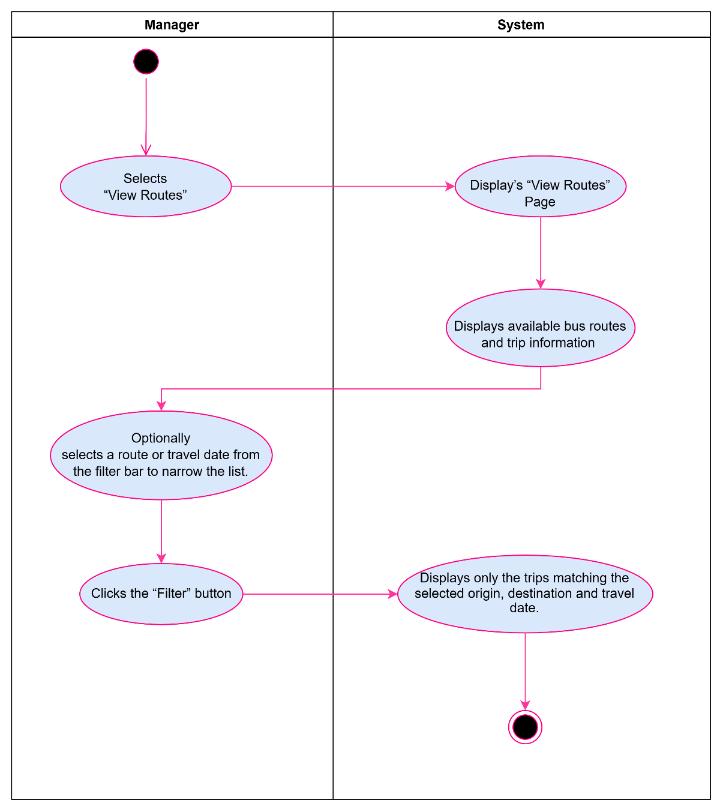
Figure 11 Activity Diagram: UC13 View Routes

1.2.23. Use Case Narrative: UC10 Report Fuel Use
BusNova
Use Case Specification
Use Case Id | UC10
User Case Name | Report Fuel Use
Actor(s) | Driver
Brief Description | Allows the driver to record the amount of fuel used by the assigned bus after or during a trip. The system stores the fuel usage information for monitoring and reporting.
Frequency of use | Daily after finishing all the trips.
Preconditions | 1. Driver is logged into the system.  2. Driver is assigned to the bus.  3. The bus exists in the system.
Main Flow of Events | Actor |  | System
Main Flow of Events | - Selects ‘Report fuel use”.  - Selects the assigned bus.  - Enters fuel usage (in litres) and trip details.  - Clicks Submit. |  | 1.1 Display fuel reporting form.  4.1 Validates the entered information.  4.2 Saves the fuel usage record.  4.3 Updates the bus fuel usage.  4.4 Displays confirmation message.
Alternative Flows of Events | 1.Fuel usage is missing or invalid, the system displays an error message.  2.The submitted value is unrealistic (e.g., negative) the system requests a valid value.
Postconditions | 1.Fuel usage record is stored.  2.Bus fuel usage history is updated.
Special Requirements | 1. Fuel usage must be entered in litres and must be a positive numerical value.  2. The system must automatically record the date and time of the fuel usage report.  3. The system must identify the logged-in driver and the bus assigned to them.  4. The system must validate all entered information before saving the fuel usage record.  5. Only authorised drivers may submit fuel usage reports.
Created by | Yonwaba Mqulwana | Last Modified by |  | Simanye Siximba
Date | 24/08/2026 | Date |  | 03 November 2026
Table 12 Use Case Narrative: Report Fuel

1.2.24. Activity Diagram: UC10 Report Fuel
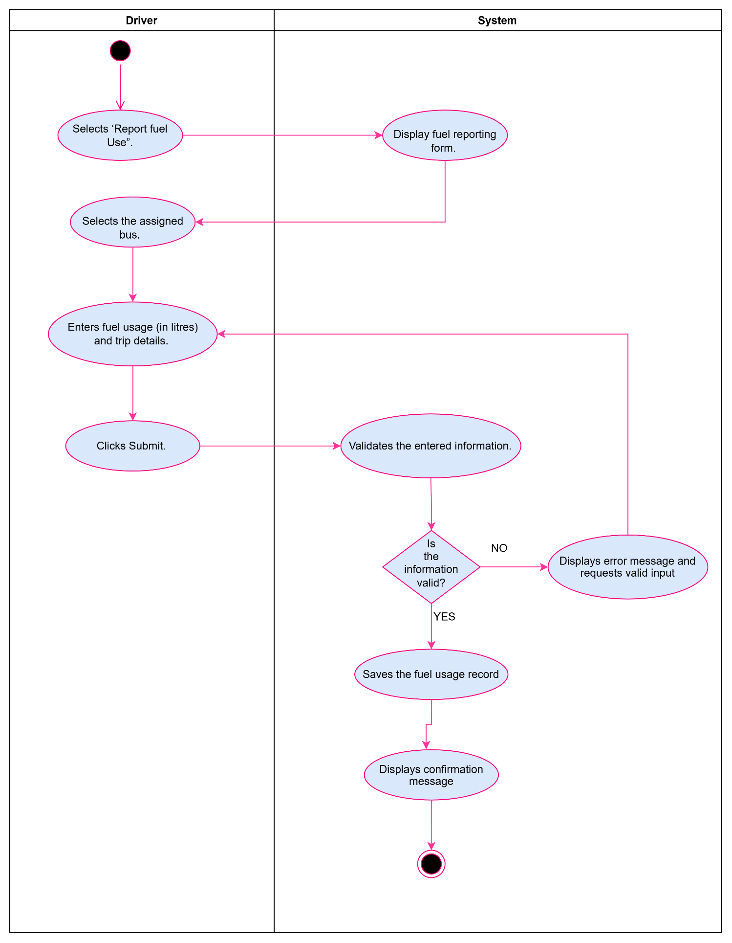
Figure 12 Activity Diagram: UC10 Report Fuel

1.2.25. Use Case Narrative: UC18 Log Servicing Activities
BusNova
Use Case Specification
Use Case Id | UC18
User Case Name | Log servicing Activities
Actor(s) | Maintenance staff
Brief Description | Maintenance staff logs details of a completed service/repair on a bus; the system saves the record and updates the bus's service history.
Preconditions | 1.Maintenance staff is registered and logged into the system  2.The bus to be serviced exists in the system.  3.The maintenance staff has been assigned access to the maintenance/service logging module.
Main Flow of Events | Actor |  | System
Main Flow of Events | 1.Selects “Log service activity”  2.Selects the bus that was serviced.  3.Enters the service details  4.Clicks Save Records |  | 1.1. Displays log service activity form.  2.1. Displays the bus’s maintenance history.  4.1. Validates the required fields.  4.2. Saves the service record to maintenance log.  4.3. Updates the bus’s condition and next service due date.  4.4. Displays a confirmation message
Alternative Flows of Events | 1. If required fields are missing or invalid, the system displays an error message and returns the maintenance staff to the form.  2. If the next service due date entered is earlier than the service date, the system displays a validation error and prompts for a correct date.
Postconditions | 1. Service record is saved to the bus’s maintenance log.  2. Bus's vehicle condition status is updated to reflect the completed service.  3. Bus's next service due date is updated in the system.  4. Confirmation message is displayed.  5. Maintenance history is updated for future reference.
Special Requirements | 1. Required fields must be validated before saving.  2. Next service due date must be later than the service date.  3. Service records must be saved reliably so no data loss.
Created by | Anesipho Kalazana | Last Modified by |  | Yonwaba Mqulwana
Date | 23 August 2026 | Date |  | 03 November 2026
Table 13 Use Case Narrative: Log Servicing Activities

1.2.26. Activity Diagram: UC18 Log Servicing Activities
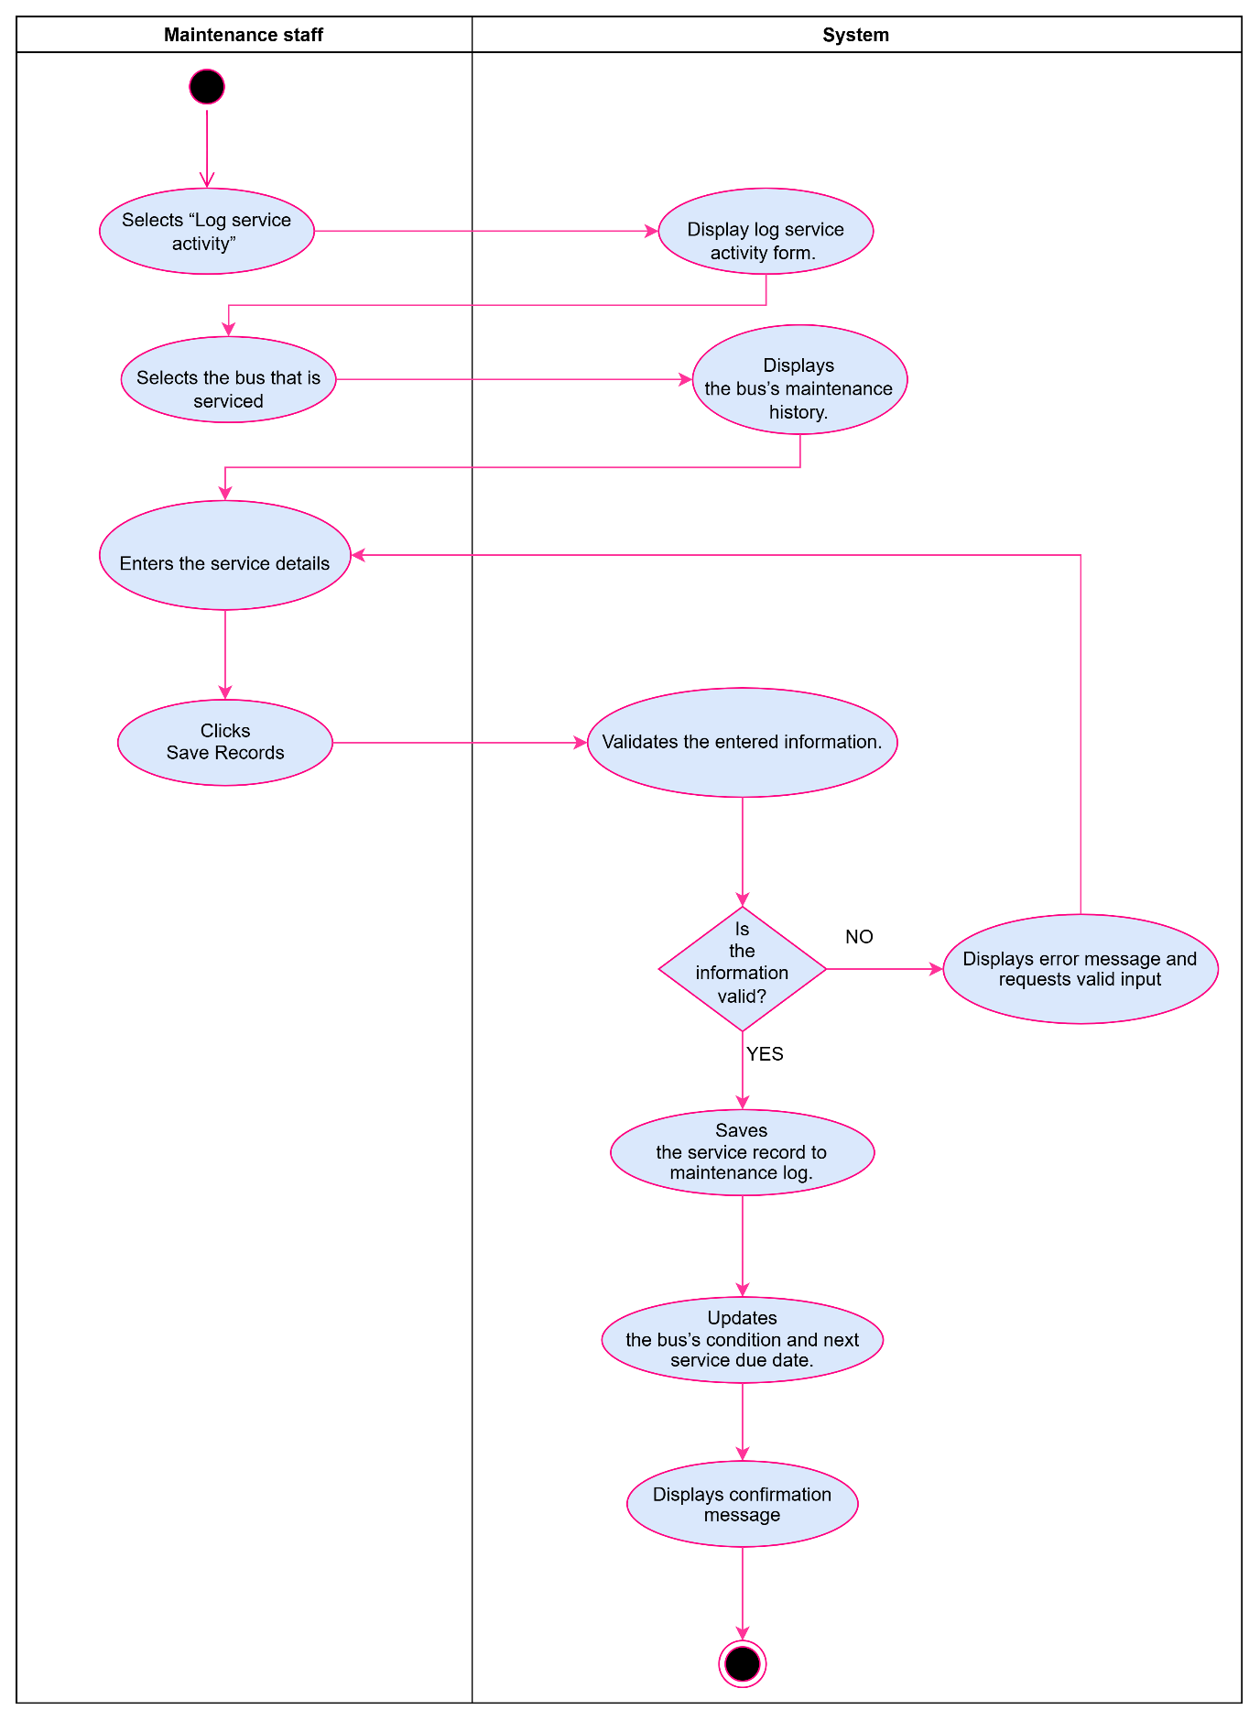

Figure 13 Activity Diagram: UC18 Log Servicing Activities

1.2.27. Use Case Narrative: UC15 Purchase Ticket
BusNova
Use Case Specification
Use Case Id | UC15
User Case Name | Purchase Ticket
Actor(s) | Passenger
Brief Description | The passenger picks a route, enters their details, pays and the system checks seat availability, processes the payment and generates the ticket.
Frequency of use | High, whenever a passenger wants to book a trip.
Preconditions | 1.Passenger has a registered account and is logged into the system.  2. The selected route and trip have at least one available seat.
Main Flow of Events | Actor |  | System
Main Flow of Events | 1. Checks route availability.  2. Clicks “Purchase Ticket” for the desired trip.  3.Selects seat and details.  4.Enters payment, clicks pay |  | 1.1 Shows trips and seat.  2.1. Displays the purchase ticket form.  4.1 Validates payment and seat.  4.2 Processes the payment  4.4. Generates ticket and saves.  4.5. Sends confirmation email.
Alternative flow of events | 1. If the payment fails, the system displays an error message and prompts the passenger to retry or use a different payment method.  2. If the selected seat becomes unavailable before payment is confirmed, the system notifies the passenger and returns them to seat selection.
Postconditions | A ticket record is created and stored in the database, seat availability for the trip is updated, and the passenger receives a booking confirmation.
Special requirements | Payment details must be processed securely, seat availability must be validated in real time to prevent double booking, and each ticket must be assigned a unique ticket number.
Created by | Anesipho Kalazana | Last Modified by |  | Nadia Mphohlekana
Date | 24 August 2026 | Date |  | 03 November 2026
Table 14 Use Case Narrative: Purchase Ticket

1.2.28. Activity Diagram: UC15 Purchase Ticket
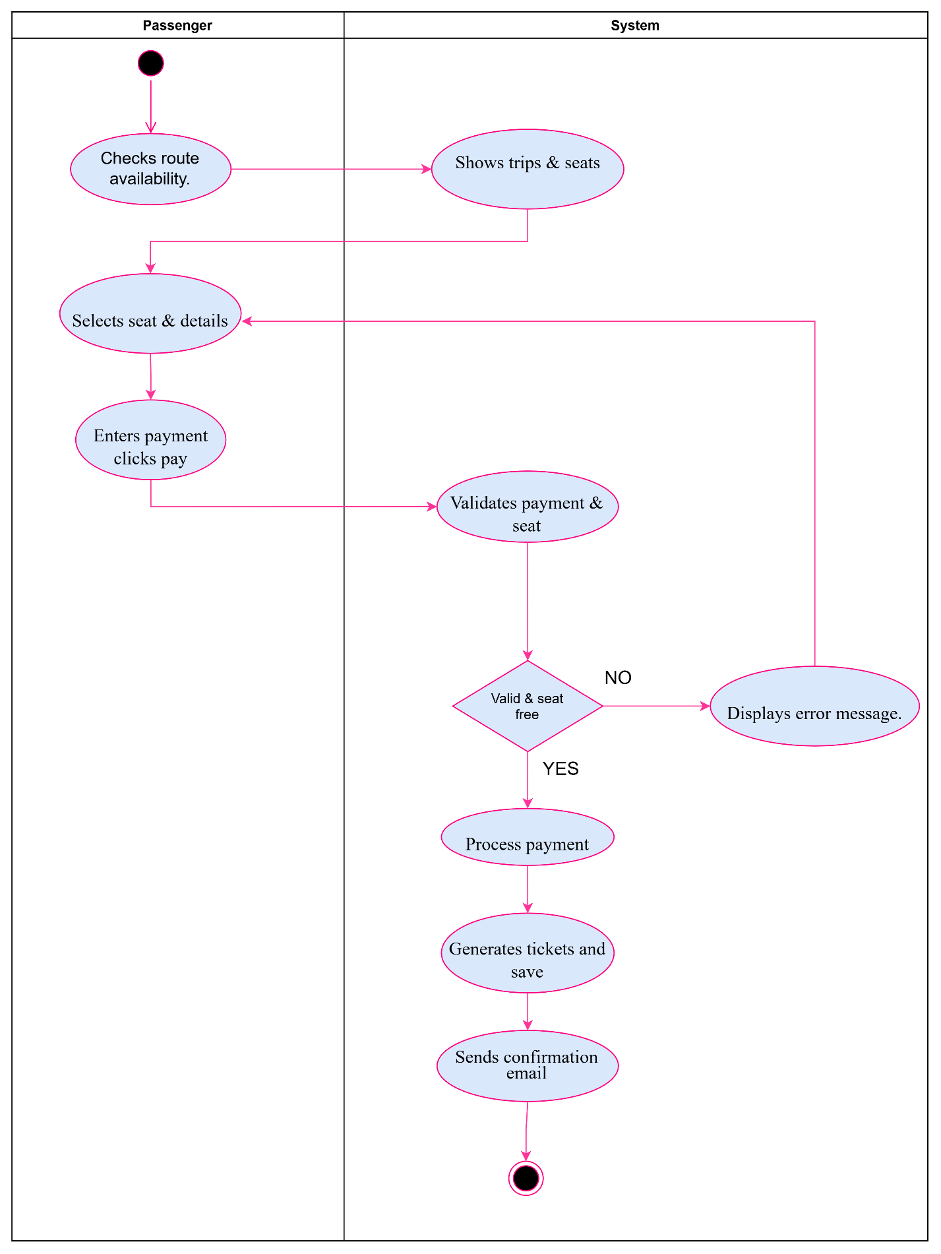
Figure 14 Activity Diagram: UC15 Purchase Ticket

1.2.29. Use Case Narrative: UC14 Check availability
BusNova
Use Case Specification
Use Case Id | UC14
User Case Name | Check availability
Actor(s) | Passenger
Brief Description | This use case allows a passenger to check the availability of buses by entering the departure location, destination and travel date. The system validates the information, checks available seats and displays the available bus options.
Frequency of use | High, whenever a passenger wants to check available buses before making a booking.
Preconditions | 1. The bus booking system must be available.  2. The passenger must have access to the system.  3. Bus schedules and seat availability must be available in the system.
Main Flow of Events | Actor |  | System
Main Flow of Events | 1. Selects “Check availability”.  2 Enters the departure location, destination and travel date.  3. Views the availability results.  4. Selects an available bus. |  | 2.1 Validate search details  3.1. Displays the book ticket option for an available bus.  4.1. Allows the passenger to proceed to booking.  4.2. Ends the Check availability use case.
  1.1. Displays the search form.
  2.2 Checks the availability of buses and seats
  based on the search details.
Alternative Flows of Events | 1. If invalid details are entered, the system will show an error message and prompt the passenger to correct them.  2. If no seats or no buses are found, the system will display a "No seats available" or "No buses available" message and allow the passenger to search again with new details
Postconditions | 1. Available buses and seats are displayed, allowing the passenger to select a bus and proceed to booking.  2. If no seats or buses are available, the system displays an appropriate message.
Special requirements | 1.The system must verify the departure location, destination, and travel date, provide current, correct bus, and seat availability, and ensure fast search responses.  2. It must also keep passenger details secure during the search and offer a simple, user-friendly experience on all supported devices.
Created by | Esethu Mtose | Last Modified by |  | Olebogeng Gumbu
Date | 23/08/2026 | Date |  | 03 November 2026
Table 15 Use Case Narrative: Check availability

1.2.30. Activity diagram: UC14 Check availability
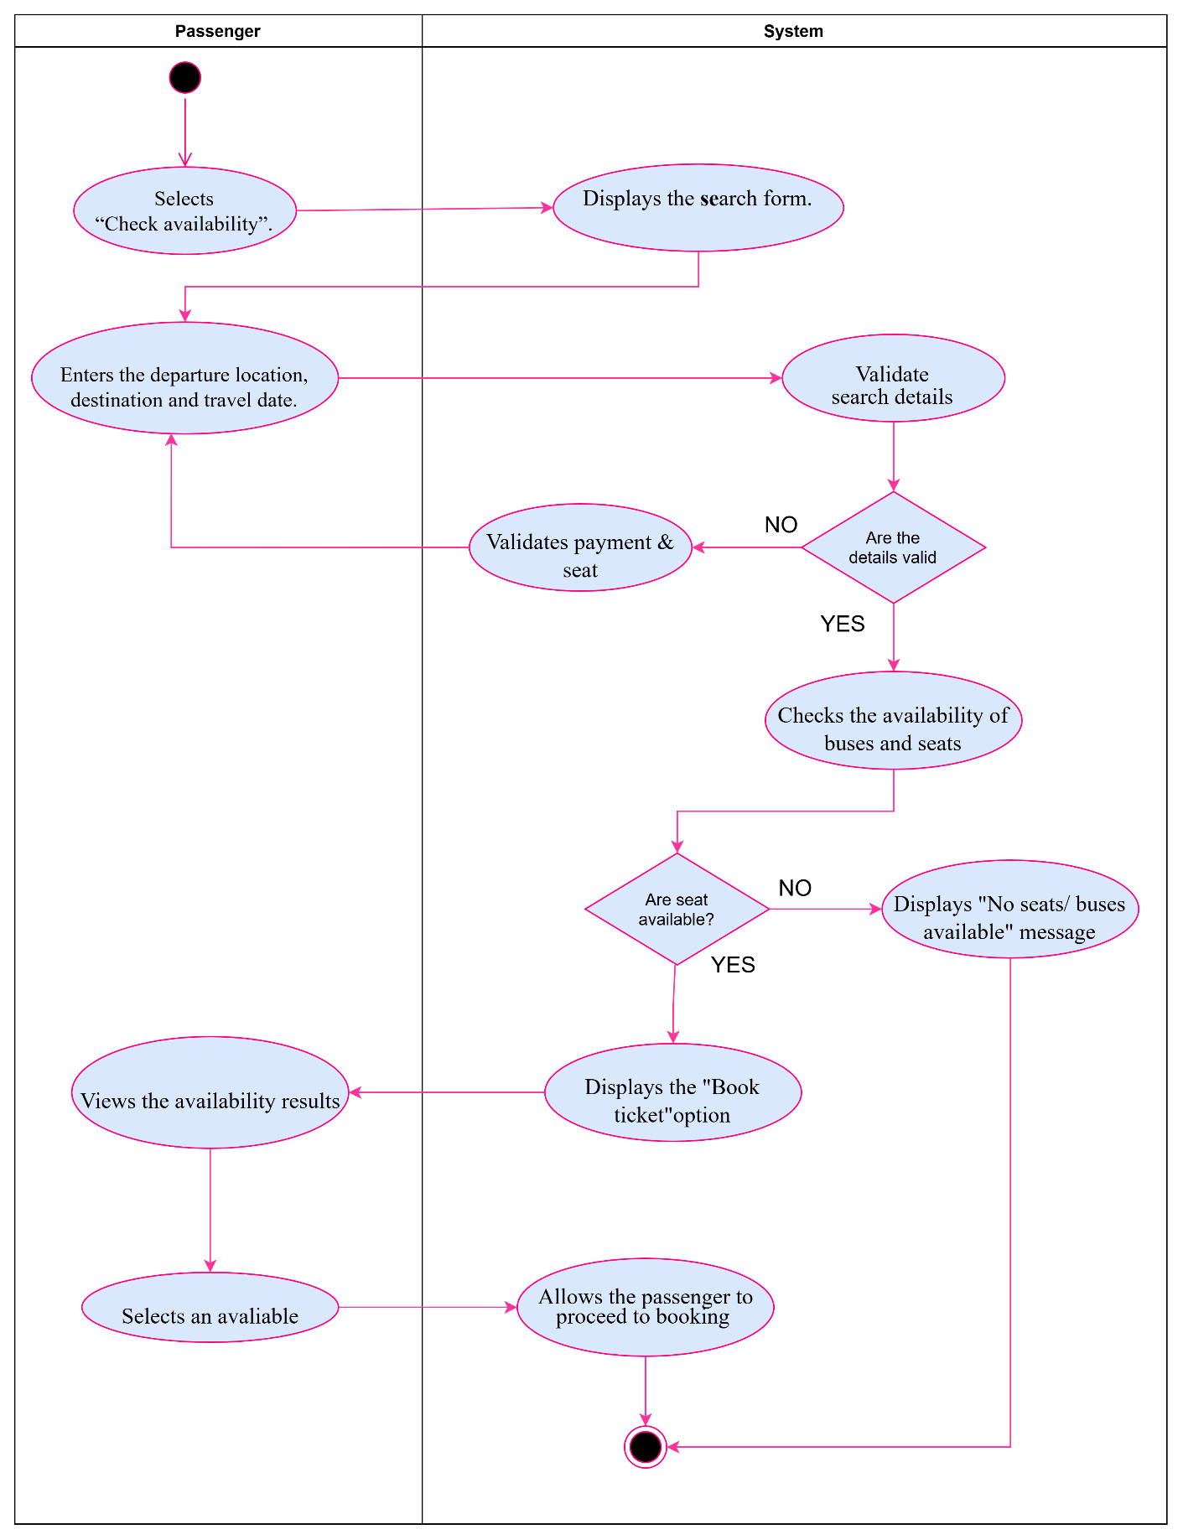
Figure 15 Activity diagram: UC14 Check availability

1.2.31. Use Case Narrative: UC11 Report Issues
BusNova
Use Case Specification
Use Case Id | UC11
User Case Name | Report Issues
Actor(s) | Driver
Brief Description | The Report Issue use case allows drivers to report problems identified while operating or inspecting a bus. The driver provides information about the issue, such as the bus, issue type, description, and severity. System stores the report in the centralised database and makes the information available to Maintenance Staff for follow-up and maintenance.
Frequency of use | As required, whenever a Bus Driver identifies an issue with an assigned bus. This may occur multiple times per day across the entire fleet, depending on vehicle conditions and operational activities.
Precondition | Driver must be registered in the system.  Driver must be authenticated and logged into the system.  Driver must have an assigned bus.
Main Flow of Events | Actor |  | System
Main Flow of Events | 1. Select “Report issues”  2. Enter the issue details  3. Submit issue |  | - Display Report Form  3.1 Save the issue  3.2 Display Confirmation message
Alternative Flows of Events | 1. If the Driver submits the issue report without completing all required fields, the system displays an error message identifying the missing fields.  2. The issue is not saved until all required fields have been completed and the report is submitted again.
Postconditions | An issue reference number is generated.  Maintenance Staff can view and manage the reported issue.  The issue status is set to Reported.
Special requirements | Only registered and authenticated Bus Drivers should be allowed to report issues.  The system should prevent loss of issue reports and maintain accurate records even when multiple Drivers are reporting issues simultaneously
Created by | Elihle Nteyi | Last Modified by |  | Yonwaba Mqulwana
Date | 30 August 2026 | Date |  | 03 November 2026
Table 16 Use Case Narrative: Report Issues

1.2.32. Activity Diagram: UC11 Report Issues
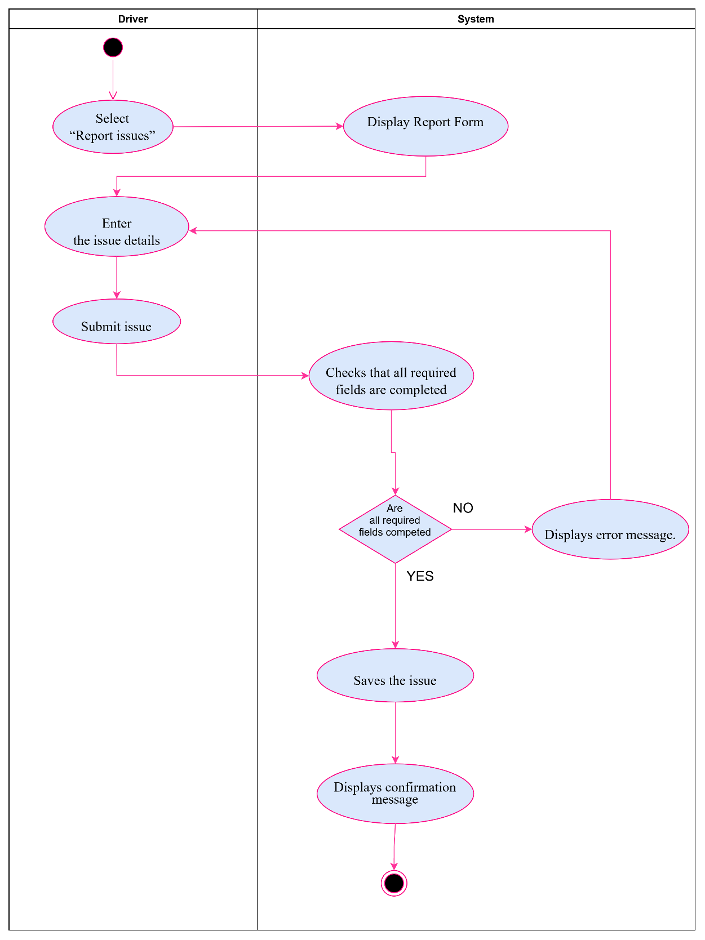
Figure 16 Activity Diagram: UC11 Report Issues

1.2.33. Use Case Narrative: UC21 Register Employees
BusNova
Use Case Specification
Use Case Id | UC21
User Case Name | Register Employees
Actor(s) | Manager
Brief Description | The Manager registers a new employee by creating a staff account. The Manager selects the employee's role (Manager, Driver or Maintenance Staff) and enters the employee's details, such as name, email address, username, temporary password and role-specific information (e.g., driver's licence number and expiry date, or specialisation). The system validates the information, checks that the username and email address are unique, encrypts the temporary password, saves the account and confirms that the account was created.
Frequency of use | Low. Only when a new employee joins the organisation.
Precondition | 1. The Manager has a registered account and is logged into the system.  2. The employee does not already have a registered account.
Main Flow of Events | Actor |  | System
Main Flow of Events | 1. Selects "Manage Users".  2. Selects the employee's role  3. Enter employee details  4. Clicks "Create staff account". |  | 1.1. Displays the staff registration form.  4.1. Validates the entered information  4.2. Encrypts the temporary password and saves the employee account.  4.3. Displays account created message.
Alternative Flows of Events | 1. If required fields are missing or invalid, the system displays an error message, and the Manager must correct the details and submit again.  2. If the username or email address already exists, the system displays an error message, and the Manager must enter a different username or email address.
Postconditions | 1. A new employee account is created and stored in the system with the selected role.  2. The employee can log in using the username and temporary password.
Special requirements | 1. Staff accounts can only be created by the Manager and never from the public Register page.  2. The temporary password must be encrypted before it is stored.  3. The username and email address must be unique across all roles.
Created by | Yonwaba Mgqulwana | Last Modified by |  | Nadia Mpohlekana
Date | 06 October 2026 | Date |  | 03 November 2026
Table 17 Use Case Narrative: Register Employees

1.2.34. Activity Diagram: UC21 Register Employees
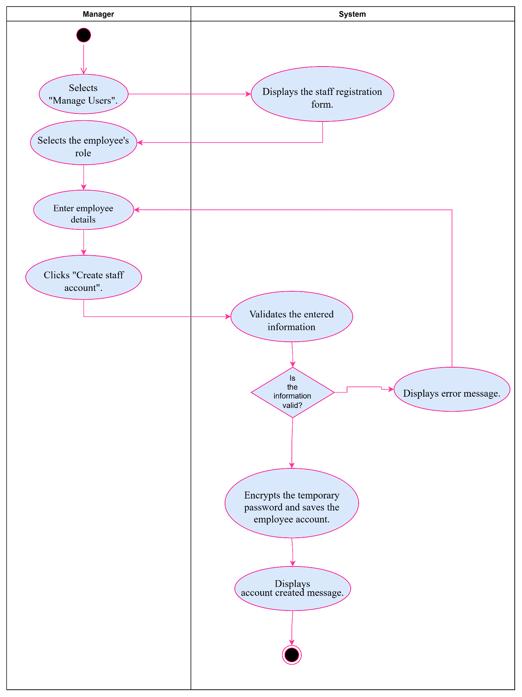
Figure 17 Activity Diagram: UC21 Register Employees

1.2.35. Use Case Narrative: UC7 View Reports
BusNova
Use Case Specification
Use Case Id | UC7
User Case Name | View Reports
Actor(s) | Manager
Brief Description | Enables managers to generate, view, and analyse operational metrics, financial summaries, fuel usage, and maintenance history across the fleet
Frequency of use | Daily, anytime the manger wants to see the reports.
Preconditions | Manger must be logged on the system with authorized manager role privileges.
Main Flow of Events | Actor |  | System
Main Flow of Events | 1. Select "Reports"  2. Select report category, date range, and filter parameters  3. Click "Generate Report"  4. Select "Export to PDF/CSV" |  | 1.1 Display Reports Dashboard  3.1 Render analytical charts and summaries  4.1 Download formatted report document
Alternative Flows of Events | 1. The Manager attempts to generate a report for a date range with no matching records. The system displays 'No data records found for the selected range' and prompts filter adjustment.  2. The Manager attempts to export a report when the document export service fails. The system logs the exception, displays an error alert, and keeps the active report view on screen.
Postconditions | 1. Operational report is generated and displayed on screen.  2. Exported report file is downloaded locally.  3. Report generation activity is recorded in Audit Logs.
Special Requirements | Only registered and authenticated Managers should be allowed to view reports.
Created by | Anesipho Kalazana | Last Modified by |  | Elihle Nteyi
Date | 02 October 2026 | Date |  | 03 November 2026
Table 18 Use Case Narrative: UC17 View Reports

1.2.36. Activity Diagram: UC7 View Reports
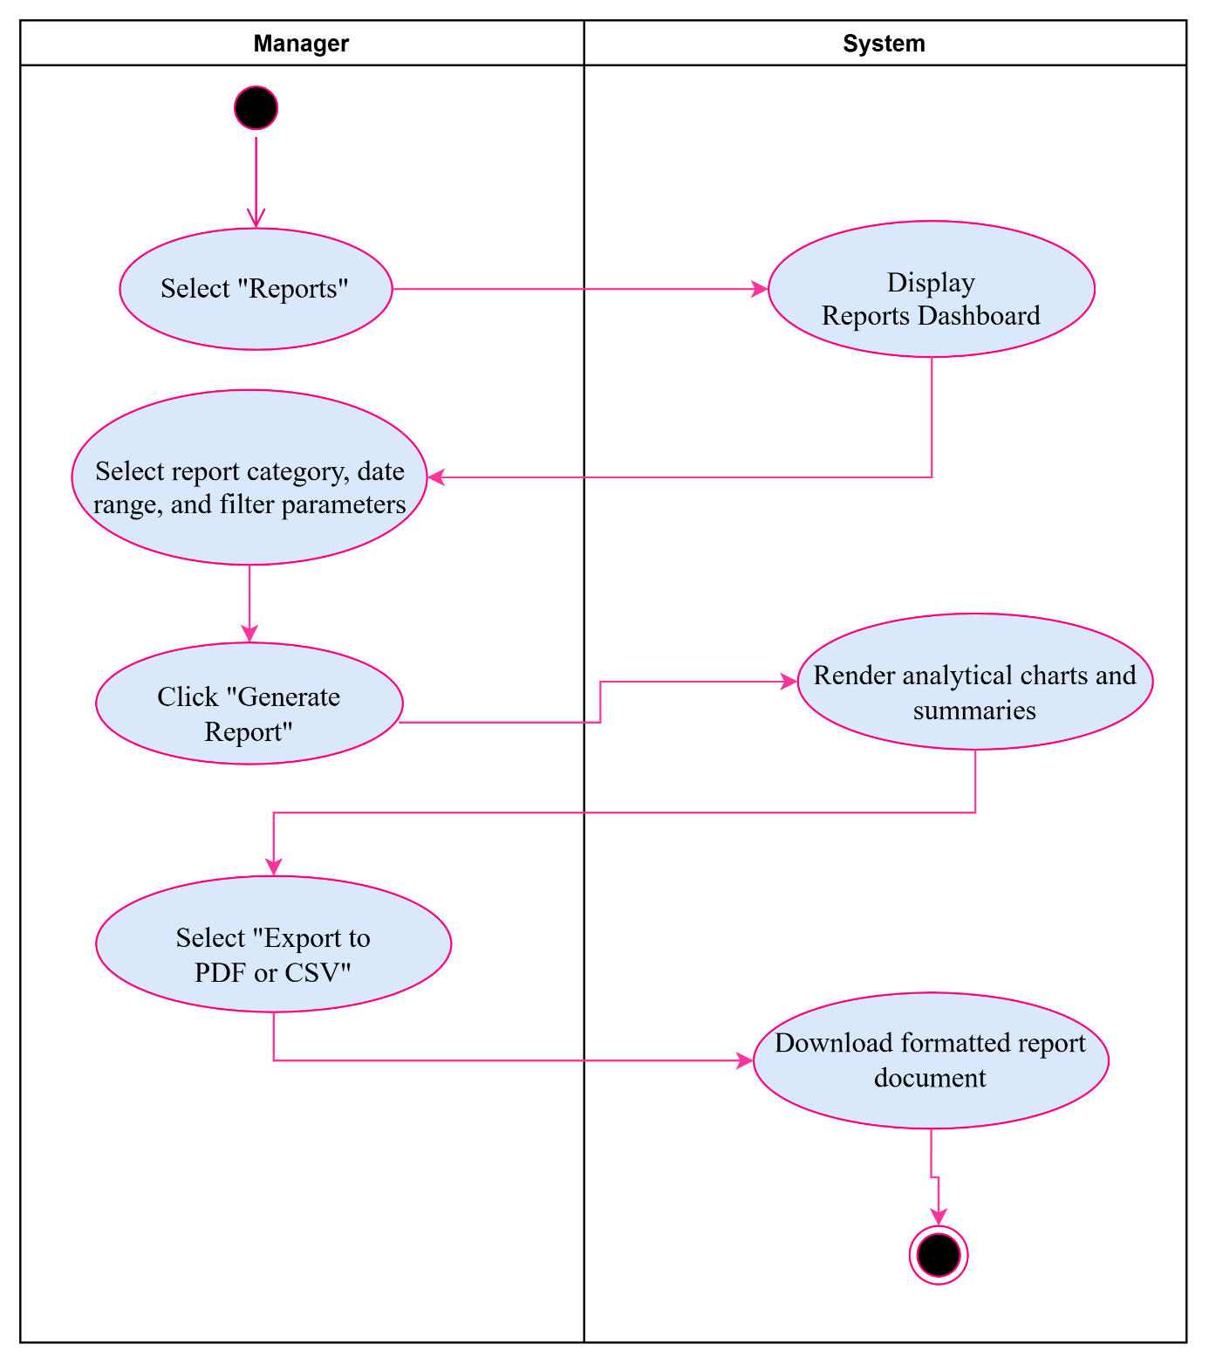
Figure 18 Activity Diagram: UC7 View Reports

1.2.37. Use Case Narrative: UC12 Update Status
BusNova
Use Case Specification
Use Case Id | UC12
User Case Name | Update Status
Actor(s) | Driver
Brief Description | Allows assigned drivers to update the real-time operational status of an active trip (e.g., Scheduled, Boarding, In Transit, Delayed, Completed) on their interface.
Frequency of use | Multiple times per assigned route or trip whenever the driver updates journey progress.
Preconditions | Driver must have an active assigned route schedule
Main Flow of Events | Actor |  | System
Main Flow of Events | 1. Select "MY Schedule"  2. Choose trip status from dropdown  3. Submit status update |  | 1.1 Display Active Route Schedule  3.1 Validate status transition  3.2 Update bus schedule status  3.3 Display confirmation message
Alternative Flows of Events | 1. Delay reported: If driver selects status as 'Delayed', system prompts driver for a brief delay reason and records text in schedule notes.  2. Driver attempts to mark trip 'Completed' without transitioning through 'In Transit'. System displays a validation error and prevents saving.
Postconditions | 1. Real-time trip status is updated in Bus database table.  2. Updated status is broadcasted to passenger tracking views.
Special Requirements | Only authenticated Bus Drivers assigned to the specific route should be permitted to update status.
Created by | Esethu Mtose | Last Modified by |  | Nadia Mpohlekana
Date | 08 October 2026 | Date |  | 03 November 2026
Table 19 Use Case Narrative: UC12 Update Status

1.2.38. Activity Diagram: UC12 Update Status
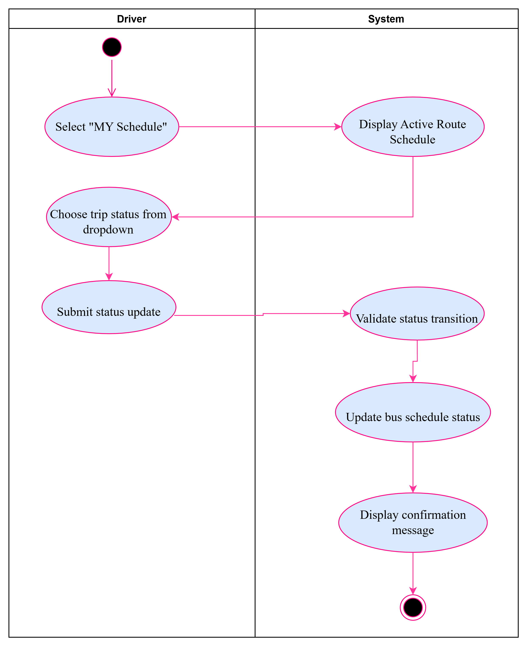
Figure 19 Activity Diagram: UC12 Update Status

1.2.39. Use Case Narrative: UC16 Receive Confirmation
BusNova
Use Case Specification
Use Case Id | UC16
User Case Name | Receive Confirmation
Actor(s) | Passenger
Brief Description | Provides passengers with digital ticket confirmation, reference details, and booking summary immediately following a successful purchase.
Frequency of use | Per successful ticket booking transaction.
Preconditions | Passenger must have selected route and seat in an active upcoming bus trip.  Passenger must have successfully completed the Purchase ticket payment process.
Main Flow of Events | Actor |  | System
Main Flow of Events | 1. Complete seat payment in book trip.  2. View confirmation screen  3. Click "Print Ticket" or "Save" |  | 1.1 Validate transaction and issue ticket  1.2 Create record in Tickets and Payment Transaction  2.1 Display digital booking receipt with QR code  2.2 Send confirmation notice/email
Alternative Flows of Events | Email notification failure: If automated email delivery encounters an error, system logs notification failure in database and provides a direct on-screen 'Download PDF Pass' button.
Postconditions | Ticket status is set to Active in Tickets table.  Confirmation receipt is displayed and stored for passenger retrieval.
Special Requirements | Confirmation screen must render in under 1 second post-payment.  Generated ticket reference codes must be uniquely hashed for security validation.
Created by | Olebogeng Gumbu | Last Modified by |  | Simanye Siximba
Date | 14 October 2026 | Date |  | 03 November 2026
Table 20 Use Case Narrative: UC16 Receive Confirmation

1.2.40. Activity Diagram: UC16 Receive Confirmation
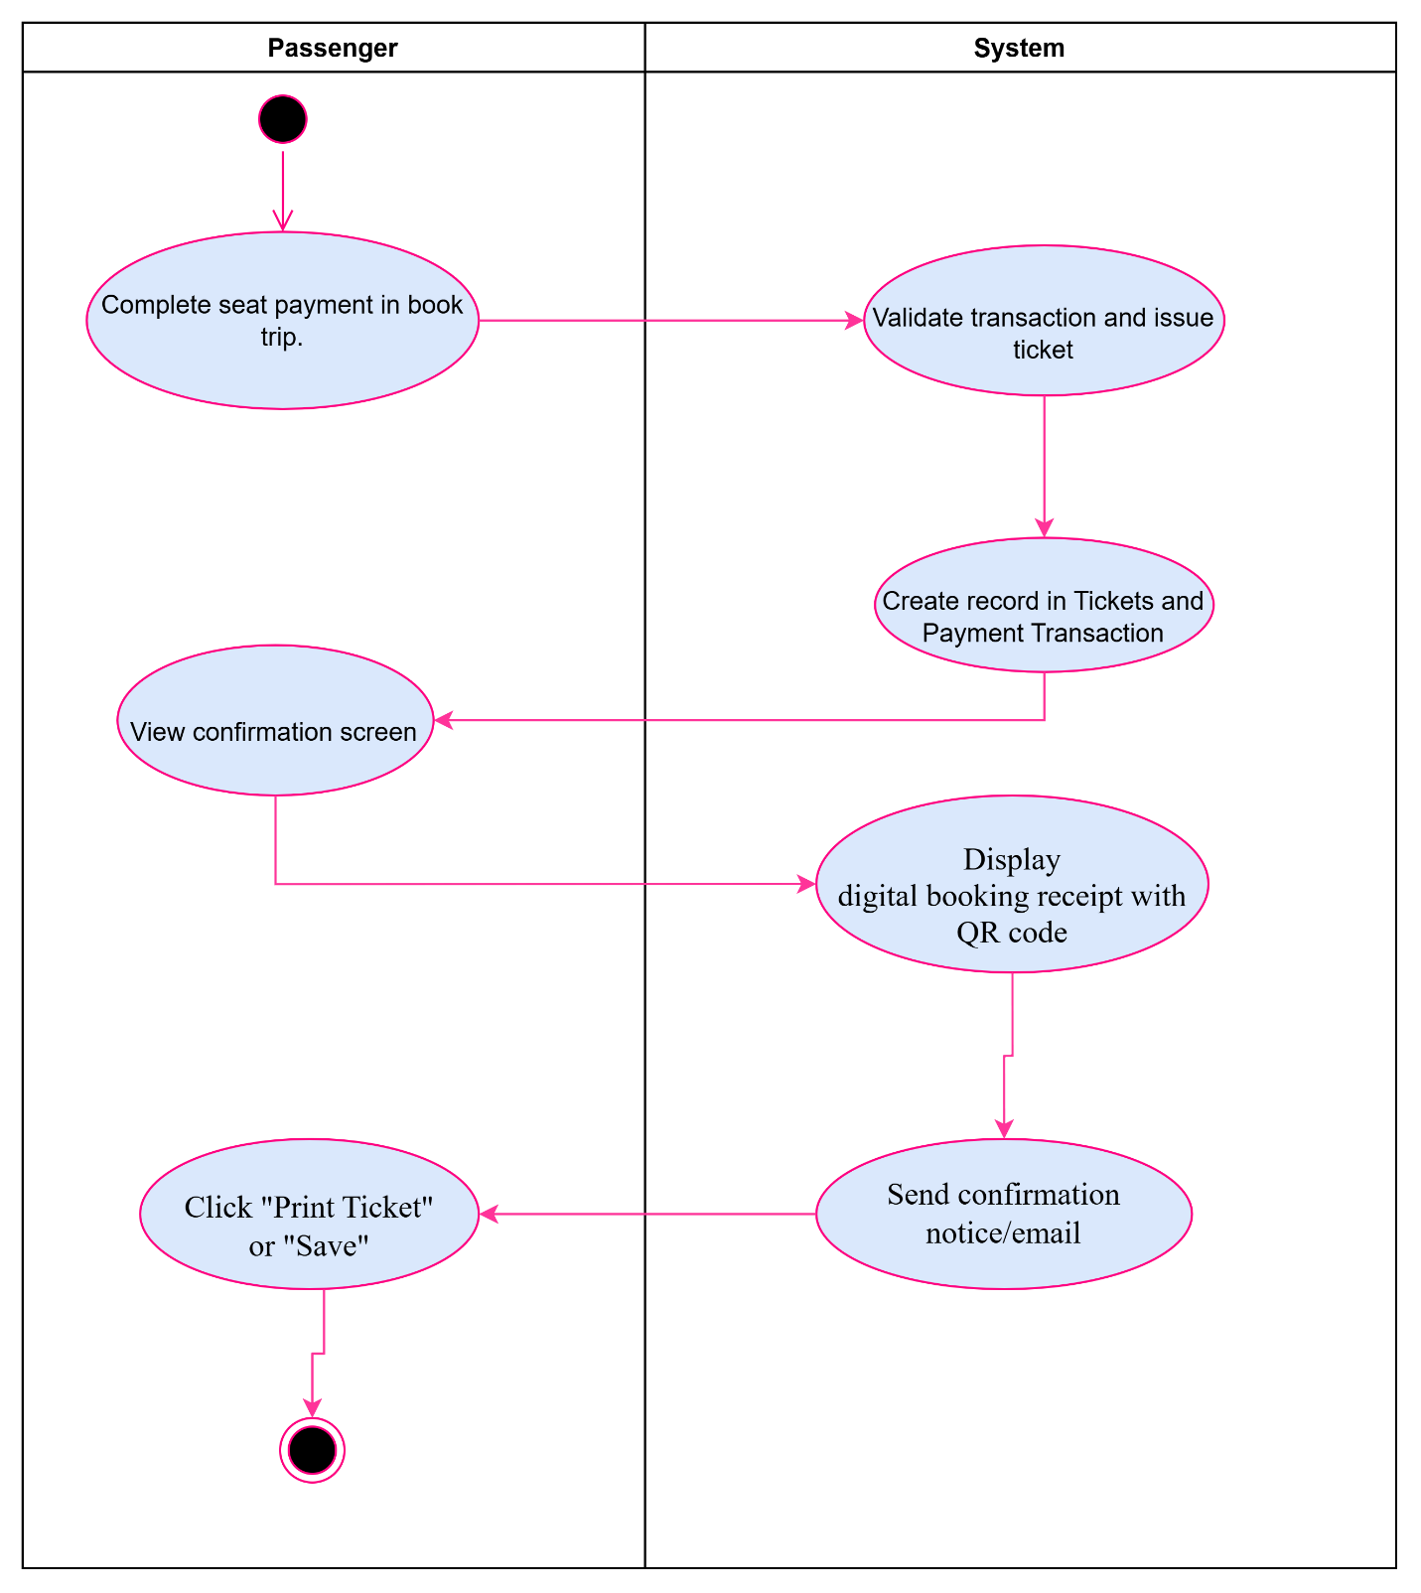
Figure 20 Activity Diagram: UC16 Receive Confirmation

1.2.41. Use Case Narrative: UC19 Update Vehicle Status
Bus Nova
Use Case Specification
Use Case Id | UC19
User Case Name | Update Vehicle Status
Actor(s) | Maintenance Staff
Brief Description | Enables maintenance staff to update a bus vehicle's operational status (e.g., Operational, Under Maintenance, Out of Service) post-repair or inspection.
Frequency of use | Whenever maintenance work is conducted.
Precondition | 1. Maintenance Staff must be authenticated and logged into the system.  2. Vehicle record must exist in Bus database table.
Main Flow of Events | Actor | System
Main Flow of Events | 1. In the maintenance dashboard they Search for vehicle  2. Select updated vehicle status  3. Enter service notes and submit | 1.1 Fetch bus record and current maintenance state  3.1 Update bus status  3.2 Log change event in Audit Logs  3.3 Display status update confirmation
Alternative Flows of Events | Maintenance Staff attempts to set vehicle status to 'Operational' while critical work orders remain open in Maintenance Logs. System flags open issues and blocks status change until resolved.
Postconditions | 1. Vehicle status is updated in Bus database table.  2. Vehicle availability is updated across route assignment module.
Special requirements | Only authorized Maintenance Staff can modify vehicle operational status.  All vehicle status changes must be logged in AuditLogs for compliance.
Created by | Yonwaba Mgqulwana | Last Modified by | Anesipho Kalazana
Date | 18 October 2026 | Date | 03 November 2026
Table 21 Use Case Narrative: UC19 Update Vehicle Status

1.2.42. Activity Diagram: UC19 Update Vehicle Status
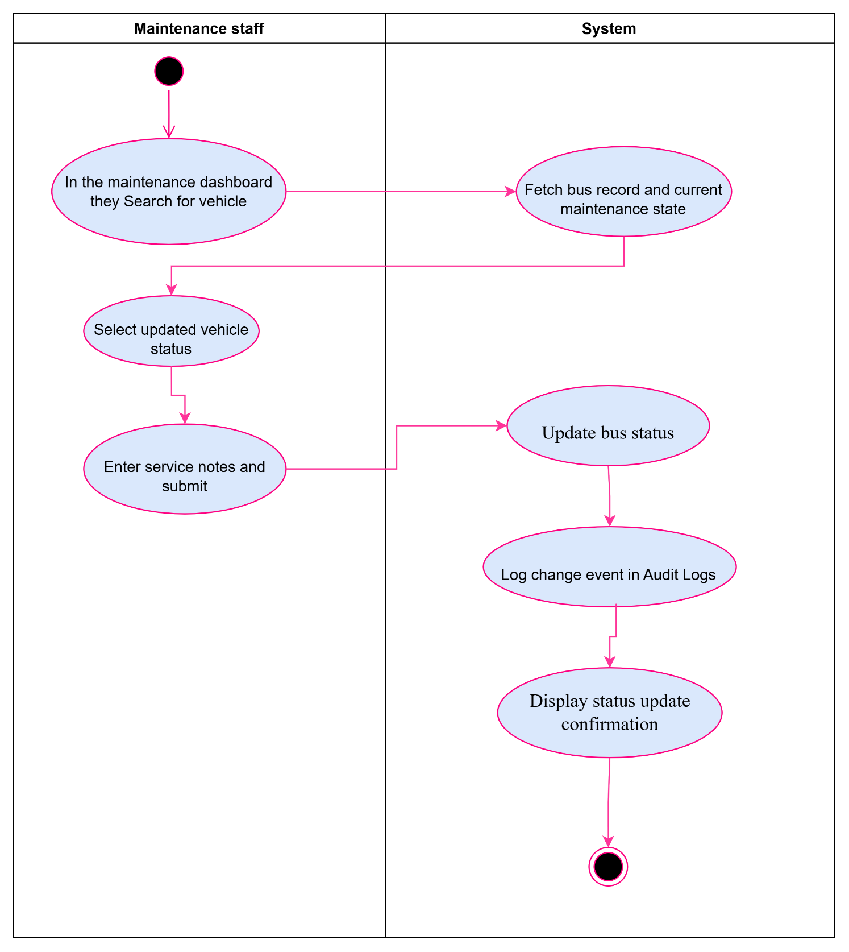
Figure 21 Activity Diagram: UC19 Update Vehicle Status

1.2.43. Use Case Narrative: UC20 Receive Maintenance Alerts
Bus Nova
Use Case Specification
Use Case Id | UC20
User Case Name | Receive Maintenance Alerts
Actor(s) | Maintenance Staff
Brief Description | Automatically generates and delivers maintenance alert notices to maintenance personnel when routine service thresholds are met or vehicle faults are reported.
Frequency of use | Continuous / Event-driven whenever a fault is logged or service interval is reached.
Precondition | Maintenance Staff must be registered and logged into the system.  Vehicle fault logged via UC11, or automated mileage/time service trigger activated in background.
Main Flow of Events | Actor | System
Main Flow of Events | 1. Access Maintenance Portal Dashboard  2. Click alert notification item  3. Acknowledge alert and issue work order | 1.1 Generate alert record in Notification table  1.2 Display alert highlighted by severity  2.1 Display detailed fault record and inspection notes  3.1 Update alert status to 'Acknowledged'
Alternative Flows of Events | High-priority breakdown alert: If issue is tagged as 'Breakdown/Safety Hazard', system displays high-priority warning badge on screen and sends priority push/email notification to on-duty staff.
Postconditions | Alert status is marked as Acknowledged in Notification table.  Maintenance work order is created in Maintenance Logs.
Special requirements | System should support background polling to deliver alerts in real time.  Alerts must link directly to relevant vehicle inspection and fault logs.
Created by | Elihle Nteyi | Last Modified by | Esethu Mtose
Date | 21 October 2026 | Date | 03 November 2026
Table 22Use Case Narrative: UC20 Receive Maintenance Alerts

1.2.44. Activity Diagram: UC20 Receive Maintenance Alerts
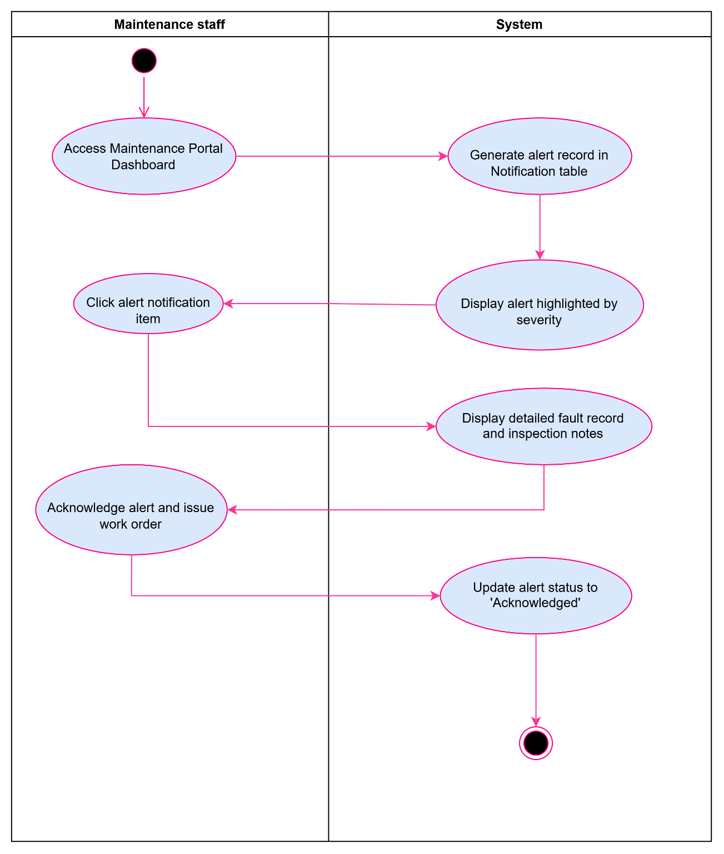
Figure 22 Activity Diagram: UC20 Receive Maintenance Alerts

2. Section B: Data Modelling Requirements

2.1. Entity Relationship Diagram
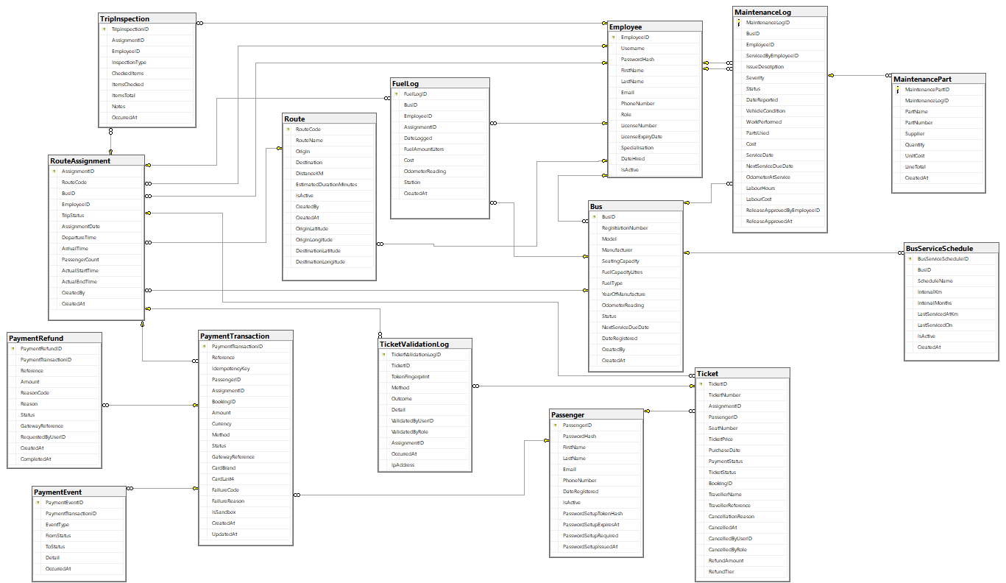
Figure 23 Entity Relationship Diagram

2. 2. Attribute Framing

2.2.1. Employees
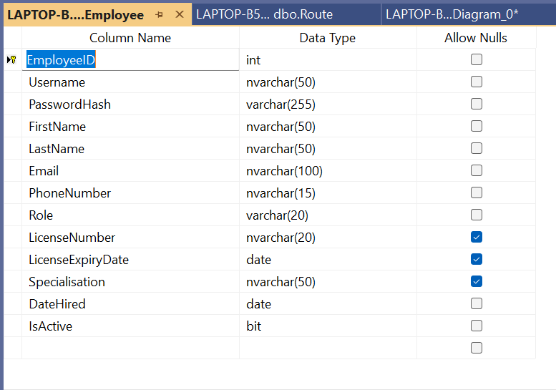
Table 23 Employees

2.2.2. Passengers
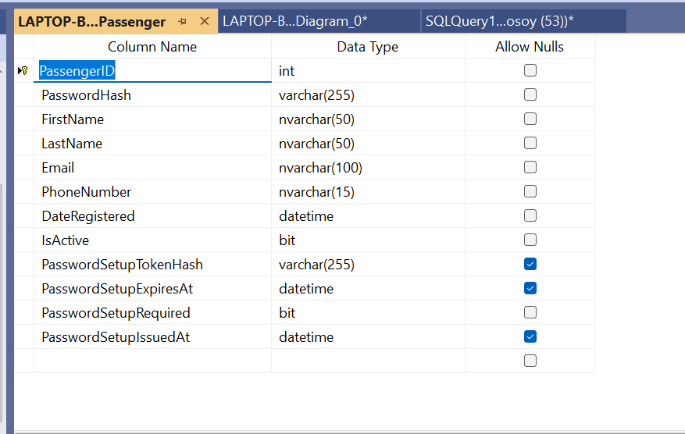
Table 24 Passengers

2.2.3. Bus
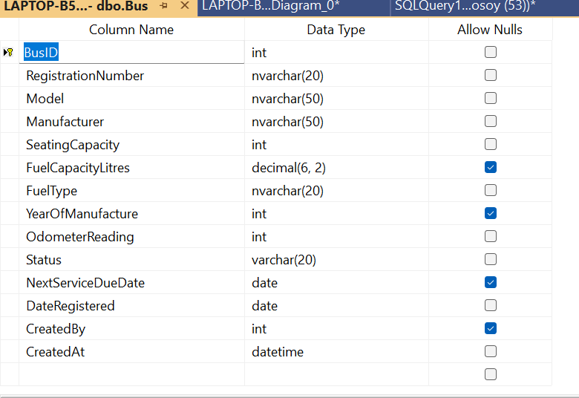
Table 25 Bus

2.2.4. Bus Schedule
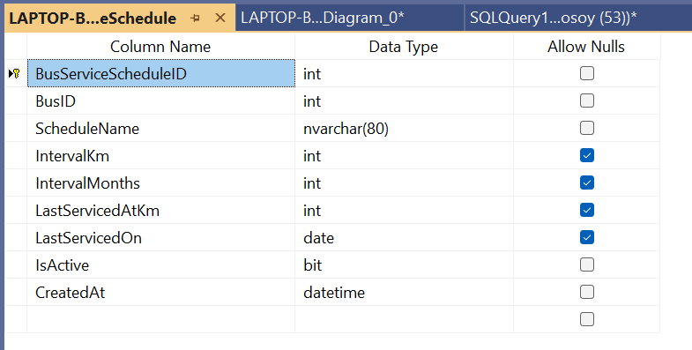
Table 26 Bus Schedule

2.2.5. Route
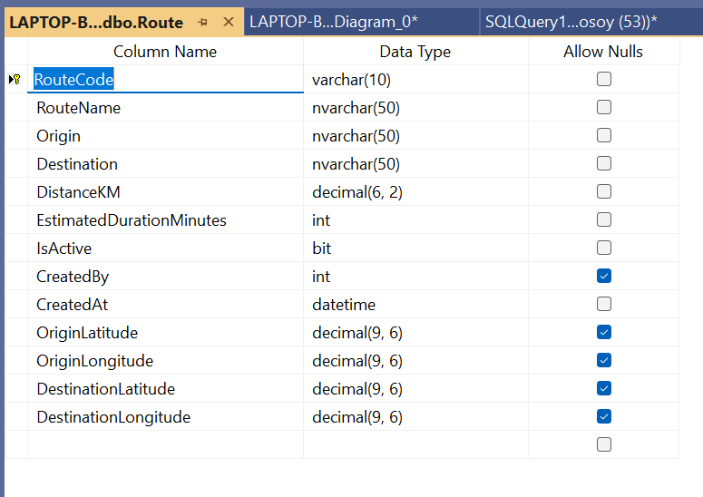
Table 27 Route

2.2.6. Route Assignments
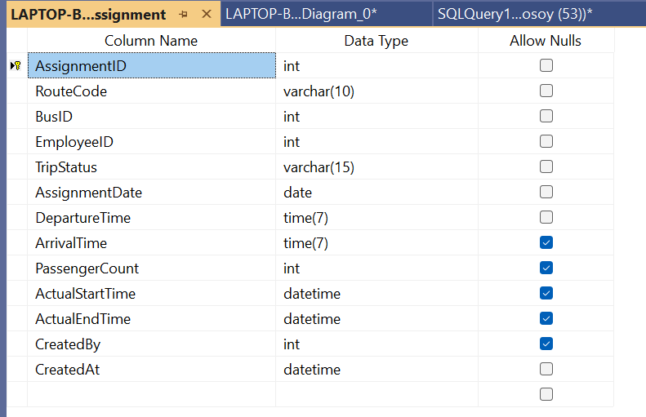
Table 28 Route Assignments

2.2.7. Maintenance Logs
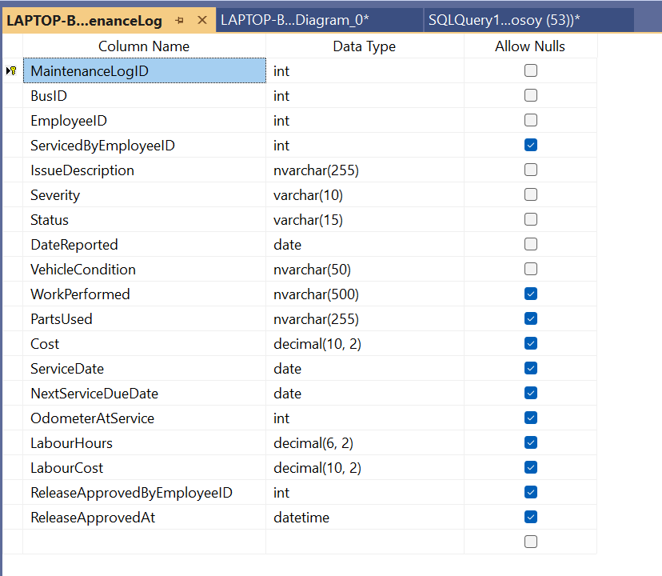
Table 29 Maintenance Logs

2.2.8. Maintenance Parts
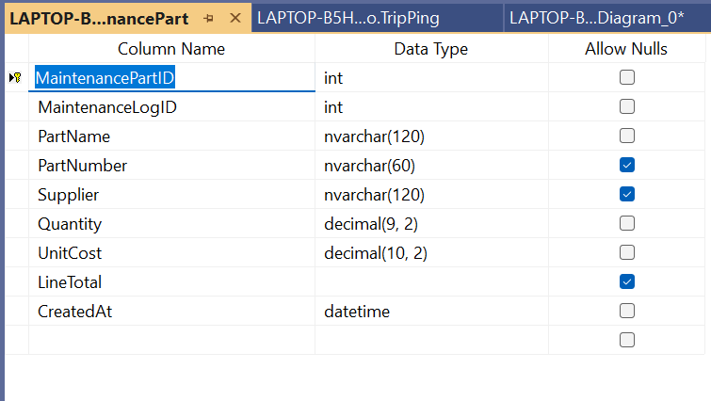
Table 30 Maintenance Parts

2.2.9. Fuel Logs
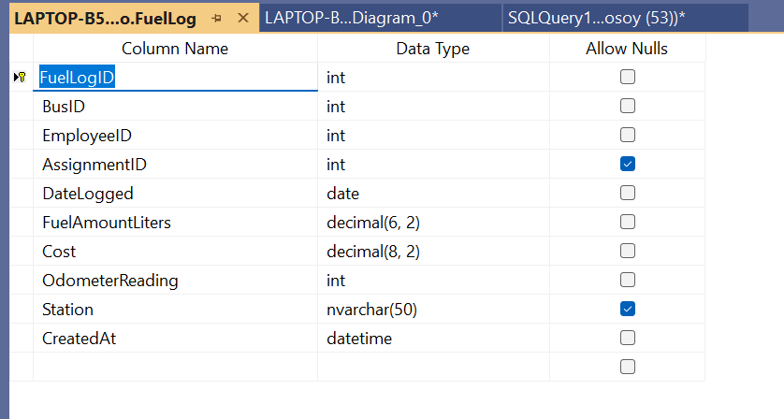
Table 31 Fuel Logs

2.2.10. Tickets
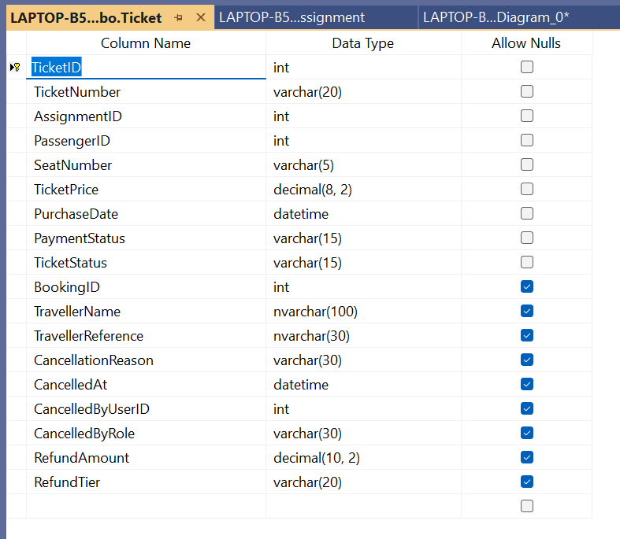
Table 32 Tickets

2.2.11. Tickets Validation
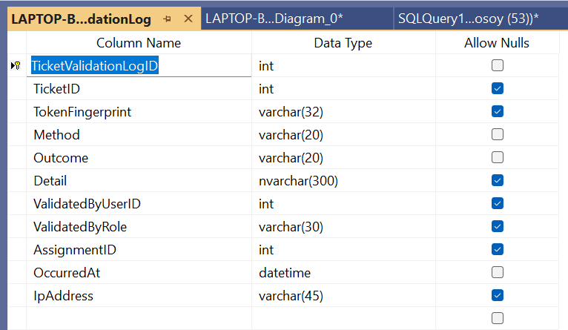
Table 33 Tickets Validation

2.2.12. Booking
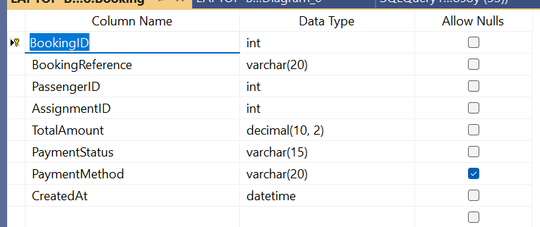
Table 34 Booking

2.2.13. Notification
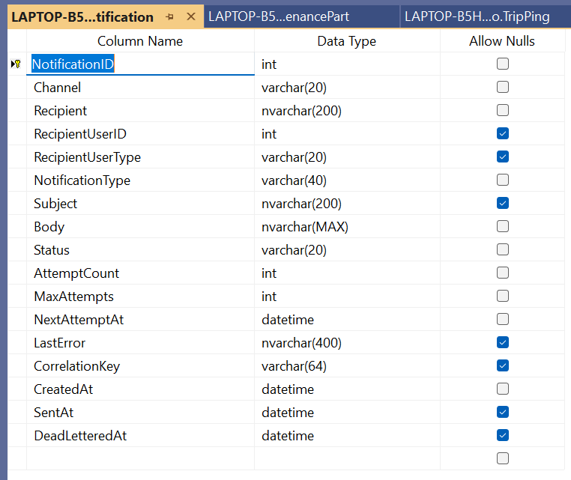
Table 35 Notification

2.2.14. Payment Event
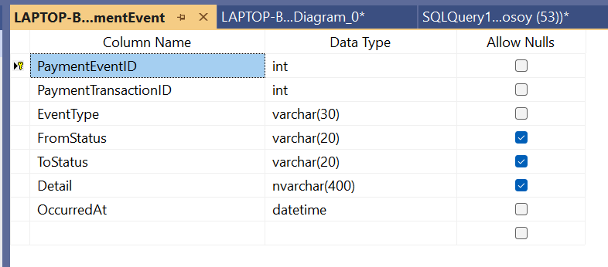
Table 36 Payment Event

2.2.15. Payment Refund
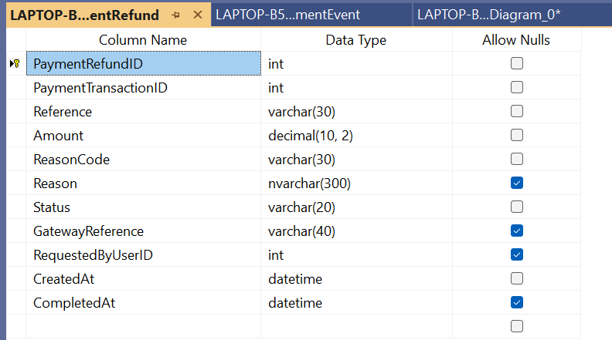
Table 37 Payment Refund

2.2.16. Payment Transaction
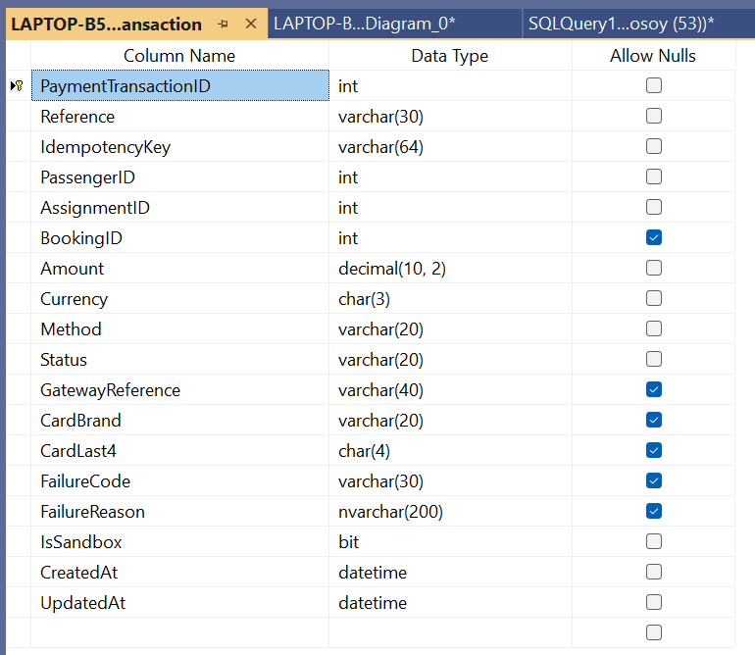
Table 38 Payment Transaction

2.2.17. Audit Logs
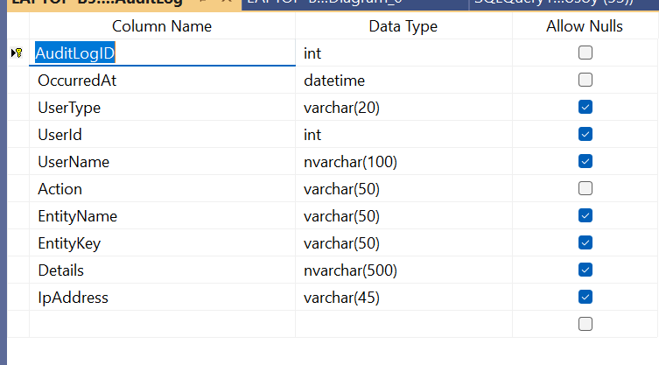
Table 39 Audit Logs

2.2.18. Trip Inspection
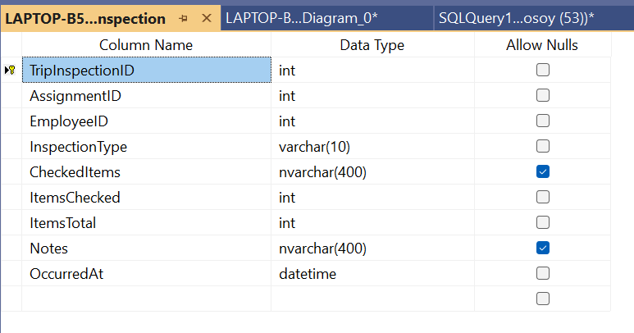
Table 40 Trip Inspection

2.2.19. Trip Pin
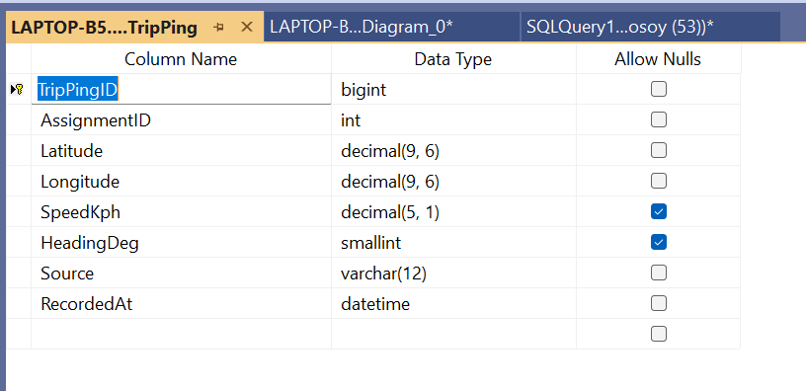
Table 41 Trip Pin

3. Section C: Systems Design Requirements

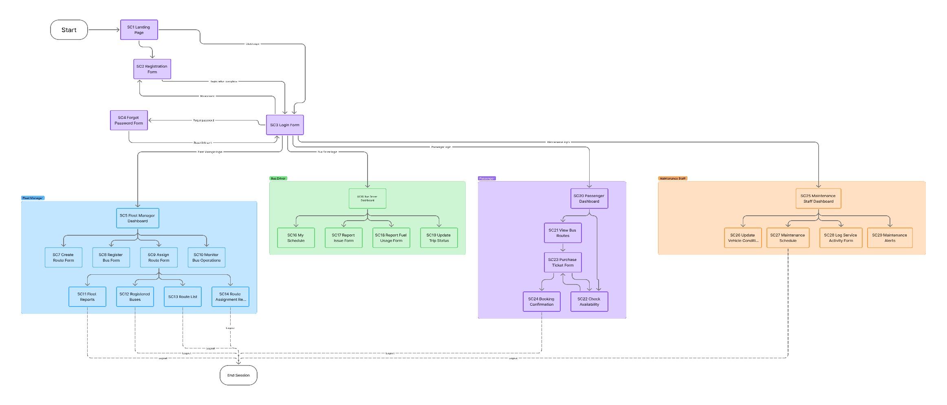
3.1. Windows Navigation Diagram
Figure 24 Windows Navigation Diagram

3.2. Screen Design Specification

3.2.1. Screen 01: Home Page
The Home Page serves as the main entry point to the BusNova System. It introduces users to the system and provides navigation options to access the relevant functionality. Users can select Get Started, Login, or Register to proceed to the appropriate part of the system.
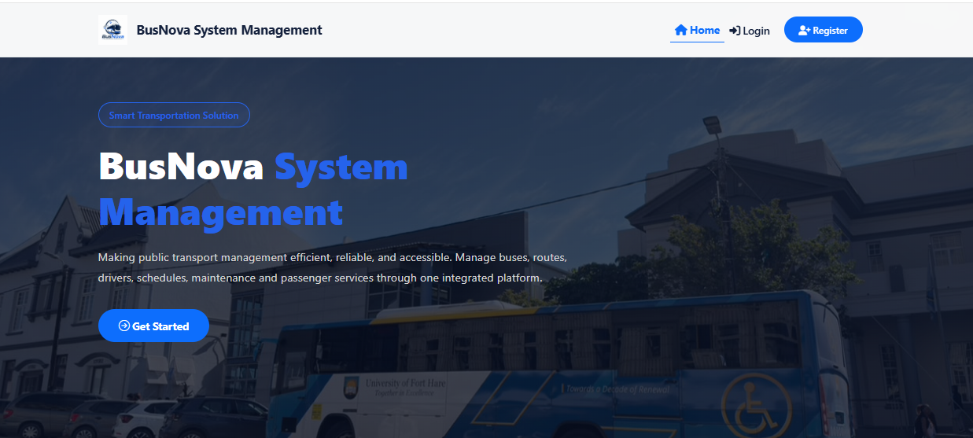
CR4: Button for Login page
CR3: Button for Home page
CR2: Button for Register page
CR1: Button for login page
Figure 25 Screen 01: Home Page

Screen Narrative and Controls: SC1
Reference | Control Type | Data Input | Data Output
CR1 | Button | Click | Login page
CR2 | Button | Click | Register page
CR3 | Button | Click | Home page
CR4 | Button | Click | Login page
Table 42 Screen Narrative and Controls: SC1

3.2.2. Screen 02: Register
The Register screen allows new users to create a BusNova account by entering their personal and account information, including their name, username, email address, contact number and password. The user also selects their appropriate system role during registration. The information provided is used to create the user's account and enable authenticated access to the system.
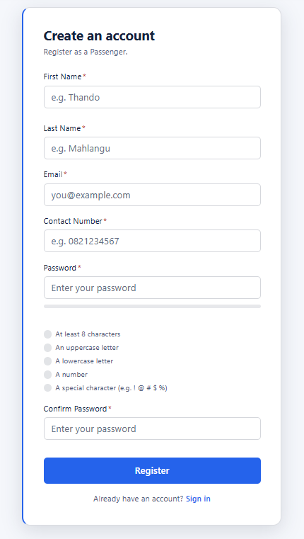
CR6: Textbox for Last name
CR9: Textbox for Password
CR10: Radio button for verification
CR12: Button for Register
CR11: Textbox for Confirm Password
CR8: Textbox for Contact Number
CR7: Textbox for Email
CR5: Textbox for First name
Figure 26 Screen 02: Register

Screen Narrative and Controls: SC2
Reference | Control Type | Data Input | Data Output
CR5 | Textbox | User’s first name
CR6 | Textbox | User’s last name
CR7 | Textbox | User’s email
CR8 | Textbox | Contact details
CR9 | Textbox | User enters password
CR10 | Radio Button |  | Fills up to verify password
CR11 | Textbox | Confirms user’s password
CR12 | Button | Click | Login page
Table 43 Screen Narrative and Controls: SC2

3.2.3. Screen 03: Login
The Login screen allows registered users to securely access the BusNova System by entering their email address and password. Upon successful authentication, the user is directed to the appropriate dashboard based on their assigned role.

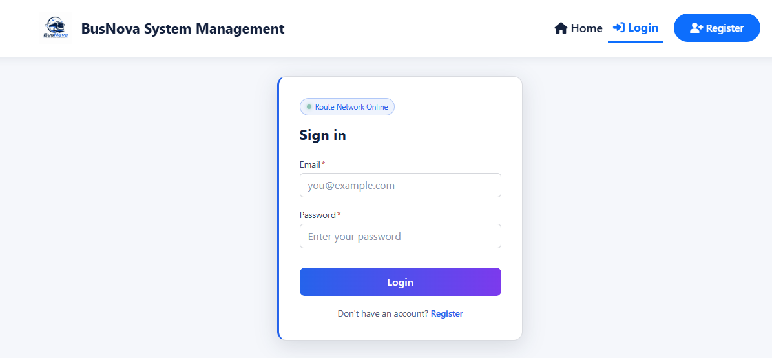
CR15: Button for Login
CR14: Textbox for Password
CR13: Textbox for Email
Figure 27 Screen 03: Login

Screen Narrative and Controls: SC3
Reference | Control Type | Data Input | Data Output
CR13 | Textbox | User’s email
CR14 | Textbox | User enters password
CR15 | Button | Click | Display dashboard
Table 44 Screen Narrative and Controls: SC3

3.2.4. Screen 04: Manager Dashboard
The Manager Dashboard is the operational home page for the Manager role. It consolidates fleet, staffing and ticketing counters into a single decision surface, surfaces urgent items under a "Needs attention" section, and provides direct navigation to the five primary Manager actions. The screen is read-only; all writes occur on the destination pages.
CR22: Card for completed trips
CR21: Card for trips
CR20: Card for active route
CR18: Card for deactivated accounts
CR19: Card for active Bus
CR17: Card for passenger account
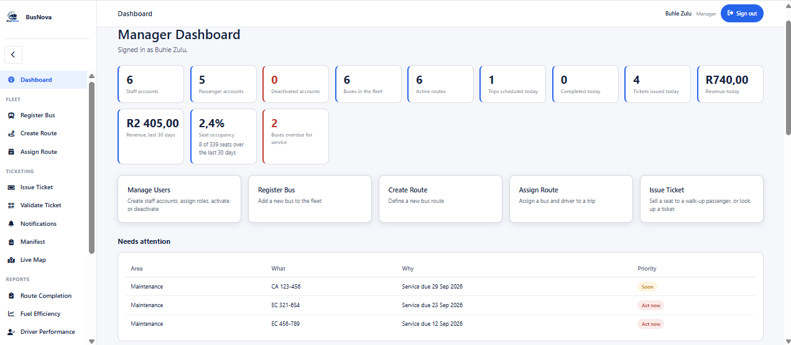
CR31: Card for assigning routes
CR30: Card for creating routes
CR32: Card for creating routes
CR29: Card for registering buses
CR28: Card for manging users
CR26: Card for seat occupancy rate
CR25: Card for total revenue
CR27: Card for buses overdue
CR24: Card for revenue
CR23: Card for tickets booked
CR16: Card for staff account
Figure 28 Screen 04: Manager Dashboard
CR33: Grid view for attention list

Screen Narrative and Controls: SC04
Reference | Control Type | Data Input | Data Output
CR16 | Card |  | Active Staff account
CR17 | Card |  | Active Passenger account
CR18 | Card |  | Deactivated Accounts
CR19 | Card |  | Active Bus
CR20 | Card |  | Active Routes
CR21 | Card |  | Trips Scheduled
CR22 | Card |  | Trips completed
CR23 | Card |  | Tickets Issued
CR24 | Card |  | Revenue generated
CR25 | Card |  | Overall Revenue generated
CR26 | Card |  | Seat Occupancy rate
CR27 | Card |  | Bus Services overdue
CR28 | Card | Click | Manage users page
CR29 | Card | Click | Bus Register page
CR30 | Card | Click | Create Route page
CR31 | Card | Click | Assing Rout page
CR32 | Card | Click | Issue Ticket page
CR33 | Grid view |  | Need attention list
Table 45 Screen Narrative and Controls: SC04

3.2.5. Screen 05: Bus Driver Dashboard
The Bus Driver Dashboard is the operational home page for the Driver role. It shows the driver how many trips are ahead, presents the three actions a driver performs (view schedule, log fuel, report an issue), and lists the next scheduled trips with their status.
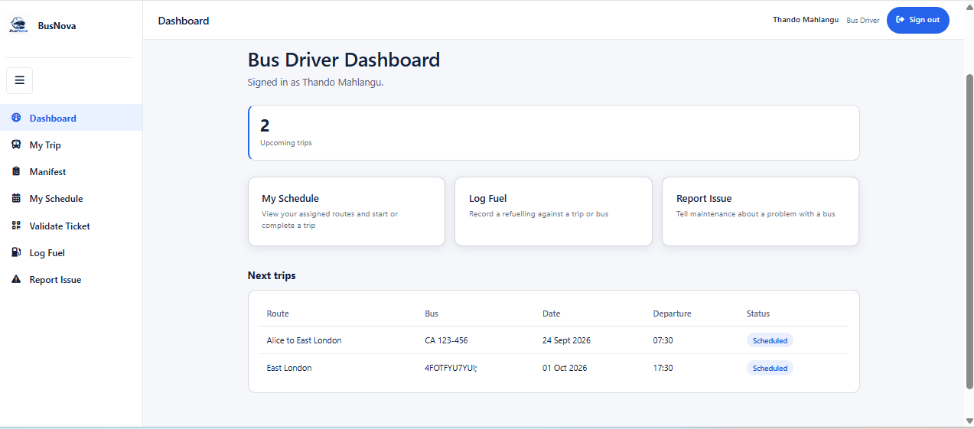
CR37: Card for report issue
CR39: Pill for trip status
CR38: Grid view for next trip
CR36: Card for Log fuel
CR35: Card for viewing schedule
CR34: Card for upcoming trips
Figure 29 Screen 05: Bus Driver Dashboard

Screen Narrative and Controls: SC05
Reference | Control Type | Data Input | Data Output
CR34 | Card |  | Upcoming trips count
CR35 | Card | Click | My Schedule page
CR36 | Card | Click | Log Fuel page
CR37 | Card | Click | Report Issues
CR38 | Grid View |  | Next trips list
CR39 | Pill |  | Trip status
Table 46 Screen Narrative and Controls: SC05

3.2.6. Screen 06: Passenger Dashboard
The Passenger Dashboard is the operational home page for the Passenger role. It provides two paths book a new trip or manage existing tickets and lists the upcoming trips the passenger can travel on, including the number of seats still free on each.

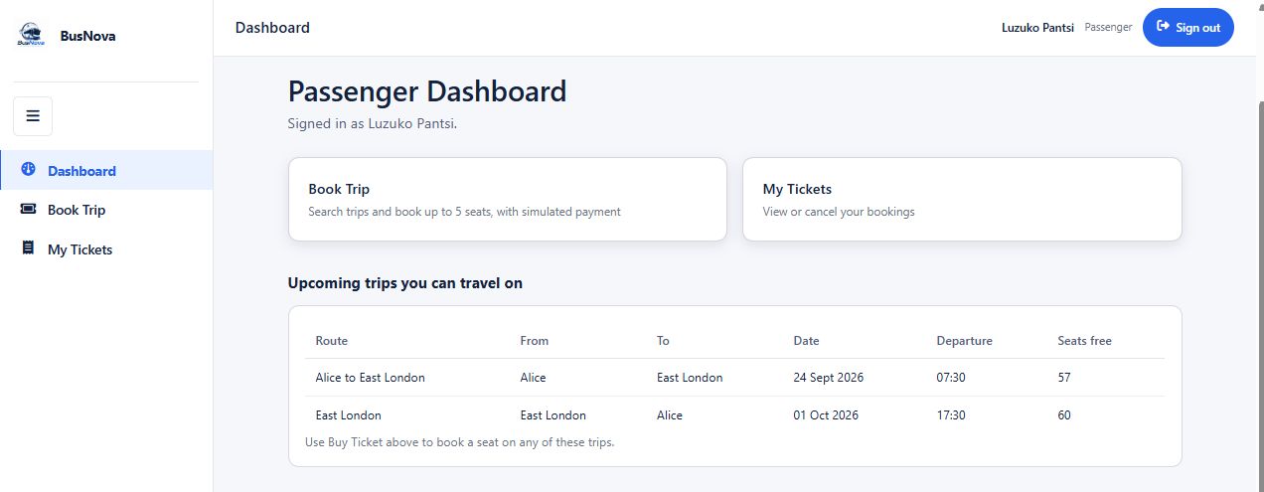
CR40: Card for booking trip
CR41: Card for viewing tickets
CR42: Grid view for viewing upcoming trips
Figure 30 Screen 06: Passenger Dashboard

Screen Narrative and Controls: SC06
Reference | Control Type | Data Input | Data Output
CR40 | Card | Click | Book trip page
CR41 | Card | Click | My Ticket page
CR42 | Grid View |  | Upcoming trips list
Table 47 Screen Narrative and Controls: SC06

3.2.7. Screen 07: Maintenance Staff Dashboard
The Maintenance Staff Dashboard is the operational home page for the Maintenance Staff role. It shows what is overdue for service and what is coming up, links to the maintenance work screen, and lists the buses currently needing attention in urgency order.
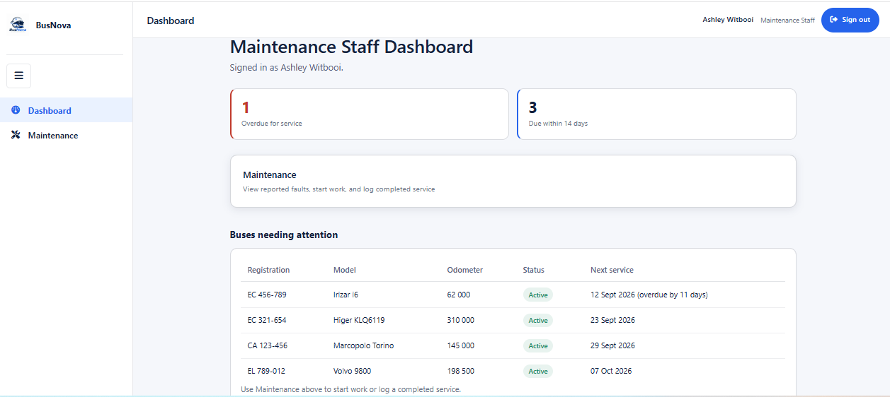
CR46: Gid view for viewing buses needing attention
CR44: Card for viewing services due in 14 days
CR43: Card for viewing overdue services
CR45: Card for viewing maintenances
Figure 31 Screen 07: Maintenance Staff Dashboard

Screen Narrative and Controls: SC07
Reference | Control Type | Data Input | Data Output
CR43 | Grid view | Display assigned route
CR44 | Card |  | Due within 14 days count
CR45 | Card | Click | Maintenance work page
CR46 | Grid View |  | Buses needing attention list
Table 48 Screen Narrative and Controls: SC07

3.2.8. Screen 08: Manage Users
The Manage Users screen allows the Manager to create staff accounts and to activate or deactivate staff and passenger accounts. Staff accounts (Manager, Driver, Maintenance Staff) can only be created here and never from the public Register page; the screen states this explicitly to make the security boundary visible to the operator. 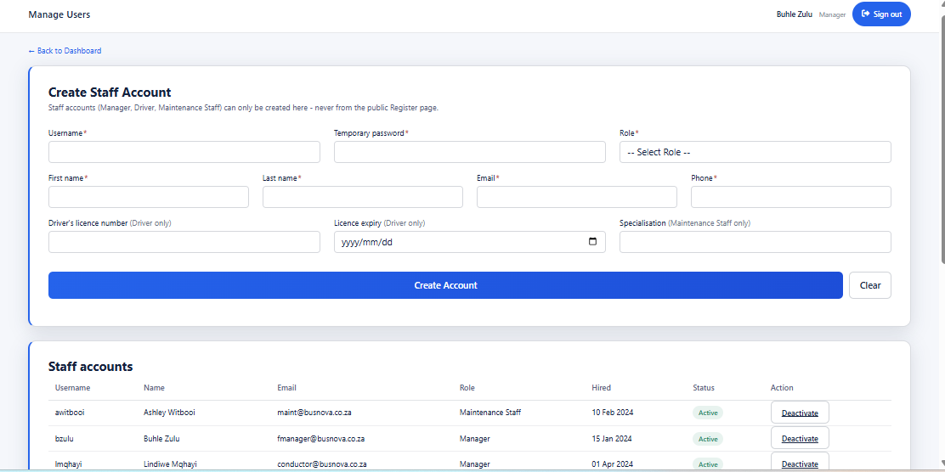
CR53: Textbox for phone
CR50: Textbox for first name
CR51: Textbox for last name
CR47: Textbox for username
CR56: Textbox for specialisation
CR54: Textbox for driver’s license
CR55: Date box for licence expiry
CR52: Textbox for Email
CR48: Textbox for temp password
CR49: Dropdown for role
CR58: Button for clearing form
CR57: Button for creating account
CR60: Button to deactivate an account
CR59: Grid view for staff accounts
Figure 32 Screen 08: Manage Users

Screen Narrative and Controls: SC08
Reference | Control Type | Data Input | Data Output
CR47 | Textbox | Username
CR48 | Textbox | Temporary password
CR49 | Dropdown | Role | Role
CR50 | Textbox | First name
CR51 | Textbox | Last name
CR52 | Textbox | Email
CR53 | Textbox | Phone
CR54 | Textbox | Driver’s licence number
CR55 | Date box | Licence expiry
CR56 | Textbox | Specialization
CR57 | Button | Click | Creates staff account
CR58 | Button | Click | Clear the form
CR59 | Grid view |  | Staff accounts list
CR60 | Button | Click | Deactivate staff account
Table 49 Screen Narrative and Controls: SC08

3.2.9. Screen 09: Log Fuel
The Log Fuel screen allows a Driver to record a refuelling event against either a scheduled trip or a bus directly. The date defaults to today, and the trip-or-bus selection is combined in a single dropdown.
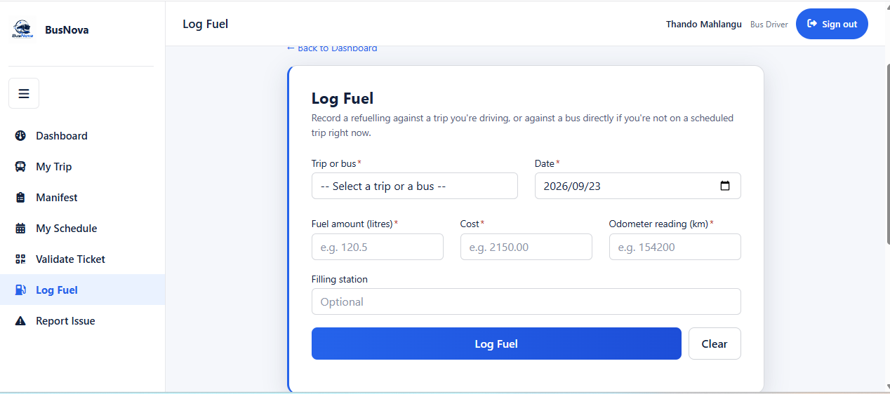
CR64: Textbox for cost
CR66: Textbox for filling station
CR63: Textbox for fuel amount
CR61: Dropdown for trip or bus
CR62: Date box for date of refuelling
CR65: Textbox for odometer
CR68: Button for clearing form
CR67: Button for login fuel
Figure 33 Screen 09: Log Fuel

Screen Narrative and Controls: SC09
Reference | Control Type | Data Input | Data Output
CR61 | Dropdown | Selects trip bus
CR62 | Date box | Date of refueling
CR63 | Textbox | Fuel amount
CR64 | Textbox | Cost
CR65 | Textbox | Odometer
CR66 | Textbox | Filling station
CR67 | Button | Click | Logs the fuel record
CR68 | Button | Click | Clears the form
Table 50 Screen Narrative and Controls: SC09

3.2.10. Screen 10: Report Issue
The Report an Issue screen allows a Driver to report a fault against a bus, creating a maintenance record visible to Maintenance Staff. Selecting a Critical severity takes the bus out of service immediately, which the screen states above the fields.
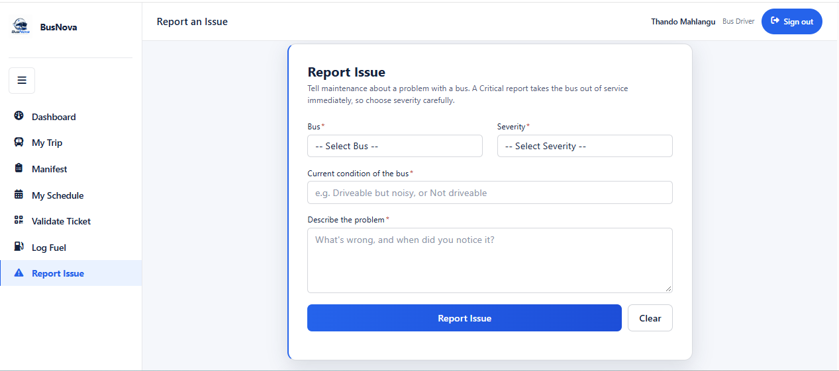
CR74: Button for clearing form
CR70: Dropdown for severity
CR71: Textbox for current condition of bus
CR69: Dropdown for selecting Bus
CR72: Text are for problem description
CR73: Button for issue report
Figure 34 Screen 10: Report Issue

Screen Narrative and Controls: SC10
Reference | Control Type | Data Input | Data Output
CR69 | Dropdown | Selects bus | Bus
CR70 | Dropdown | Select severity | Severity
CR71 | Textbox | Current condition of the bus
CR72 | Text area | Description of the problem
CR73 | Button | Click | Report the issue
CR74 | Button | Click | Clear the form
Table 51 Screen Narrative and Controls: SC10

3.2.11. Screen 11: Register Bus
The Register Bus screen enables the Manager to add a new bus to the BusNova fleet by capturing details such as the registration number, model, manufacturer, seating capacity, fuel type and year of manufacture. The Register Bus button saves the bus information to the system.
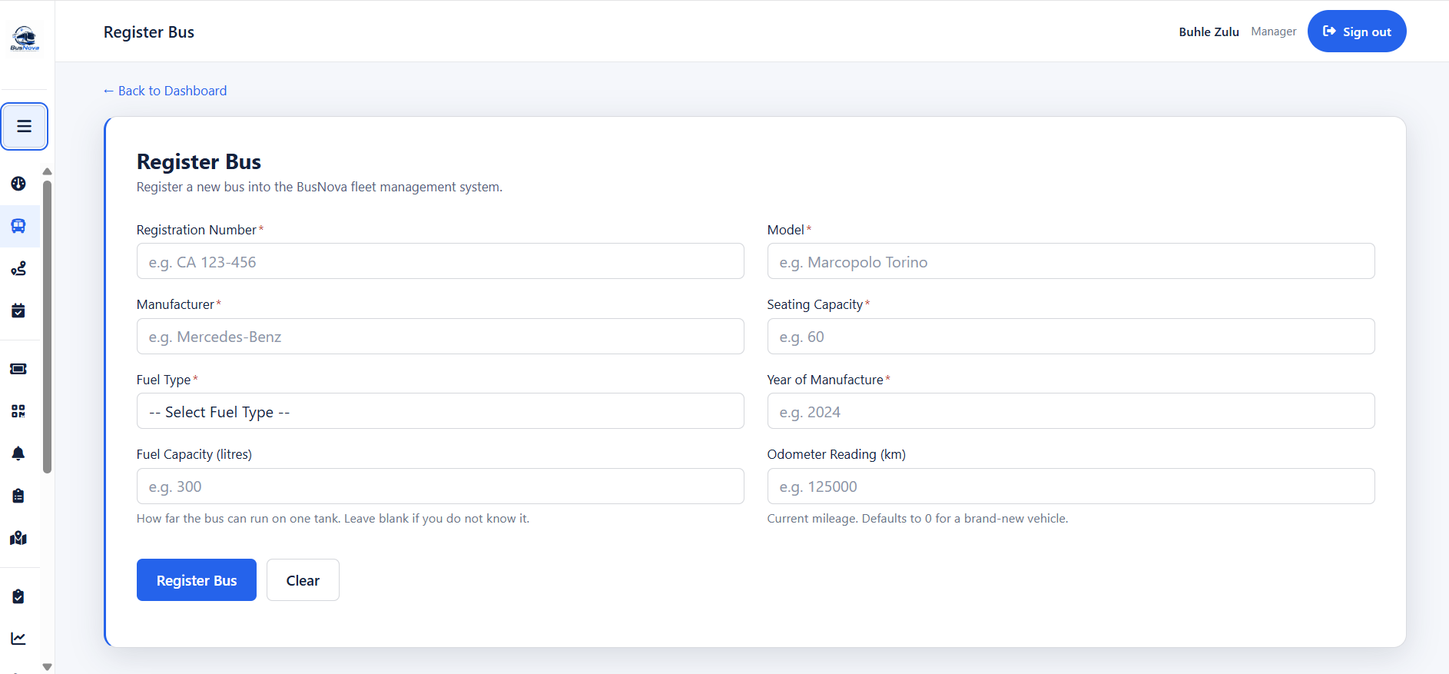
CR78: Textbox for seating capacity
CR76: Textbox for model type
CR75: Textbox for registration number
CR79: Textbox for fuel type
CR77: Textbox for manufacture
CR80: Textbox for year of manufacture
CR84: Button for clearing the form
CR81: Textbox for fuel capacity
CR82: Textbox for Odometer reading
Figure 35 Screen 11: Register Bus
CR83: Button for registering the bus

Screen Narrative and Controls: SC11
Reference | Control Type | Data Input | Data Output
CR75 | Textbox | Registration number
CR76 | Textbox | Bus model
CR77 | Textbox | Bus manufacturer
CR78 | Textbox | Seating capacity
CR79 | Dropdown | Select fuel type | Fuel type
CR80 | Textbox | Year of bus manufacture
CR81 | Textbox | Fuel capacity
CR82 | Textbox | Odometer reading
CR83 | Button | Click | Register bus
CR84 | Button | Click | Clear the form
Table 52 Screen Narrative and Controls: SC11

3.2.12. Screen 12: Create Routes
The Create Route screen enables the Manager to create a new bus route by entering the required route information, including the route name, origin, destination, distance and estimated travel time. The entered information is submitted to create and store the new route in the system.
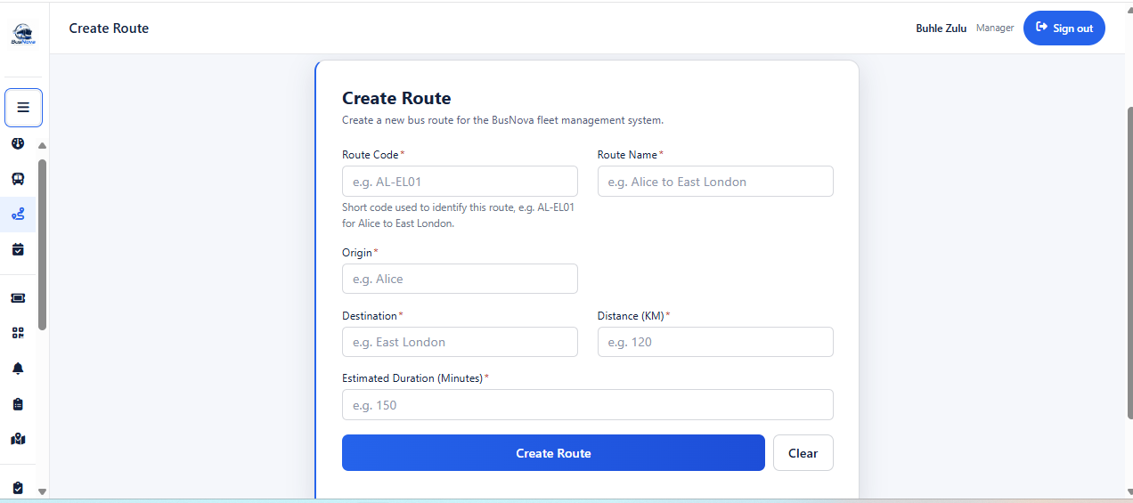
CR90: Textbox for distance
CR93: Button for clearing the form
CR91: Textbox for estimate duration
CR89: Textbox for destination route
CR86: Textbox for route name
CR87: Textbox for origin of route
CR85: Textbox for route code
Figure 36 Screen 12: Create Routes
CR92: Button for creating route

Screen Narrative and Controls: SC12
Reference | Control Type | Data Input | Data Output
CR85 | Textbox | Route code
CR86 | Textbox | Route name
CR87 | Textbox | Origin of route
CR89 | Textbox | Route destination
CR90 | Textbox | Distance in KM
CR91 | Textbox | Estimated duration in minutes
CR92 | Button | Click | Creates route
CR93 | Button | Click | Clear the form
Table 53 Screen Narrative and Controls: SC12

3.2.13. Screen 13: Assign Routes
The Assign Routes screen enables the Manager to assign an available bus and driver to a selected route and schedule. The Manager provides the required assignment details, including the route, driver, bus, date and departure information, allowing the system to allocate resources to a specific trip.
CR95: Dropdown for selecting a bus
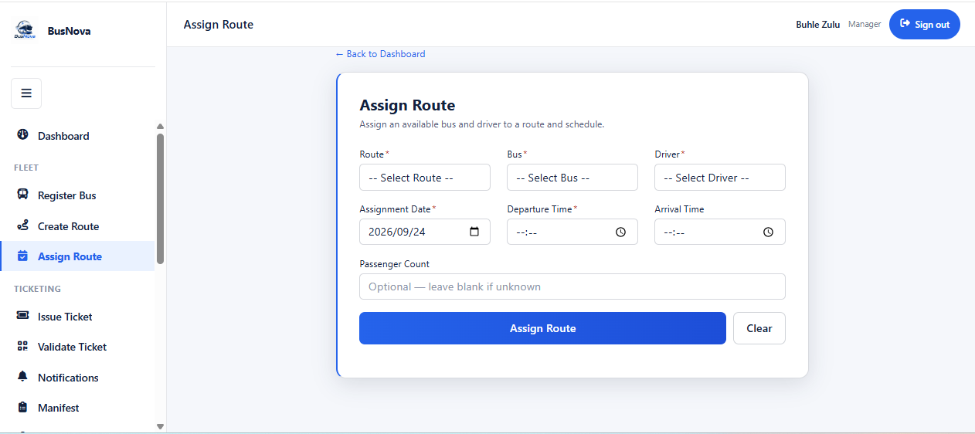
CR94: Dropdown for selecting route
CR97: Dropdown for assignment date
CR98: Textbox for departure time
CR96: Dropdown for selecting a driver
CR99: Textbox for arrival time
CR100: Textbox for passenger count
CR102: Button for clearing the form
CR101: Button for assigning route
Figure 37 Screen 13: Assign Routes

Screen Narrative and Controls: SC13
Reference | Control Type | Data Input | Data Output
CR94 | Dropdown | Select route | Route
CR95 | Dropdown | Select a bus | Bus
CR96 | Dropdown | Select a driver | Driver
CR97 | Dropdown | Assignment date
CR98 | Textbox | Departure time
CR99 | Textbox | Arrival time
CR100 | Textbox | Passenger count
CR101 | Button | Click | Assign route
CR102 | Button | Click | Clear the form
Table 54 Screen Narrative and Controls: SC13

3.2.14. Screen 14: View Assigned Routes
The View Assigned Routes screen allows the Bus Driver to access their assigned routes and trip schedules. It displays important trip information, including the assigned route, bus, date, departure and arrival times, passenger count and current trip status, enabling the driver to monitor their scheduled transportation duties.
CR104: Button to start trip
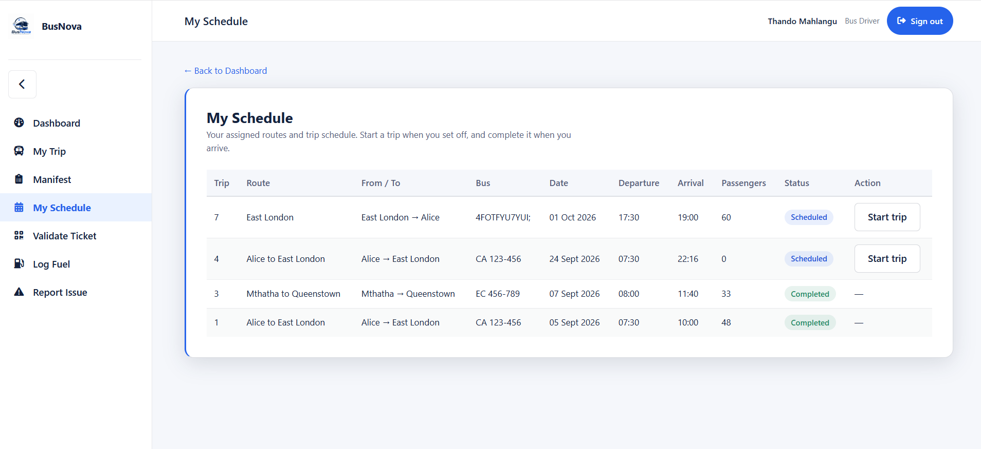
CR105: Pill for status of the trip
CR103: Grid view for viewing route schedule
Figure 38 Screen 14: View Assigned Routes

Screen Narrative and Controls: SC14
Reference | Control Type | Data Input | Data Output
CR103 | Grid view | Display assigned route
CR104 | Button | Click | Starting the trip
CR105 | Pill |  | Status of the trip
Table 55 Screen Narrative and Controls: SC14

3.2.15. Screen 15: Issue Ticket
The Issue Ticket screen allows the Manager to issue a ticket to a passenger at the counter. The Manager selects a date and trip, optionally searches for an existing passenger or registers a new one, picks a seat, and issues the ticket. A separate section on the same page allows an existing ticket to be looked up by number.
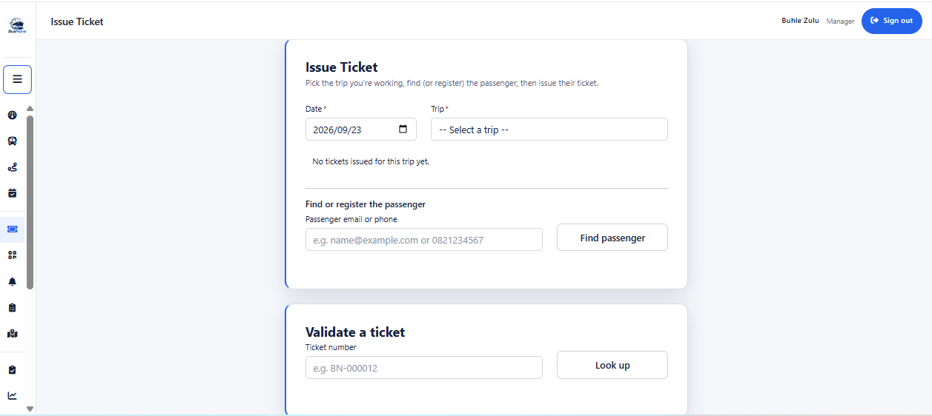
CR1: Card for viewing schedule
CR112: Button for looking ticket
CR111: Textbox for ticket number
CR110: Button to find passenger
CR109: Textbox for email
CR108: Label for ticket count
CR107: Dropdown for trip
CR106: Dropdown for date travel
Figure 39 Screen 15: Issue Ticket

Screen Narrative and Controls: SC15
Reference | Control Type | Data Input | Data Output
CR106 | Dropdown | Date of travel
CR107 | Dropdown | Select trip | Trip
CR108 | Label |  | Ticket count for selected trip
CR109 | Textbox | Passenger email or phone
CR110 | Button | Click | Finds matching passenger
CR111 | Textbox | Ticket number
CR112 | Button | Click | Looks up ticket by number
Table 56 Screen Narrative and Controls: SC15

3.2.16. Screen 16: Ticket
The Tickets screen displays the passenger's confirmed tickets as printable e-tickets. Each ticket is a self-contained document carrying the traveller's name, route, travel date, departure time, bus, seat, fare, and a scannable QR code encoding the ticket number and booking reference.
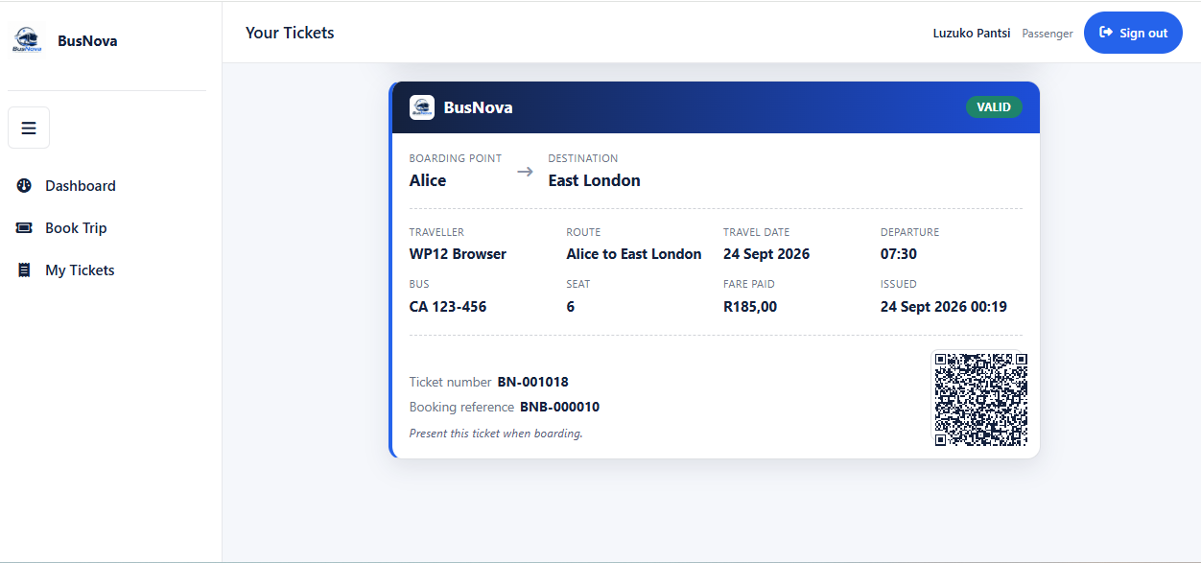
CR114: QR image for bar code
CR113: Card for ticket
Figure 40 Screen 16: Ticket

Screen Narrative and Controls: SC16
Reference | Control Type | Data Input | Data Output
CR113 | Card |  | Ticket details
CR114 | Image (QR) |  | Scannable QR code
Table 57 Screen Narrative and Controls: SC16

3.2.17. Screen 17: Route Completion
The Route Completion report shows how every trip scheduled for a chosen day actually ran — whether it was completed, how late it departed, and how full the bus was. The report includes a calculation note explaining how occupancy and the "carried" figures are derived.2
CR116: Button to run report
CR115: Dropdown list for date
CR123: Card for occupancy rate
CR118: Button to export to CSV
CR117: Button for setting period date
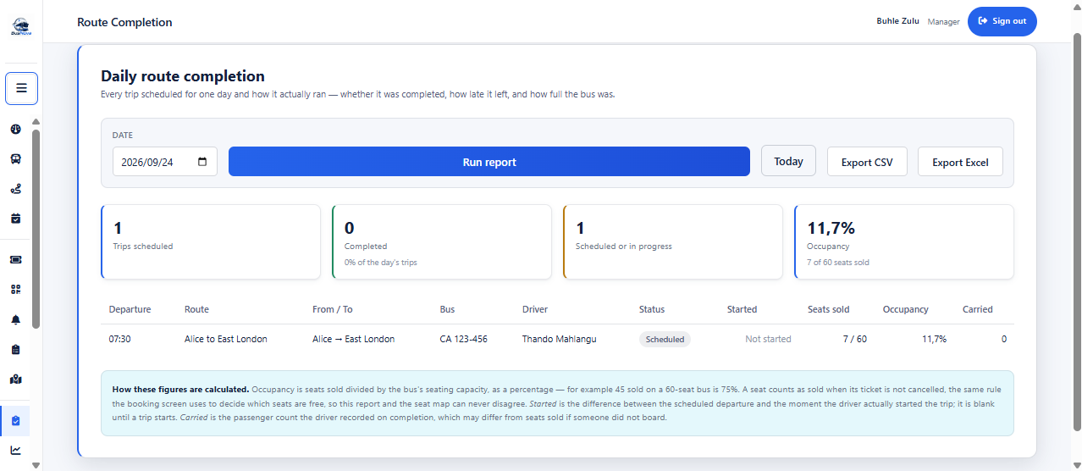
CR124: Grid view for driver’s route
CR120: Card for trip scheduled
CR119: Button for exporting to export excel
CR122: Card for scheduled or in progress
CR121: Card for completed trips
Figure 41 Screen 17: Route Completion

Screen Narrative and Controls: SC17
Reference | Control Type | Data Input | Data Output
CR115 | Dropdown | Date to report on
CR116 | Button | Click | Runs the report
CR117 | Button | Click | Sets period to last 90 days
CR118 | Button | Click | Exports as CSV
CR119 | Button | Click | Exports as Excel
CR120 | Card |  | Trips scheduled count
CR121 | Card |  | Completed count
CR122 | Card |  | Scheduled or in progress count
CR123 | Card |  | Occupancy percentage
CR124 | Grid view |  | Route completion list
Table 58 Screen Narrative and Controls: SC17

3.2.18. Screen 18: Fuel Efficiency
The Fuel Efficiency report shows consumption and running cost per bus over a chosen period, so that a vehicle drinking more fuel than it should is visible before the fuel bill arrives. Where a bus has too few fills in the period to compute a meaningful figure, the report displays "Not enough data" rather than a misleading zero.
CR125: Dropdown list for from date
CR135: Grid view for driver’s performance
CR133: Card for distance covered
CR132: Card for total fuel spending
CR131: Card for Liters purchased
CR134: Card for fleet average
CR129: Button to export to CSV
CR128: Button for setting period date
CR127: Button to run report
CR126: Dropdown list for to date
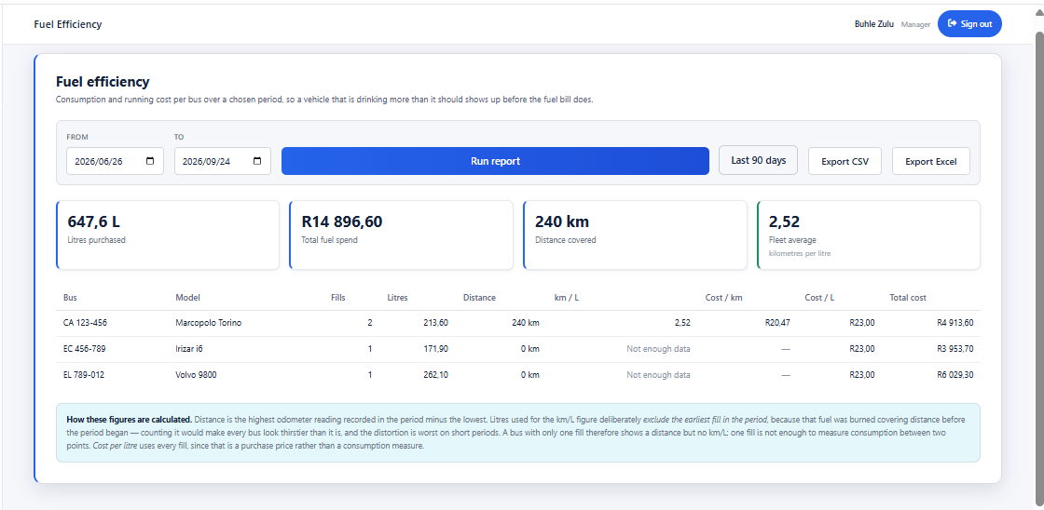
CR130: Button for exporting to export excel
Figure 42 Screen 18: Fuel Efficiency

Screen Narrative and Controls: SC18
Reference | Control Type | Data Input | Data Output
CR125 | Dropdown | From date
CR126 | Dropdown | To date
CR127 | Button | Click | Runs the report
CR128 | Button | Click | Sets period to last 90 days
CR129 | Button | Click | Exports as CSV
CR130 | Button | Click | Exports as Excel
CR131 | Card |  | Litres purchased
CR132 | Card |  | Total fuel spending
CR133 | Card |  | Distance covered
CR134 | Card |  | Fleet average (km/L)
CR135 | Grid view |  | Per-bus fuel efficiency list
Table 59 Screen Narrative and Controls: SC18

3.2.19. Screen 19: Driver Performance
The Driver Performance report shows trips run, punctuality, passengers carried and faults reported per driver over a chosen period. Licence expiry is shown alongside, because a driver who cannot legally drive next month is a scheduling problem this month.
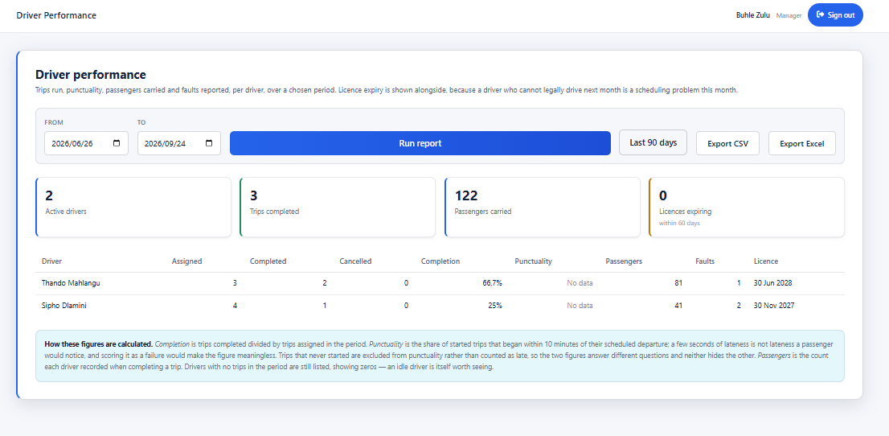
CR145: Card for licences expiring
CR141: Button for exporting to export
CR146: Grid view for driver’s performance
CR144: Card for passengers carried
CR143: Card for trips completed
CR142: Card for active drivers
CR140: Button to export to CSV
CR139: Button for setting period date
CR138: Button to run report
CR137: Dropdown list for to date
CR136: Dropdown list for from date
Figure 43 Screen 19: Driver Performance

Screen Narrative and Controls: SC19
Reference | Control Type | Data Input | Data Output
CR136 | Dropdown | From date
CR137 | Dropdown | To date
CR138 | Button | Click | Runs the report
CR139 | Button | Click | Sets period to last 90 days
CR140 | Button | Click | Exports as CSV
CR141 | Button | Click | Exports as Excel
CR142 | Card |  | Active driver count
CR143 | Card |  | Trips completed count
CR144 | Card |  | Passengers carried count
CR145 | Card |  | Licenses expiring withing 60 days
CR146 | Grid view |  | Per-driver performance
Table 60 Screen Narrative and Controls: SC19

3.2.20. Screen 20: Maintenance Due
The Maintenance Due report lists every bus in the fleet in urgency order, combining scheduled service dates with any open critical faults. An open critical fault takes precedence over an overdue service, because an unsafe bus should not be running and a merely late one can be. The report is a snapshot of now and has no date filter by design.
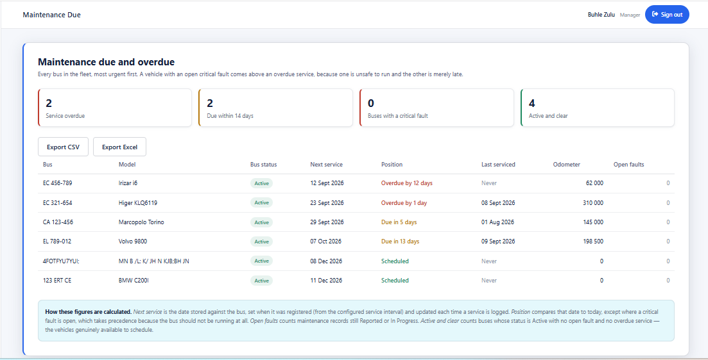
CR153: Grid view for fleet maintenance
CR152: Button for exporting to Excel
CR151: Button for exporting to CSV
CR150: Card for buses active
CR149: Card for buses in critical fault
CR148: Card for service due within 14 days
CR147: Card for service overdue
Figure 44 3.2.20. Screen 20: Maintenance Due

Screen Narrative and Controls: SC20
Reference | Control Type | Data Input | Data Output
CR147 | Card |  | Service overdue count
CR148 | Card |  | Due within 14 days count
CR149 | Card |  | Buses with a critical fault count
CR150 | Card |  | Active and clear count
CR151 | Button | Click | Exports as CSV
CR152 | Button | Click | Exports as Excel
CR153 | Grid view |  | Fleet maintenance list
Table 61 Screen Narrative and Controls: SC20

3.2.21. Screen 21: Payment
This the payment page where a passenger pays for a ticket that they booked for a trip and they can choose the payment method of their choice.
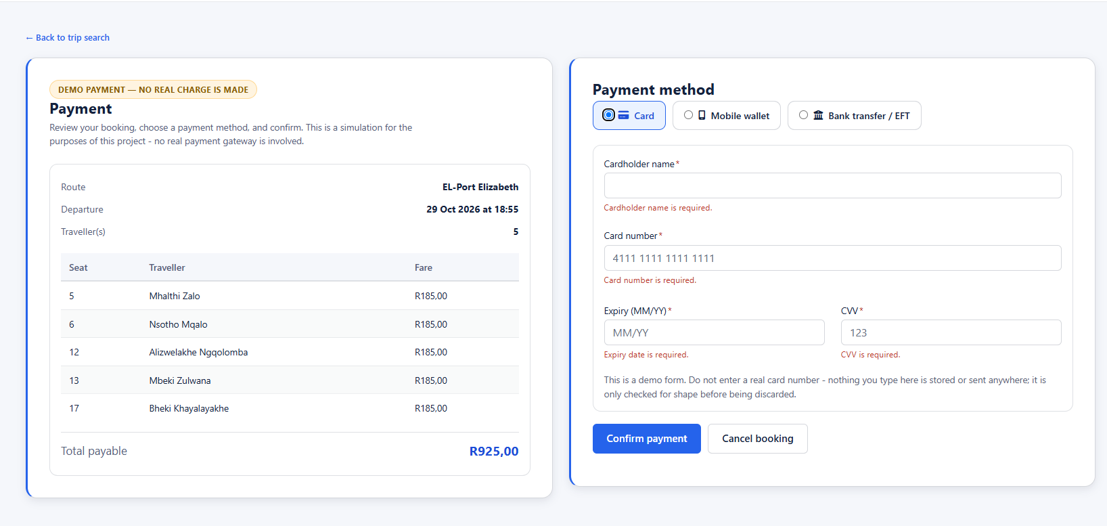
CR161: Button for cancelling booking
CR158: Textbox for expiry date
CR160: Button for payment confirmation
CR159: Textbox for CVV number
CR157: Textbox for card number
CR156: Textbox for cardholder name
CR155: Button for payment method
CR154: Grid view for tickets booked
Figure 45 Screen 21: Payment

Screen Narrative and Controls: SC21
Reference | Control Type | Data Input | Data Output
CR154 | DataGrid |  | Show the list of the travelers
CR155 | Button | Click | Choose the payment method
CR156 | Textbox | Enter cardholder name
CR157 | Textbox | Enter card number
CR158 | Textbox | Enter expiry dates
CR159 | Textbox | Enter the security number
CR160 | Button | Click | Confirms the payment
CR162 | Button | Click | Cancels the booking
Table 62 Screen 21: Payment

3.2.21. Screen 22: Live Map
This is the where the manager can see the location oof the driver of where they are in the current time of starting the trip.
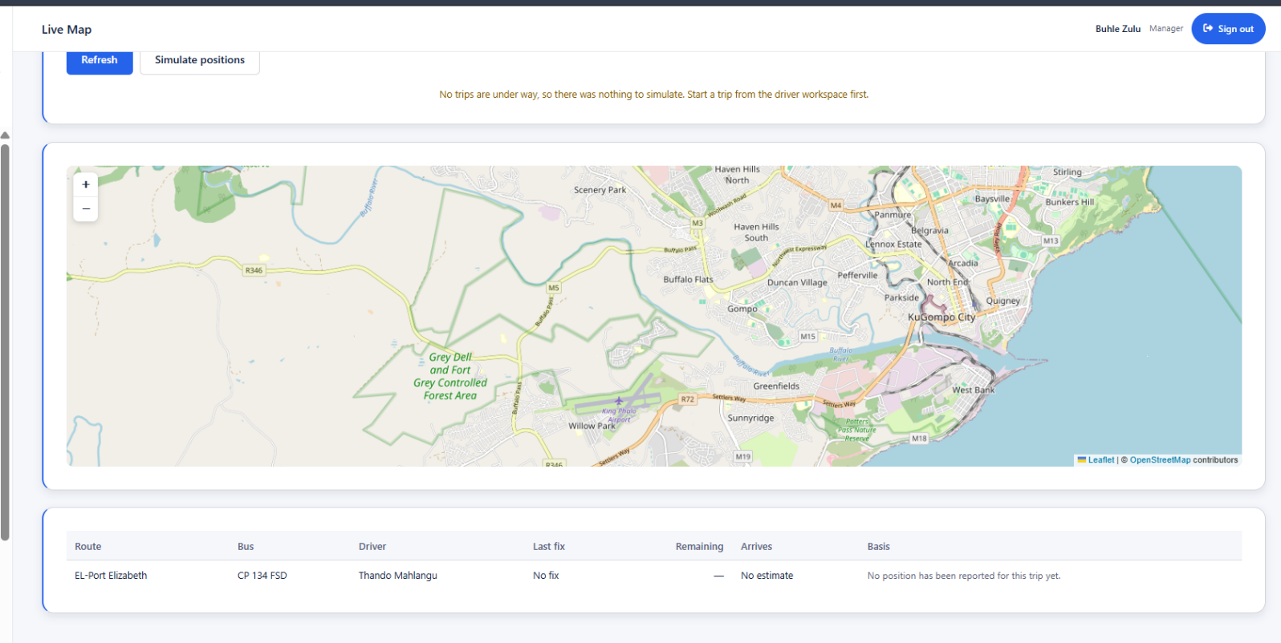
CR163: List view for viewing trip
CR162: Live map of the open street
Figure 46 Screen 22: Live Map

Screen Narrative and Controls: SC22
Reference | Control Type | Data Input | Data Output
CR162 | Open Map |  | Shows the location of the bus
CR163 | List view |  | Show the list of the active trip
Table 63 Screen 22: Live Map

3.2.22. Screen 23: Passenger Manifest
This where the driver can see all the passenger who are in a bus or booked the trip and are onboarded or not and it shows the number of bookings made against available sits.
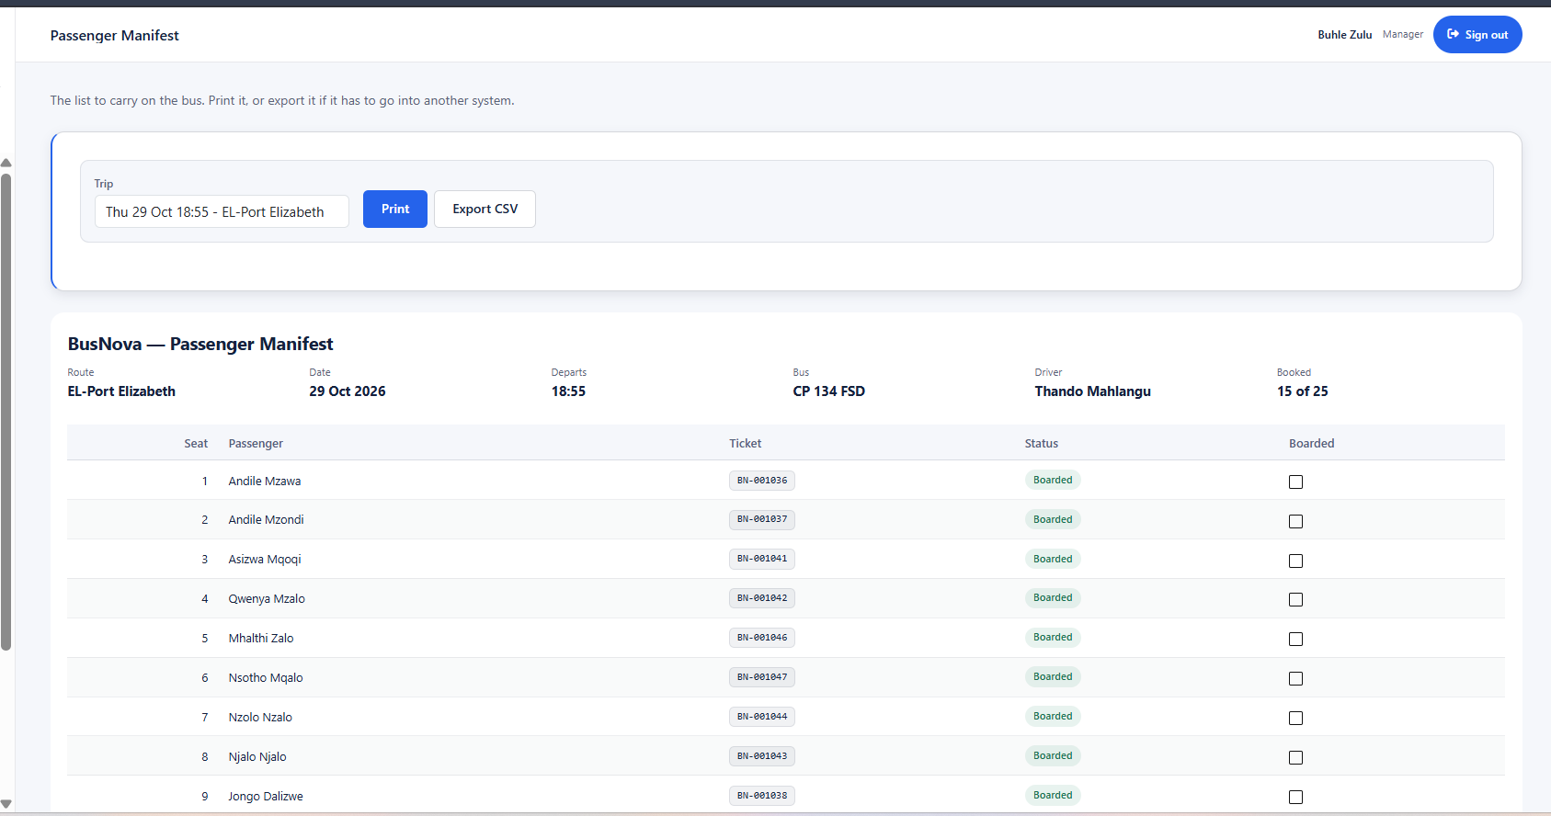
CR167: List view for view all the passengers booked and are onboarded
CR165: Button to print report
CR166: Button for export data to csv
CR164: Dropdown for trip
Figure 47 Screen 23: Passenger Manifest

Screen Narrative and Controls: SC23
Reference | Control Type | Data Input | Data Output
CR164 | Dropdown | Selects the trip to see it passengers
CR165 | Button | Click | Exports the list into a pdf
CR166 | Button | Click | Exports the list into a CSV
CR167 | List view |  | Shows the list if all the passengers who booked
Table 64 Screen 23: Passenger Manifest

3.2.23. Screen 24: Ticket Sales
This where the admin can see all the ticket sales that have being made into the system, the admin can export the reports for decision making.
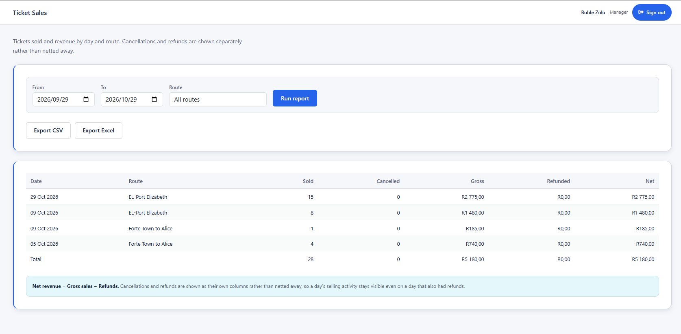
CR173: Button for export data to excel
CR172: Button for export data to csv
CR171: Button for running reports
CR170: Dropdown for route
CR169: Date picker for TO date
CR168: Date picker for from date
CR174: List view for view all the trips taken
Figure 48 Screen 24: Ticket Sales

Screen Narrative and Controls: SC24
Reference | Control Type | Data Input | Data Output
CR168 | Date picker | Selects the start date from
CR169 | Date picker | Select the end date to
CR170 | Dropdown | Selects the route
CR171 | Button | Click | Run the reports
CR172 | Button | Click | Exports the date to CSV
CR173 | Button | Click | Export to Excel
CR174 | List view |  | Shows all the trips taken in the system
Table 65 Screen 24: Passenger Manifest

3.2.24. Screen 25: Driver Schedule
The admin can see the schedule of all the drivers if they are available or not so that they can see the trip if it is completed or not.
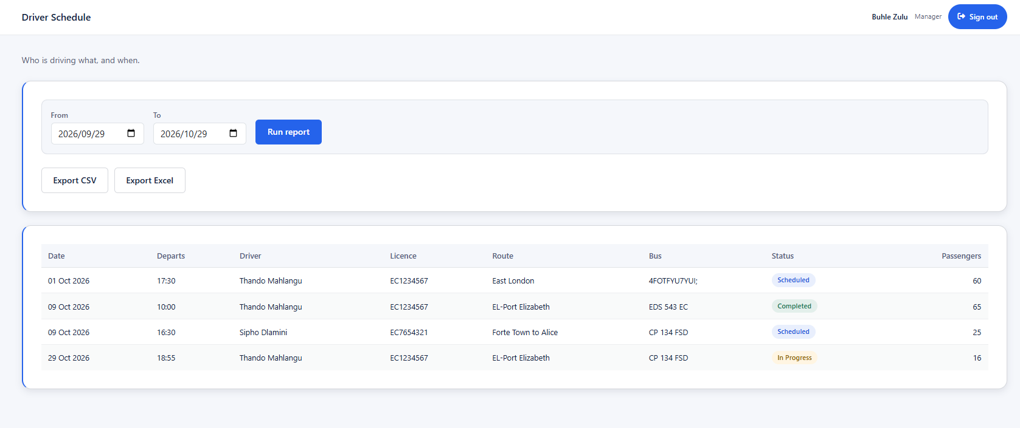
CR177: Button for running reports
CR176: Date picker for TO date
CR175: Date picker for from date
CR180: List view for view all the driver schedule
CR179: Button for export data to excel
CR178: Button for export data to csv
Figure 49 Screen 25: Driver Schedule

Screen Narrative and Controls: SC25
Reference | Control Type | Data Input | Data Output
CR175 | Date picker | Selects the start date from
CR176 | Date picker | Select the end date to
CR177 | Button | Click | Run the reports
CR178 | Button | Click | Exports the date to CSV
CR179 | Button | Click | Export to Excel
CR180 | List view |  | Shows all the drive’s trip schedule
Table 66 Screen 25: Driver Schedule

3.2.25. Screen 26: Route List
This where the admin can see all the list of the routes active in the system.
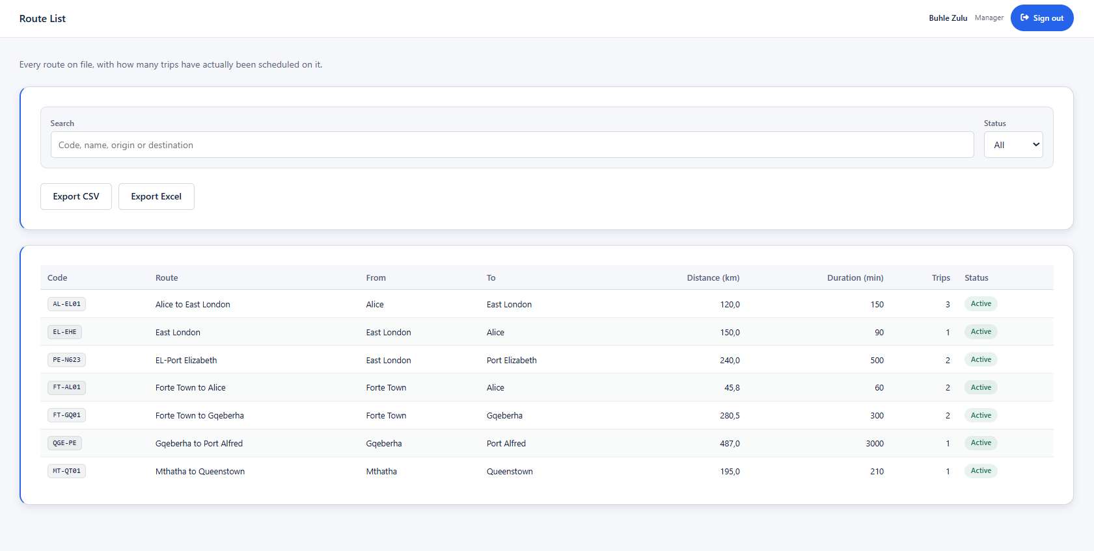
CR182: Dropdown for status
CR181: Date picker for from date
CR183: Button for export data to csv
CR184: Button for export data to excel
CR185: List view for view all the driver schedule
Figure 50 Screen 26: Route List

Screen Narrative and Controls: SC26
Reference | Control Type | Data Input | Data Output
CR181 | Textbox | Searches the route
CR182 | Dropdown | Selects the status of the route
CR183 | Button | Click | Exports the date to CSV
CR184 | Button | Click | Export to Excel
CR185 | List view |  | Shows all the routes
Table 67 Screen 26: Route List

Sprint Backlog
Requirement | Sub Tasks | Dependency | Estimated  Completion  Time (in days) | Responsible  Group Member
1.Business  Process  Description | 1.1 Update the Use Case Diagram for the entire system, highlighting the Sprint 2 use cases | Sprint 1 Use Cases | 1 day | Yonwaba Mqulwana
 | 1.3 Write Use Case Narratives (Blackboard template) | Developed use cases | 3 days | Each member for their own use case
 |  | Use Case  Narratives | 2 days | Each member for their own UCN
  1.4 Draw Activity Diagrams, placed directly after their UCN
2.Data  Modelling | 2.1 Fix the ERD for the entire system with all attributes, crow's foot notation, keys and field types | Sprint 1 ERD and feedback | 2 days | Olebogeng Gumbu
 | 2.2 Update Attribute Framing | ERD complete | 1 day | Elihle Nteyi
 | 2.3 Update the SQL script and fix the database | Attribute framing complete | 2days | Nadia  Mpohlekana
3.System Design requirements | 3.1 Update the UML Window Navigation Diagram with screen reference numbers and arrows | Activity Diagrams completed | 1 day | Anesipho Kalazana
 | 3.2 Screenshots | UML Window  Navigation  Diagram | 1 day | Esethu Mtose
 | 3.3 Screen narratives and controls | System Screens (Screenshots) completed | 1 day | Simanye  Siximba
4.Documentation | Review sprint 2 document | All tasks completed | 1 day | All members

Risk Log
Ref  No | Description | SQERT | Probability | Impact | Criticality | Proximity | Author | Mitigation  and owner | Date  Raised | Date  Updated | Current  Status | Date  Closed
1 | Incorrect bus or driver assignment to routes | SQ | 2 | 5 | 10 | During route assignment | Team Members | Programmer | 12/09//2026 | 01/10/2026 | Reducing | Not closed
2 |  | SQT | 2 | 5 | 10 | During ticket booking and payment | Team Members | Programmer | 15/09/2026 | 02/10/2026 | Reducing | Not closed
  Errors during ticket booking or payment
3 | Incorrect maintenance or fuel records | Q | 2 | 4 | 8 | During maintenance and fuel recording | Team Members | Testing Member | 20/09/2026 | 02/10/2026 | Reducing | Not closed

KEY: SQUERT
Code | Meaning
S | Scope
Q | Quality
E | Effort
R | Resources
T | Time

Sprint Progress Report
Project Name:  BusNova Bus Management System | Sprint Number:  Sprint 2
Sprint Duration:  12 August 2026 - 05 October 2026 | Report Date:  06 October 2026
Report Number:  2 | Prepared By:  Nadia Mpohlekana

Sprint Goals | Goal 1: Extend the business process documentation so that the remaining operational processes (operations monitoring, fuel, maintenance, route viewing, availability, ticketing and issue reporting) are covered by use case narratives and activity diagrams.  Goal 2: Document the complete data model, including the Entity Relationship Diagram and attribute framing for all 19 system entities.  Goal 3: Complete the system design and consolidate the Sprint 2 documentation: the Windows Navigation Diagram and specifications (screenshots, narratives and controls) for the 20 role-based screens, building on the Sprint 1 database and user interface foundation.
Completed Work in line with Sprint Backlog | Task 1: Use case narratives and activity diagrams - Completed. Eight new narratives, each with an activity diagram, were delivered: UC6 Monitor Operations, UC8 Review Fuel, UC10 Report Fuel, UC11 Report Issues, UC13 View Routes, UC14 Check Availability, UC15 Purchase Ticket and UC18 Log Servicing Activities. Fifteen of the 21 use cases in the System Matrix are now documented.  Task 2: Revision of Sprint 1 artefacts - Completed. The UC1 Register, UC2 Login and UC5 Assign Routes narratives were reviewed and updated between 29 August and 02 September 2026.  Task 3: Data modelling - Completed. The Entity Relationship Diagram and attribute framing are documented for 19 entities: Employees, Passengers, Bus, Bus Schedule, Route, Route Assignments, Maintenance Logs, Maintenance Parts, Fuel Logs, Tickets, Tickets Validation, Booking, Notification, Payment Event, Payment Refund, Payment Transaction, Audit Logs, Trip Inspection and Trip Pin.  Task 4: System design - Completed. The Windows Navigation Diagram and 20 screen specifications, each with a screenshot and a narrative and controls table, cover the Home, Register and Login screens, the four role dashboards (Manager, Bus Driver, Passenger and Maintenance Staff) and the operational screens for users, fuel, issues, buses, routes, tickets, route completion, fuel efficiency, driver performance and maintenance due.  Task 5: Documentation - Completed. The System Overview (aligned to SDG 9, 11 and 12), System Matrix, Sprint 1 backlog, Risk Log and Sprint Progress Reports were consolidated into the Sprint 2 project documentation for submission on 05 October 2026.
In-Progress Work | Task 1: Documenting the six System Matrix use cases that do not yet have a narrative and activity diagram: UC7 Review Route Completion, UC12 Update Trip Status, UC16 Receive Confirmation Email, UC19 Update Vehicle Status, UC20 Receive Maintenance Alerts and UC21 Register Employees.  Task 2: Reconciling the System Matrix with the final screen set (the matrix references SC2-SC22, while the screens are documented as Screen 01-20) and standardising table and figure captions and date formats across the document.  Task 3: System and integration testing of the implemented modules against the SQL Server database, as required to mitigate Risk 2 (insufficient system testing before submission).
Upcoming Work | Task 1: Complete the remaining CRUD operations and business logic for the entities supporting ticketing, payments, notifications, audit logging and trip inspection.  Task 2: Carry out full system, integration and user acceptance testing, and resolve all identified defects.  Task 3: Finalise the outstanding use case documentation, update the Risk Log and prepare the final submission.
Blockers and Challenges | Blocker 1: Documentation consistency. Screen references in the System Matrix do not match the final screen numbering, and captions and date formats vary between narratives. This reduces traceability between use cases, screens and reports until the artefacts are reconciled.  Blocker 2: Parallel authoring and review. Fifteen narratives and activity diagrams were written by different members and several were revised after creation. A second reviewer is recorded for only three of the eight new narratives (UC6, UC11 and UC18), which risks inconsistent quality and rework.  Blocker 3: Testing and risk tracking. The Risk Log was last updated on 08 August 2026, and Risk 2 (insufficient system testing, criticality 15) is the highest-rated risk and remains open. Limited time remains for thorough testing before submission.
Team Member Contributions | Nadia Mpohlekana (Project Manager; Documenter) - Authored UC8 Review Fuel, reviewed UC6 Monitor Operations, coordinated the sprint and consolidated the Sprint 2 documentation and this report.  Yonwaba Mgqulwana (Business Analyst; Documenter) - Authored UC10 Report Fuel and reviewed and updated UC1 Register, UC5 Assign Routes, UC11 Report Issues and UC18 Log Servicing Activities.  Anesipho Kalazana (Business Analyst) - Authored UC15 Purchase Ticket and UC18 Log Servicing Activities.  Esethu Mtose (Business Analyst) - Authored UC14 Check Availability.  Elihle Nteyi (Business Analyst) - Authored UC11 Report Issues.  Olebogeng Gumbu (Programmer) - Authored UC13 View Routes.  Simanye Siximba (Programmer) - Authored UC6 Monitor Operations and reviewed and updated UC2 Login.
Velocity and Burndown Chart | Velocity:  No story points were recorded, so velocity is measured in documented deliverables. Sprint 2 delivered 8 use case narratives with activity diagrams (Sprint 1: 7) and revised 3 existing narratives. Use case documentation coverage rose from 7 of 21 (33%) to 15 of 21 (71%). The data model (19 entities) and all 20 screen specifications are documented.
Sprint Retrospective Summary | What Went Well:  All seven members contributed to the documentation, and the eight new narratives with activity diagrams were completed between 22 and 30 August 2026.  Cross-review of narratives by a second member, introduced as a Sprint 1 action item, was applied to UC6, UC11 and UC18.  Screen designs now cover all four user roles.  What Didn’t Go Well:  Five of the eight new narratives (UC8, UC10, UC13, UC14 and UC15) have no recorded reviewer, and six use cases remain undocumented.  The System Matrix and screen numbering are misaligned.  The Risk Log was not updated during the sprint, and the Sprint 2 backlog is not included in the documentation, which makes progress against plan hard to measure.  Action Items for Improvement:  1. Record a Sprint 3 backlog with estimates and owners in the project documentation.  2. Require a second-member review before any narrative or diagram is marked final.  3. Align the System Matrix with the final screen numbering and standardise captions and date formats.  4. Update the Risk Log weekly and schedule end-to-end testing early in the next sprint.
Key Takeaways | Sprint 2 moved BusNova from a design foundation to a largely complete specification: use case coverage reached 71%, the 19-entity data model is documented, and all 20 screens are specified across the four user roles. The priorities for the next sprint are to close the remaining documentation gaps, restore traceability between the System Matrix, use cases and screens, and complete formal testing against the SQL Server database before final submission.
Prepared by | Nadia Mpohlekana
Role | Project Manager & Documentation Lead
Date | 06 October 2026

Table 15: Sprint Progress Report

